**ENGL 301 Assignment 1:3 Definition:**

**Introduction**

The purpose of this assignment is to explain intricate terms from a technical discipline to an uninformed audience. I chose to define the term Cartography from a Geographic Information Science(GIS) perspective in three ways: a parenthetical definition, a sentence definition, and an expanded definition.

**Parenthetical Definition**

Cartography is the study and process of developing a map.

**Sentence Definition**

In GIS, map making is an integral component of displaying spatial data. By following cartographic conventions(ie. putting a north arrow, legend, neatline and scale on a map) and design principles(ex. visual contrast, legibility, balance, figure-ground and hierarchical organization) a map maker is able to communicate information and findings that may otherwise prove challenging to put into words1.

**Expanded Definition**

*Who is using cartography?*

Cartography is a field in which many disciplines are apt to use. Health scientists may make a map displaying disease rates within a country or archaeologists can make maps showing potential dig sites in a particular region of interest. These maps could show policy makers what parts of a country need healthcare funding the most and what regions represent the most likely place to extract ancient relics respectively.

*Why is cartography important?*

Maps can provide an aesthetically pleasing platform on which to learn something new1. Knowing what makes a good map stand out is beneficial to the viewer(see Sentence definition). A lot of data available nowadays has a spatial component and to be able to judge a map with certain criteria in mind will either enhance or diminish the message a cartographer is trying establish.

*What devices do cartographers use?*

Traditionally, cartographers would assimilate geographical data and use it to make a map by hand then submit their work to a printing press. This was a very intense process as it requires meticulous amounts of detail both in planning and practice. Nowadays, cartographers are using GIS programs, like ArcGIS, along with image editing software such as Adobe Illustrator to make maps2.

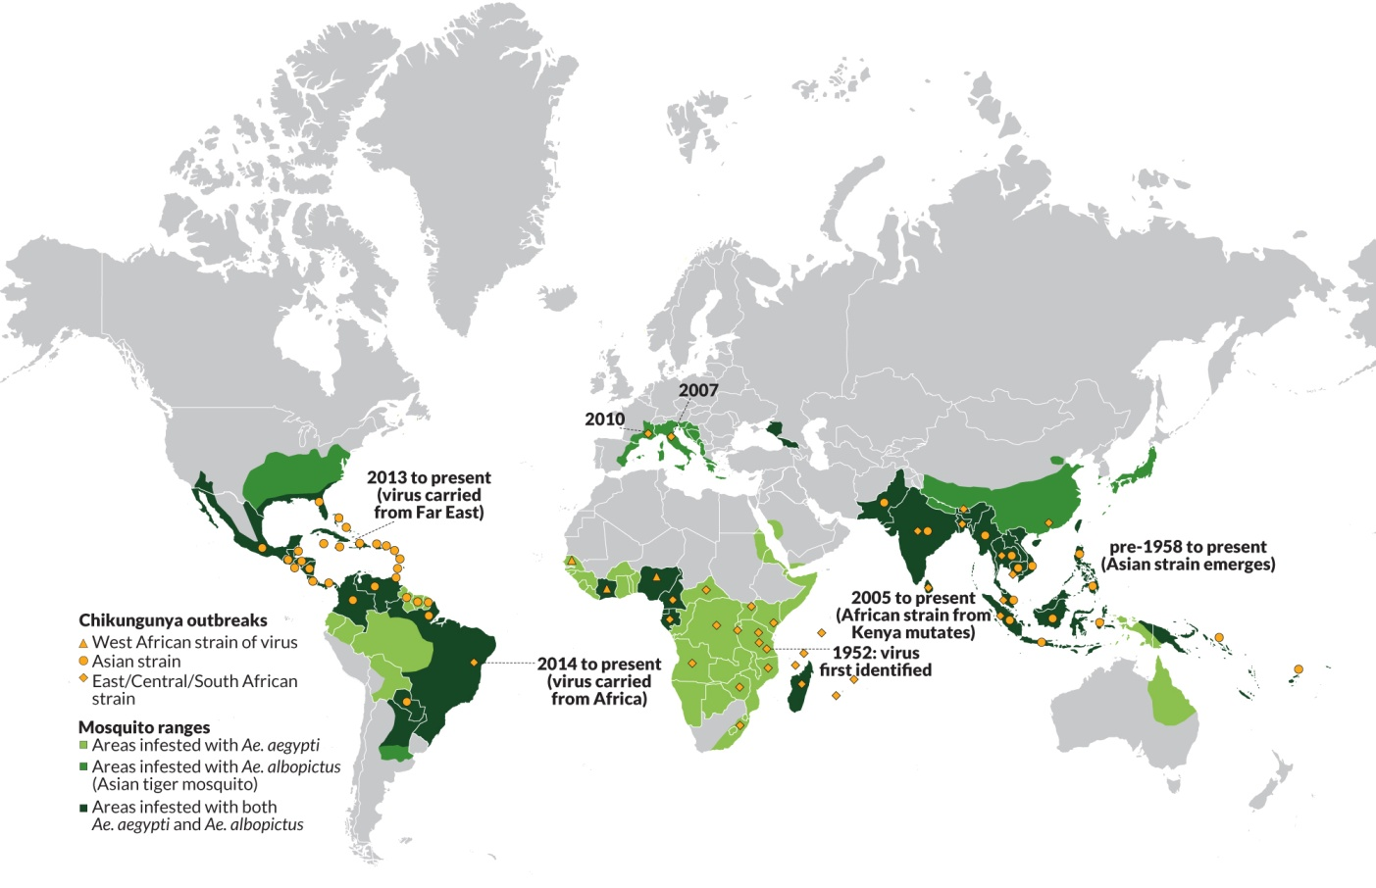3

This map is displaying the spread of the disease, Chikungunya, which has received a lot of publicity as of late. Although it communicates the pattern of disease effectively, it is still missing important cartographic features such as proper legend, a north arrow, scale, and neat line.

**Works Cited**

1. Buckley, Aileen. "Make Maps People Want to Look At" ArcUser,ESRI Winter 2012 Edition. Web. 25 Jan. 2016 <http://www.esri.com/news/arcuser/0112/make-maps-people-want-to-look-at.html>

2. Brodersen, Lars. "Value Assessment in Managing Cartography and Geo-communication" Web. 1 Feb. 2016 <http://www.cartogis.org/docs/proceedings/2006/brodersen.pdf>

3. Seppa, Nathan. "Chikungunya is on the move" ScienceNews. 2 June 2015. Web. 25 Jan.2016 <https://www.sciencenews.org/article/chikungunya-move#&gid=1&pid=1>