**Assignment 1:3 Definitions – Fetch**

The objective of this assignment is to define a technical term to readers who are unfamiliar with the subject of the term. The term ‘fetch’ will be defined using a parenthetical definition, a sentence definition, a diagram, and an expanded definition.

**Parenthetical definition:**  The greater fetch (distance that a wave has travelled in a constant direction), larger the wave is in size.

**Sentence Definition:** Fetch is the distance that a wave has travelled due to constant wind direction.

**Diagram:**

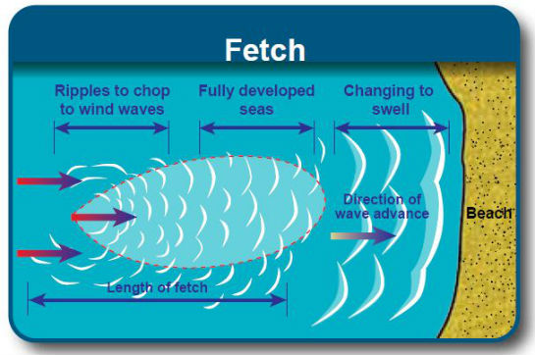

(Environment and Climate Change Canada, 2016)

**Expanded Definition:**

**What is the operating principal of fetch?:** As waves are blown by wind from their point of origin, such as a weather front, they will continue to grow in fetch as they move forward in a constant direction (Stiassnie, 2).

**What are the required conditions for fetch to occur?:** For fetch to occur there must be wind blowing over a body of water. If the body of water is too small in size, there will be a short fetch and small waves will occur. If the wind changes in direction, the fetch will begin once again after the energy created from the original fetch changes in direction to the direction of the new fetch (Kleiss, 12).

**Example:** As a weather front moved southward down Vancouver Island, the passage between the Gulf Islands and Vancouver Island grew in fetch.

**References:**

Kleiss, Jessica M., and W, Kendel Melville. "Observations of Wave Breaking Kinematics in Fetch-Limited Seas." Scripps Institution of Oceanography, La Jolla, California (2010): 12. Web. 25 Sept. 2016.

Stiassnie, Michael. "Fetch-limited Growth of Wind Waves." Journal of Geophysical Research 117.C11 (2012): 2. Web. 25 Sept. 2016.

"Weather and Meteorology." Government of Canada, Environment and Climate Change Canada. N.p., 26 Aug. 2016. Web. 02 Oct. 2016.