Instructions:
- By default, all sections in this template are required, unless explicitly denoted as optional.
- Grey shaded text denotes instructions and should be deleted before distributing.
- Square brackets [ ] denote hints and notes that should be replaced, modified, or deleted.
- Don’t forget to complete the footer. Remember to update the version date after each revision.
- This template should be used for courses offered through the Robert H. Lee Graduate School.
- Your Divisional Assistant should be able to assist with formatting issues.
- All required information must be contained in this formal syllabus; don’t direct students to a course website or Canvas for required information
COURSE INFORMATION
Course title: | [course title as shown in UBC Calendar (except pilot courses)]
Course code: | [e.g. BAFI 520] | Credits: | [1.5, 3, etc.]
Session and term: | [e.g. 2025W1, Period 1] | Class location: | [building code and room no.]
Section(s): | [section number(s)] | Class times: | [days of week and times]
Course duration: | [start and end dates] | Pre-requisites: | [course codes or n/a]
Division: | [Finance, etc.] | Co-requisites: | [course codes or n/a]
INSTRUCTOR INFORMATION
Instructor: | [name, credentials]
Phone: | [phone number] | Office location: | [building code and room no.]
Email: | [email address] | Office hours: | [days of week and times]

[When applicable …]
Teaching assistant: | [name]
Office hours: | [days of week and times, and location]
Email: | [email address]
COURSE DESCRIPTION
[Provide a detailed but succinct description of the course. Ensure consistency between this course description and the brief course description in the UBC Calendar. Avoid repeating what will be in the learning objectives below.]
COURSE FORMAT
[Additional information on course structure. Typical use of class time (lecture, discussion, cases, flipped classroom). Tutorials or labs if any. Is this a blended online + face-to-face course? Is this a flex course that meets less frequently than typical? [Please note that all courses are expected to be delivered in-person: e.g. videos and other digital media can be part of course delivery, but the instructor and students are expected to meet in-person.]
LEARNING OBJECTIVES
By the end of this course, students will be able to:
- [Identify / explain / apply / analyze / integrate / evaluate / etc.] …
- …
…
[Use actions and outcomes that are observable and measurable. Avoid unobservable outcomes such as “understand,” which can be reworded as “describe” or “explain.” Refer to Bloom’s Taxonomy. Here is an explainer complete with examples (University of Arkansas)]

SUstainable development goals (SDGs)
[We are including SDGs in course syllabi to show where they are addressed in coursework. This is a part of Sauder’s commitment to contributing meaningfully to global sustainability and resilience. For assistance or questions on SDG’s or their inclusion, please contact deansoffice.reception@sauder.ubc.ca.]

At UBC Sauder, we are committed to responsible business practices that can have transformative impacts on society. One of the ways we are reinforcing our commitment to responsible business is by showcasing relevant content in our courses via the lens of the United Nations Sustainable Development Goals. In this course, we will touch on topics that relate to the following goals:

Below is an example for a marketing course. Revise the example for your course. Please copy and paste between two to five SDG goals from the list following the example into the table for your own course. Then fill in your own description of where the goal is covered in your course.

Sustainable Development Goal | Description of how and when the goal is covered in the course.
GOAL 3: Good Health and Well-being   | In week 1, we will have one full class dedicated to negative impacts of marketing on consumer health and well-being, as well as potential ways to mitigate these. These topics will be revisited in week 3 with a small-group discussion and in week 4 with an in-class exercise. In week 6, we will have a dedicated class activity on the impact of advertising on consumer self-esteem and body image, and ways to overcome this.
GOAL 12: Responsible Consumption and Production  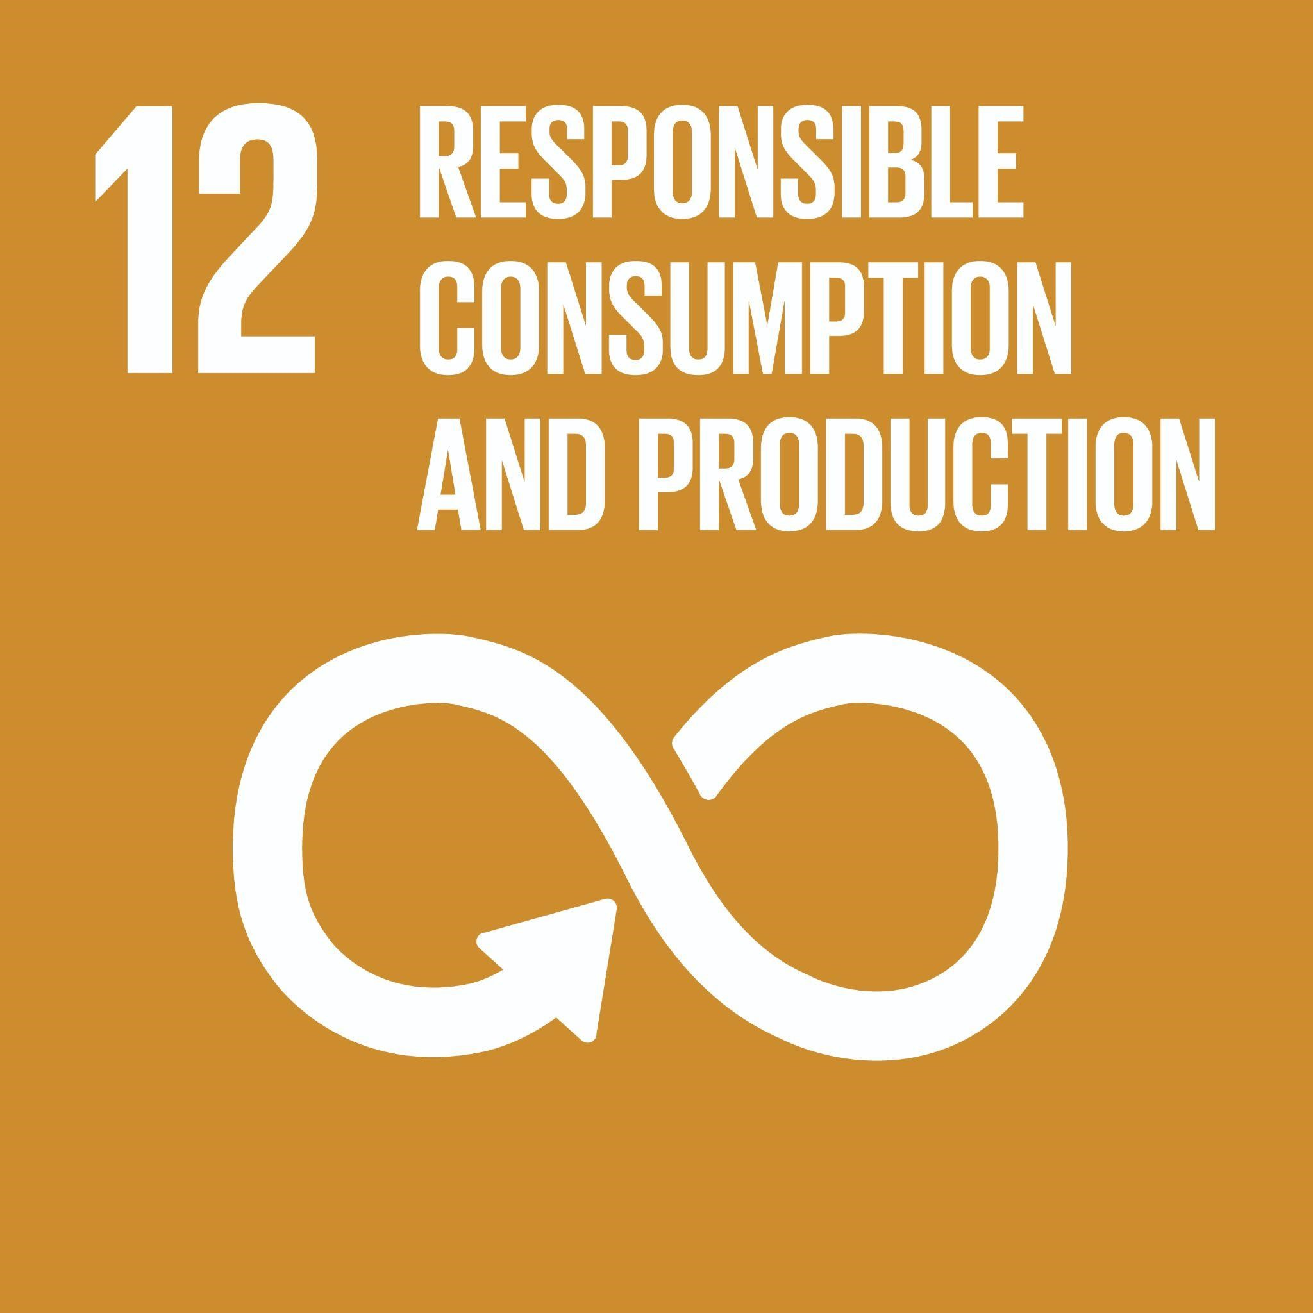 | In weeks 1 and 7, we will engage in experiential exercises that will allow us to think critically about the important role marketers have in terms of impacting responsible production and consumption. In week 12, we will consider the negative environmental impacts of consumption and a framework for encouraging more responsible consumer behaviours.
Goal 10: Reduced Inequality  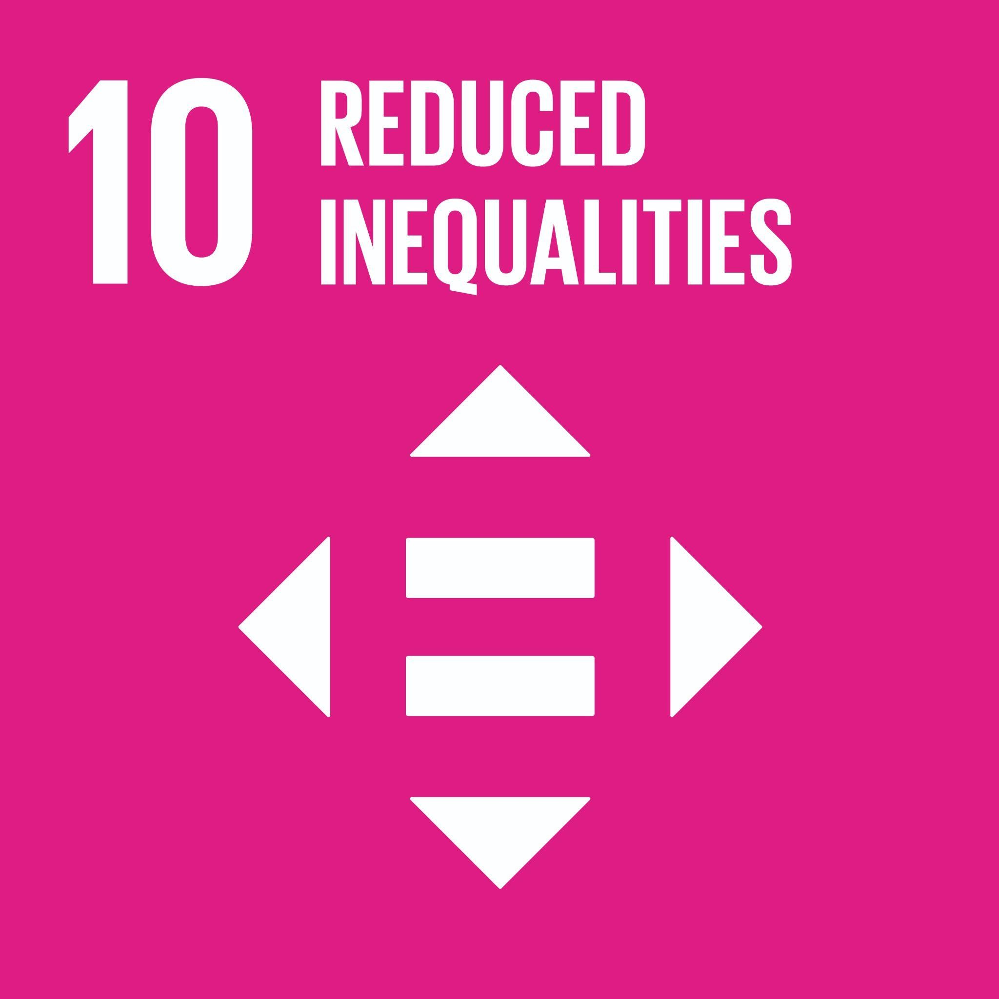 | In week 11, we will have reading, lecture content, and group discussions on how segmentation can treat consumers differentially based on various demographic differences, which can impact consumers’ access to different products and services.

Below is the complete SDG goal list to copy and paste from to use for the table above. Delete the below list once you have included your applicable goals in the table above.

Goal 1: No Poverty   | End poverty in all its forms everywhere  Global Examples: access to basic goods and services, financial security, poverty elimination, income poverty, social services, poverty elimination, homelessness, thriving wage, skills training, income support, charitable donations
Goal 2: Zero Hunger:  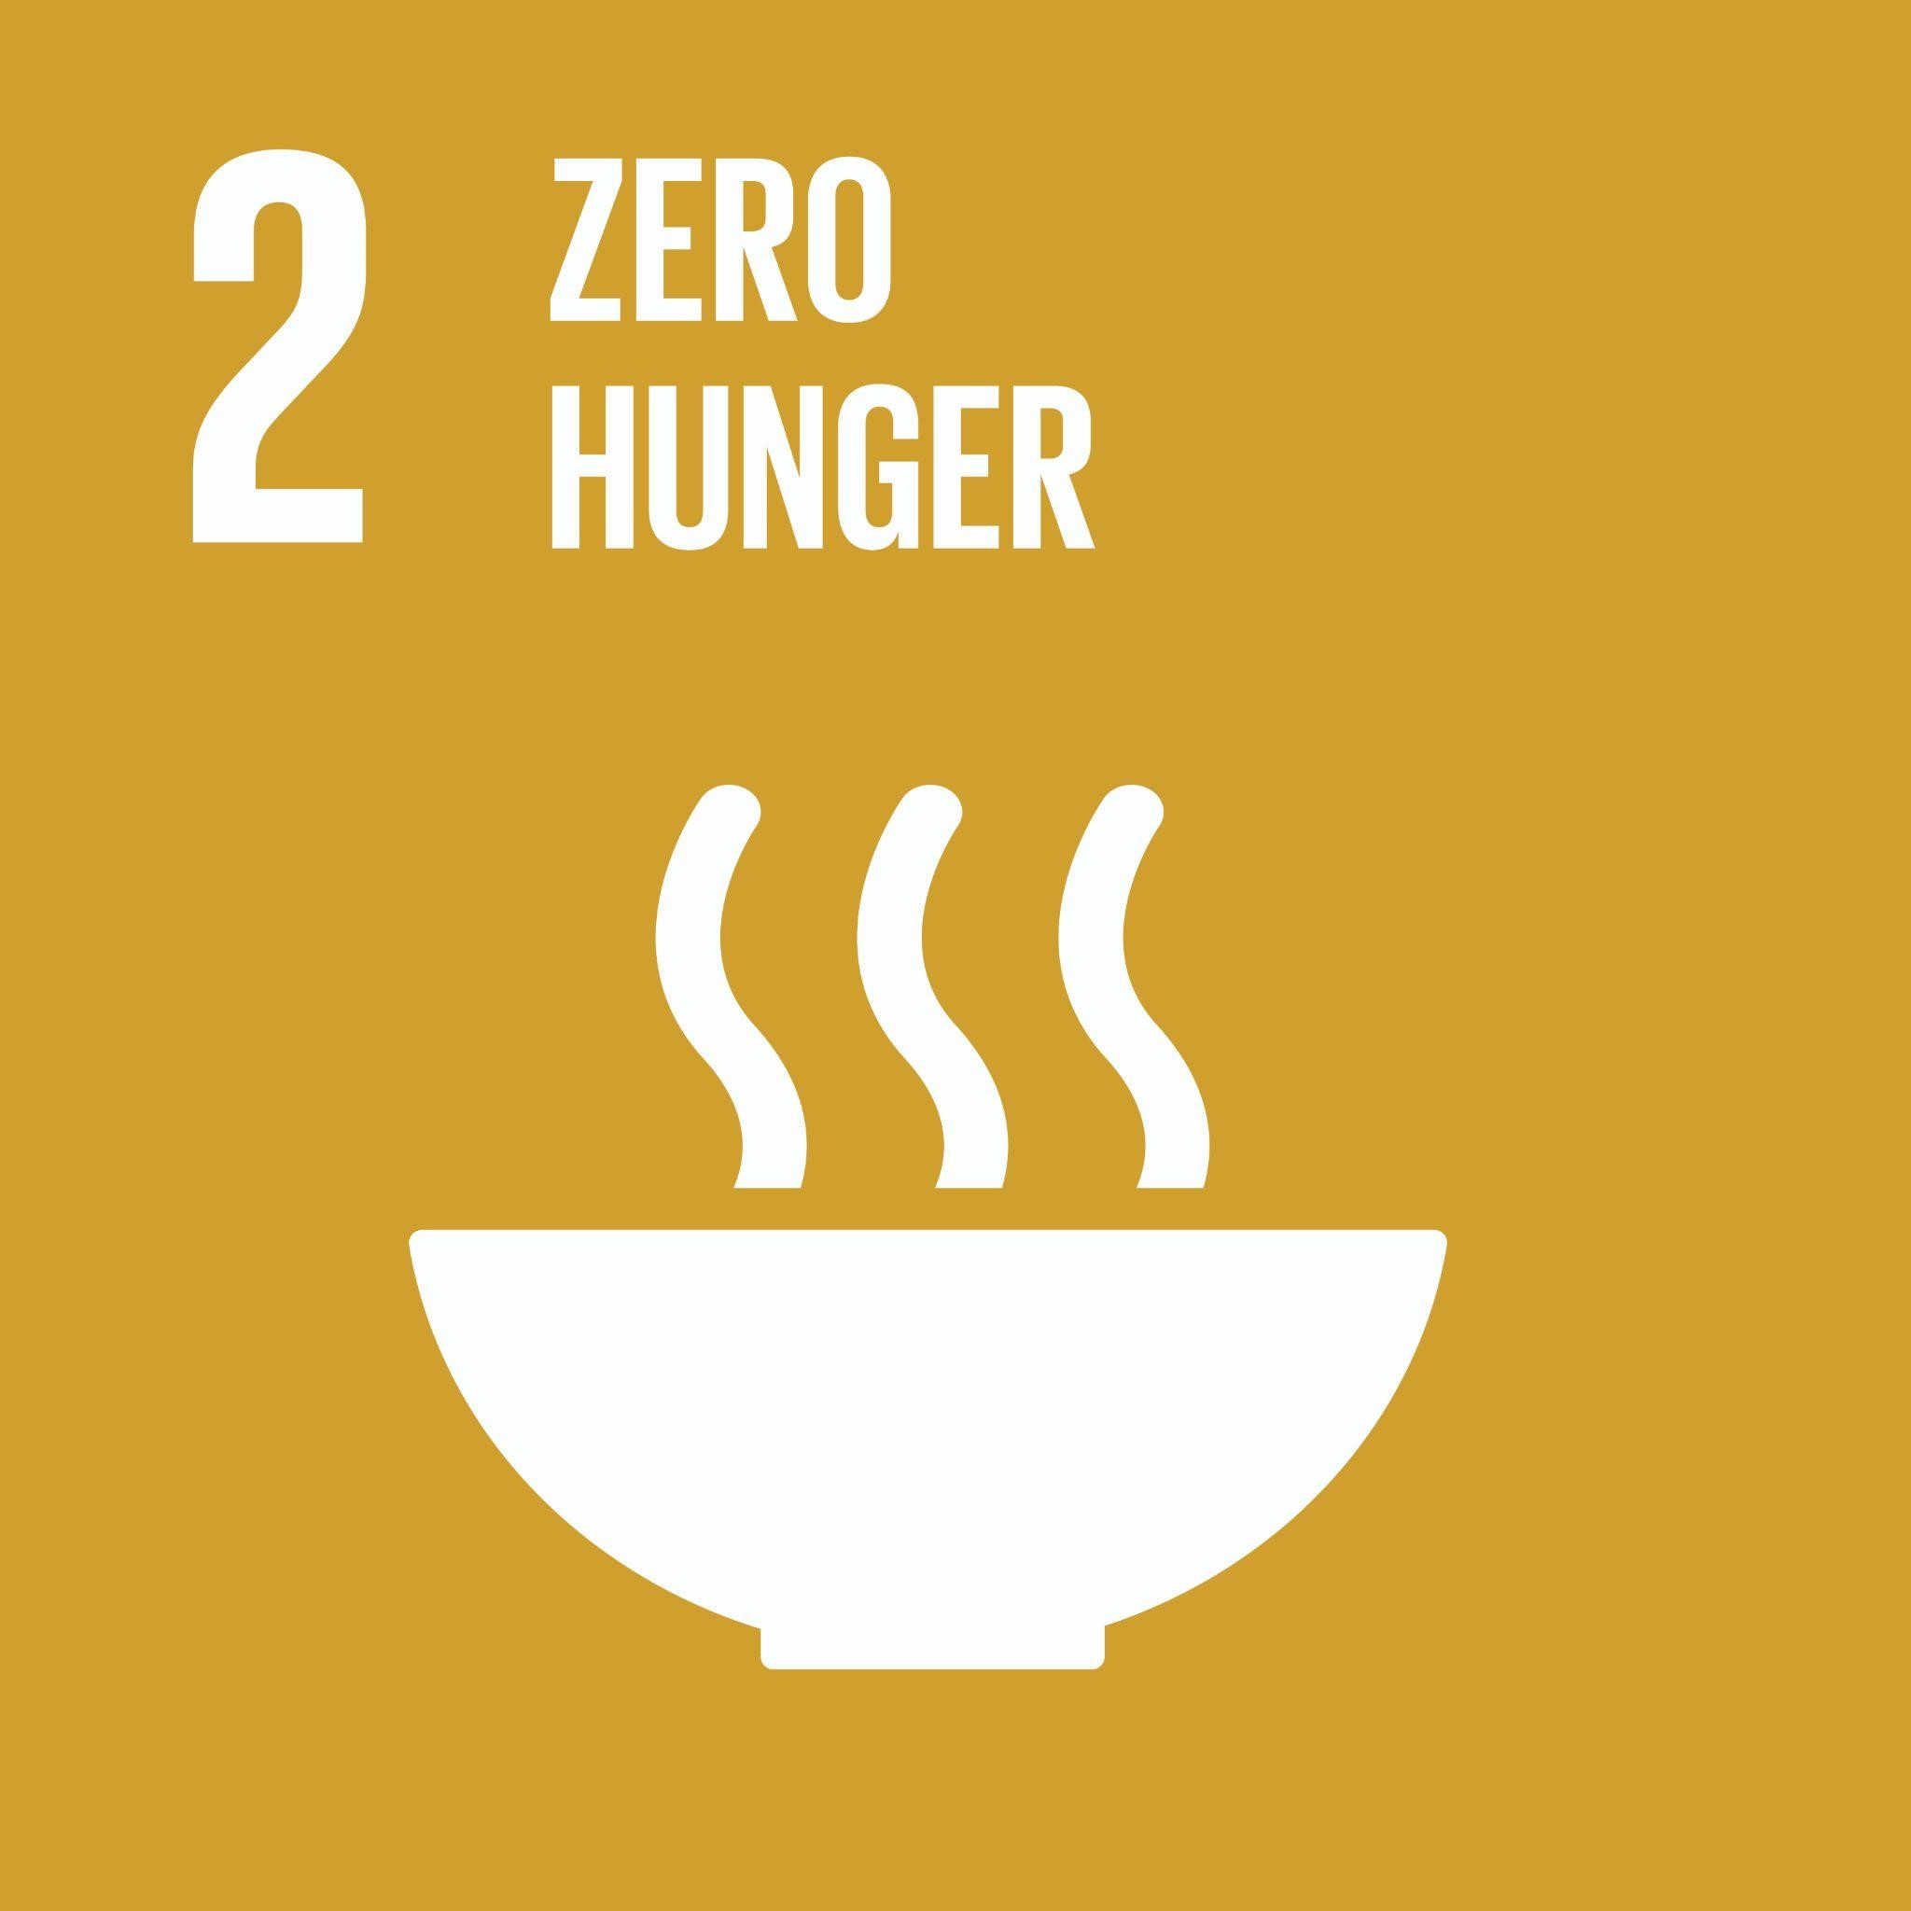 | End hunger, achieve food security and improved nutrition and promote sustainable agriculture  Global Examples: food security, malnutrition, equitable land access, healthy food, child obesity, regional food systems, farmer livelihoods, international food trade, urban agriculture, food waste, food byproducts use, food procurement, retail and distribution, food supply chains, circular food economy
Goal 3: Good Health and Well-being   | Ensure healthy lives and promote well-being for all at all ages  Global Examples: disease prevention and response, addiction prevention and treatment, healthcare access, reproductive health, medication, mental health, aging, physical activity, quality of life, public health, workplace health and safety, health equity, pandemic response consumer, well-being, employee well-being, negative effects of advertising/consumption, health care optimization
Goal 4: Quality Education   | Ensure inclusive and equitable quality education and promote lifelong learning opportunities for all  Global Examples: eliminating disparities in access to education, skill development, literacy and numeracy, equity in education, Indigenous education, responsible management topics, quality university education, safe, inclusive, and effective learning environments, financial literacy, climate literacy, life-long learning
Goal 5: Gender Equality   | Achieve gender equality and empower all women and girls  Global Examples: women’s rights and safety, violence against women, unpaid/domestic work recognition and support, women leadership and ownership, gender pay gap, non-binary gender rights, gender equity, women in entrepreneurship, LGBTQIA+ issues, employment and pay equity, diverse leadership, reproductive health, gender pay gap, gender disparities in promotions
Goal 6: Clean Water and Sanitation  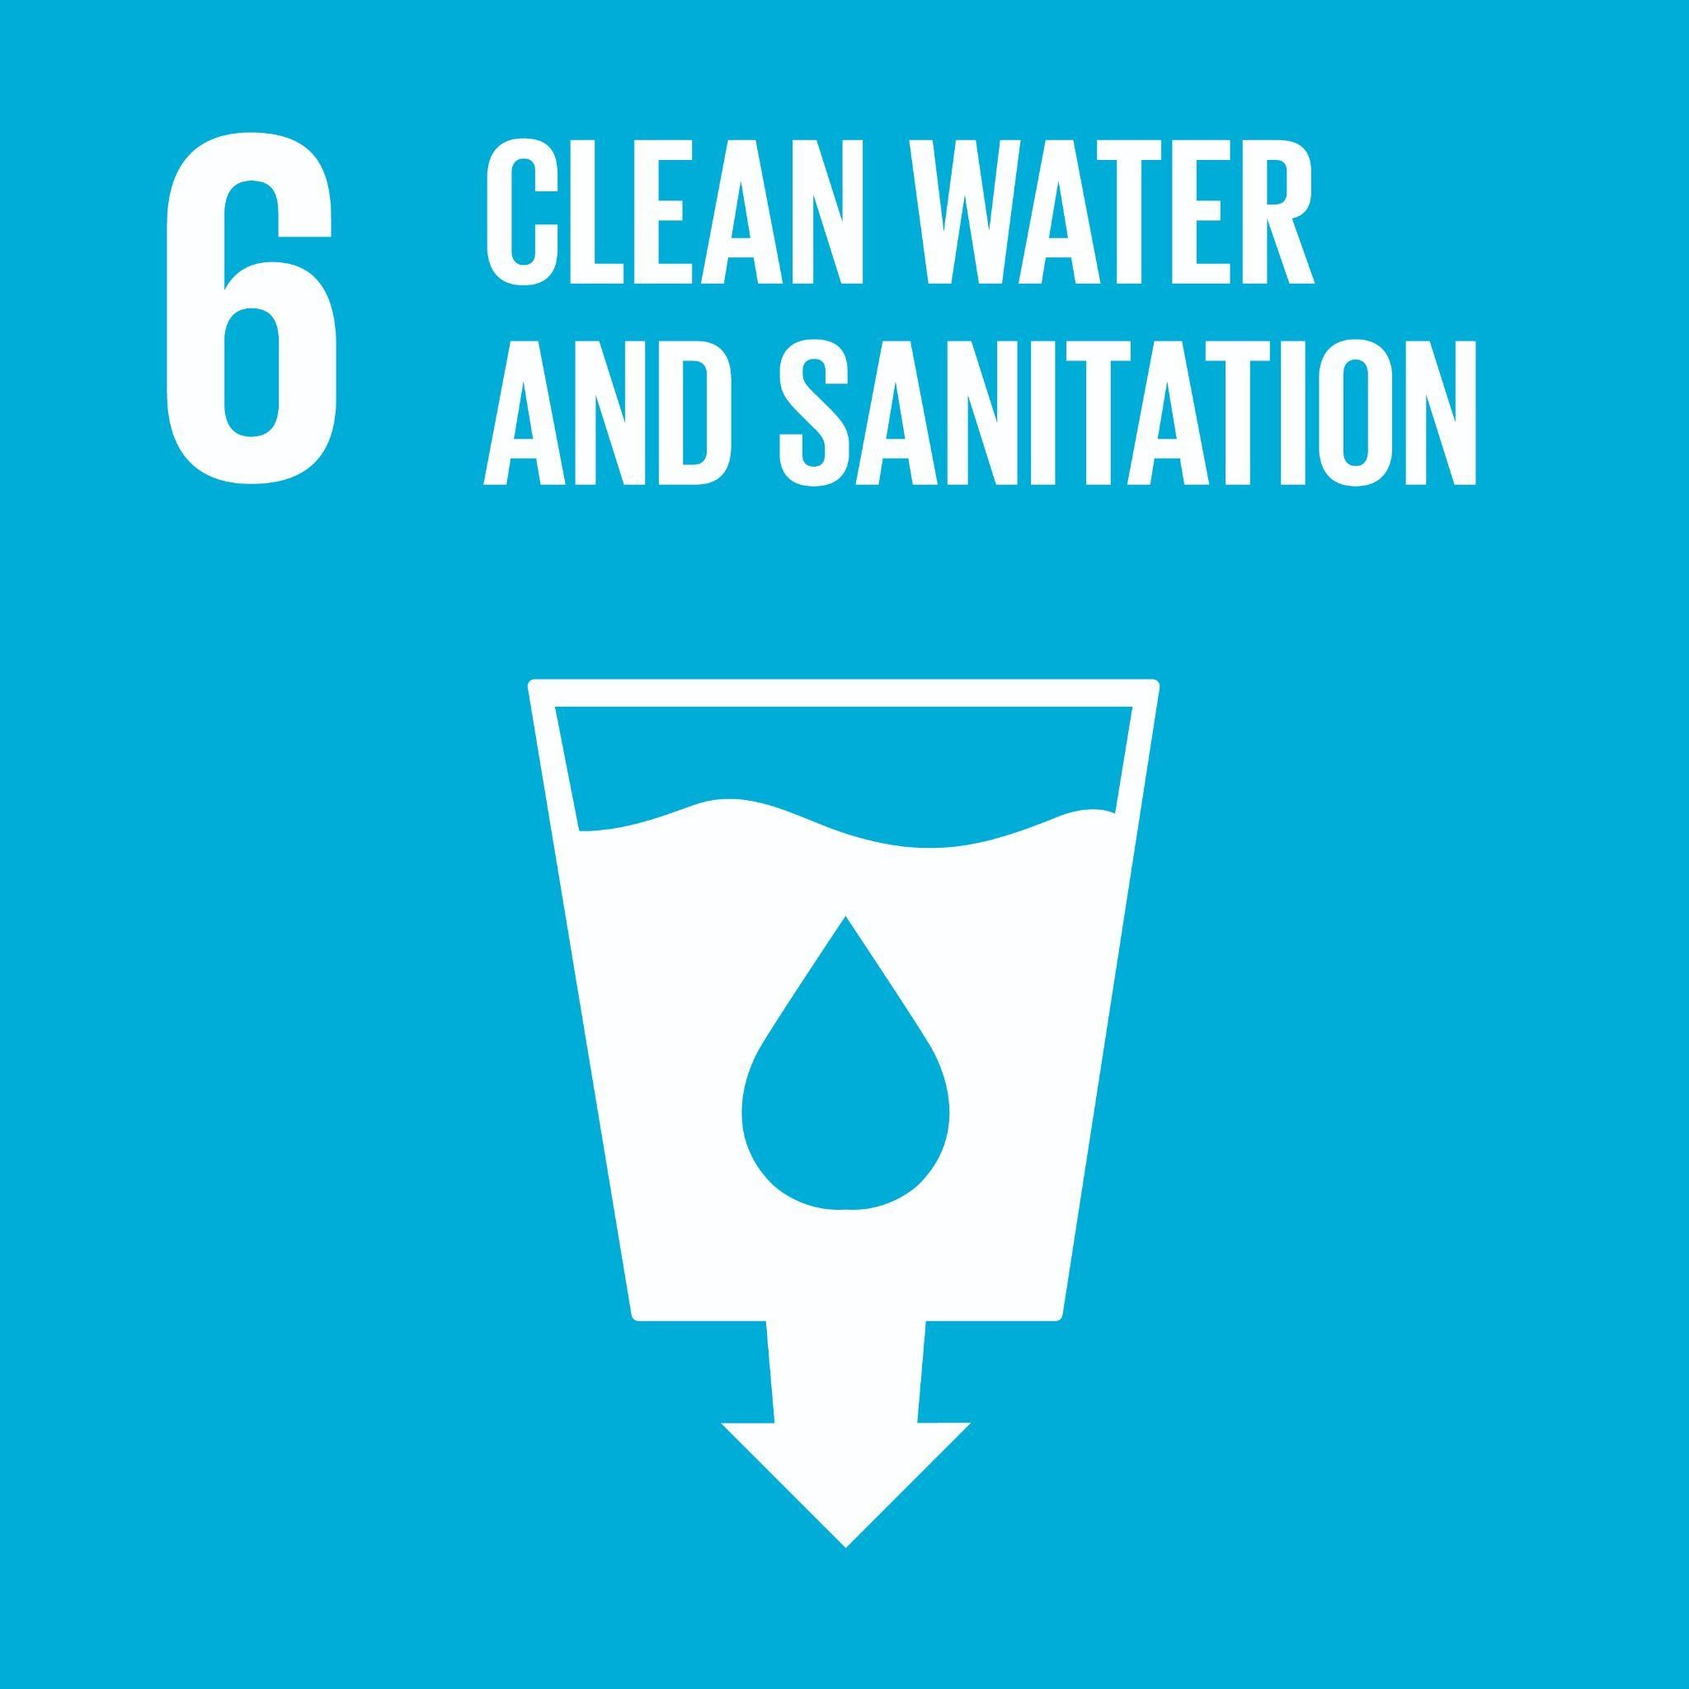 | Ensure availability and sustainable management of water and sanitation for all  Global Examples: access to clean drinking water, adequate waste water treatment, integrated water resources management, water reuse and recycling, watersheds, rivers, streams, ground water, water treatment, conservation
Goal 7: Affordable and Clean Energy   | Ensure access to affordable, reliable, sustainable and modern energy for all  Global Examples: access to clean energy, energy efficiency, energy policy, renewable energy, affordable clean energy, energy infrastructure upgrades, energy conservation, fossil fuel divestment, energy efficient buildings, renewable energy, community energy infrastructure
Goal 8: Decent Work and Economic Growth   | Promote sustained, inclusive and sustainable economic growth, full and productive employment and decent work for all  Global Examples: economic diversification, small and medium businesses, fair trade, access to financial services, decent job creation, entrepreneurship, creativity and innovation, meaningful work, employment equity, income equity, labour rights, micro-finance, social finance, safe & inclusive workspace, alternatives to never-ending growth
Goal 9: Industry, Innovation and Infrastructure   | Build resilient infrastructure, promote inclusive and sustainable industrialization and foster innovation  Global Examples: resilient infrastructure, inclusive and sustainable industrialization, innovation, access to transportation, micro-finance, access to credit, small-scale industry support, research and technology, entrepreneurship, access to technology, social enterprise
Goal 10: Reduce Inequality | Reduce inequality within and among countries  Global Examples: income equality, income support, inclusive employment policies, anti-racism, anti-discrimination, Indigenous reconciliation, disability, religion, race, equity, diversity and inclusion, wealth inequality, bias in AI, price discrimination, discrimination in segmentation, Indigenous inclusion, Indigenous participation
Goal 11: Sustainable Cities and Communities  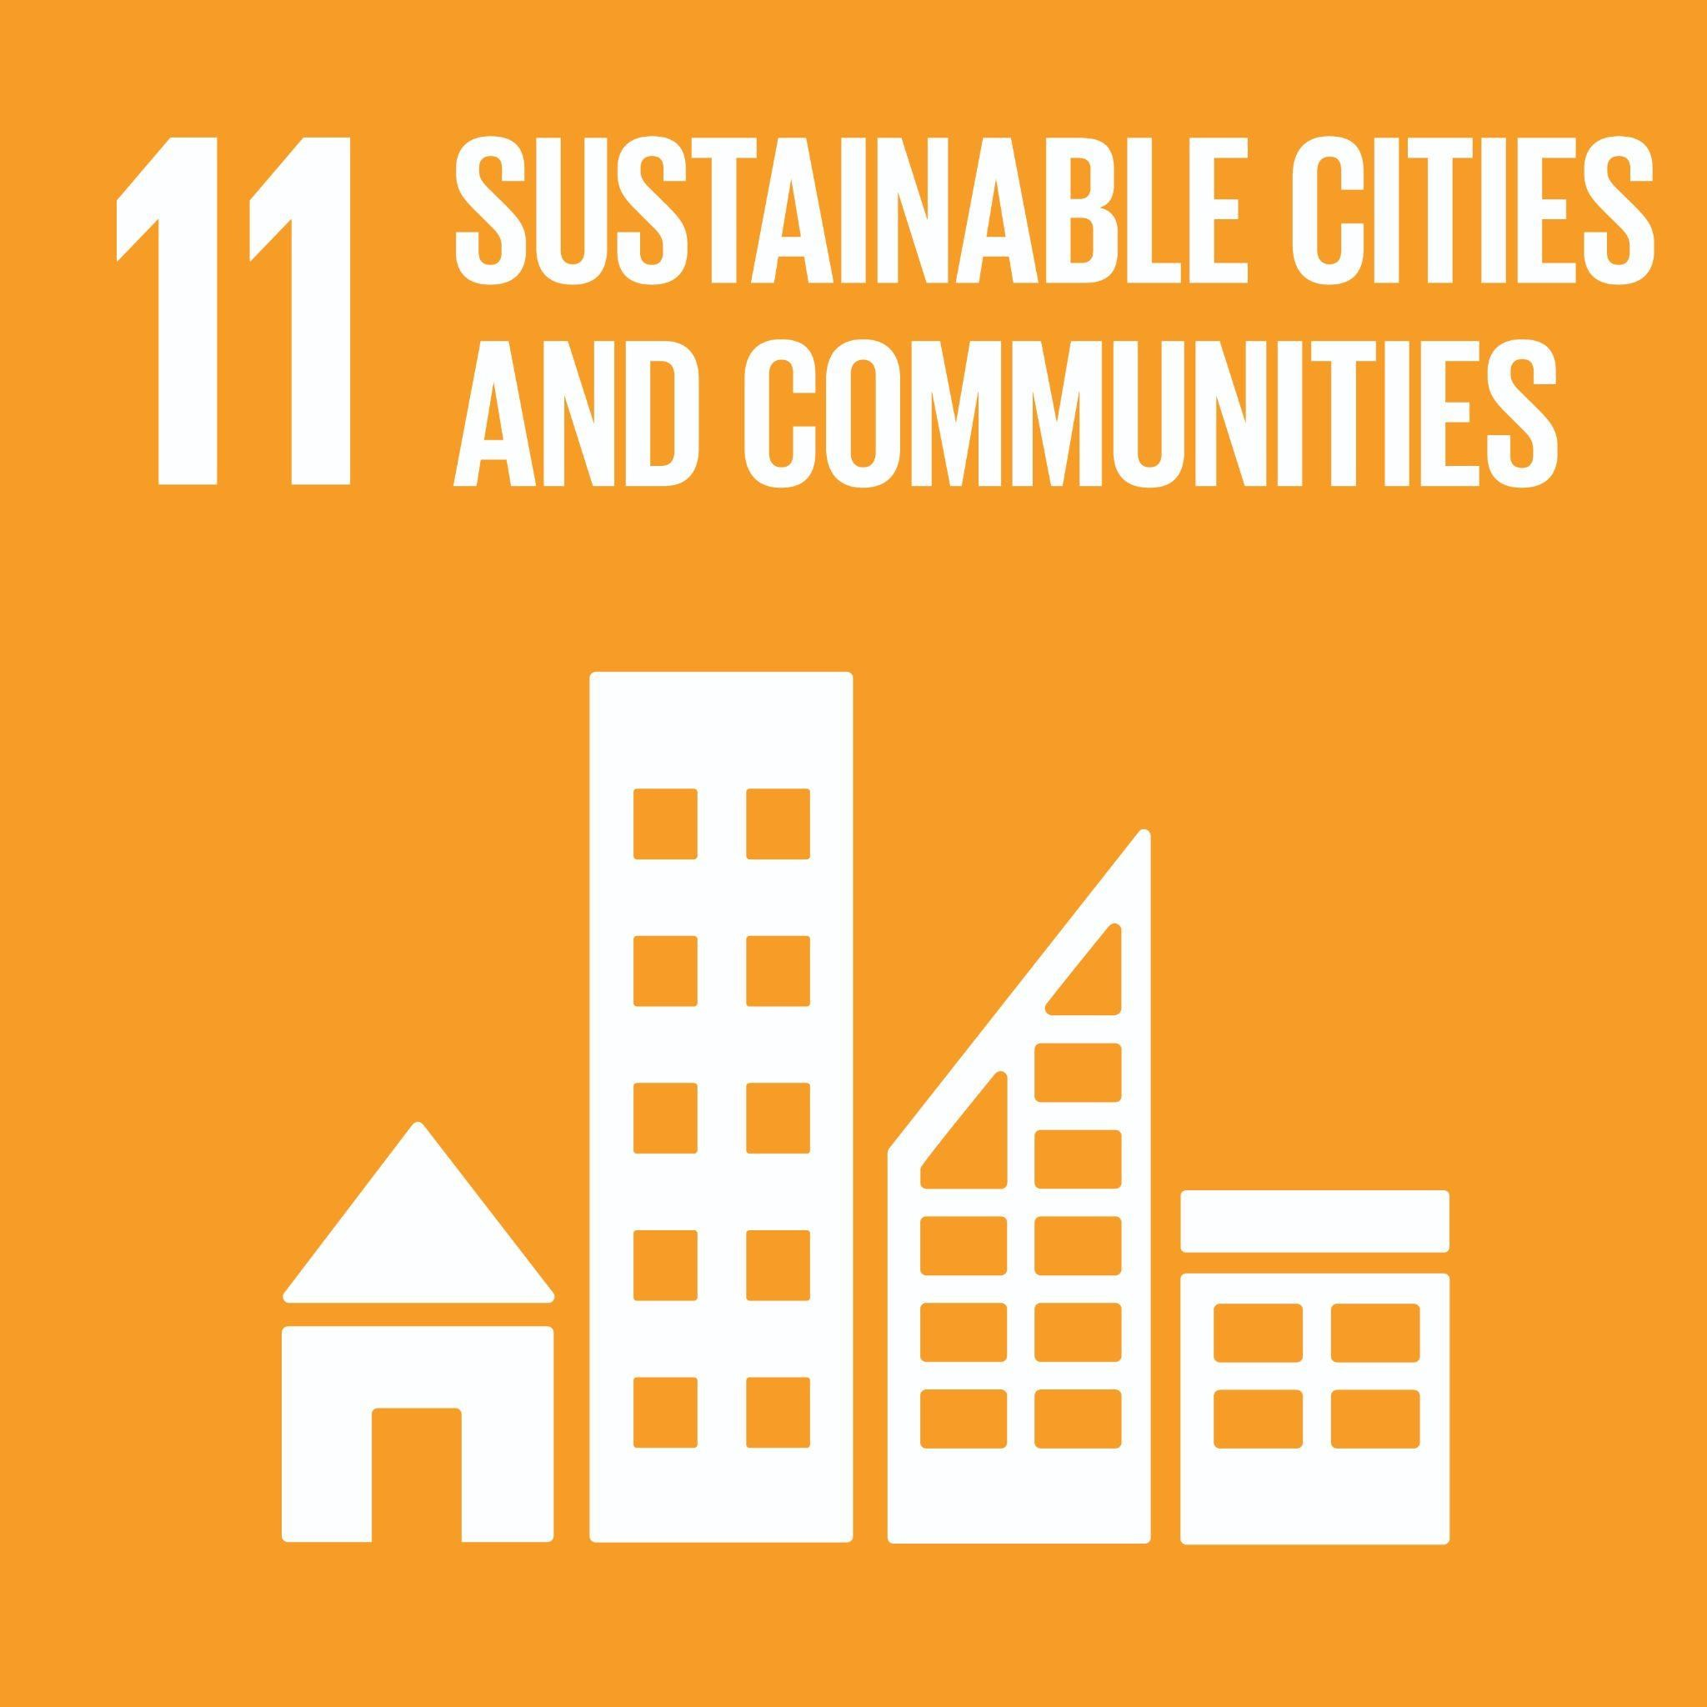 | Make cities and human settlements inclusive, safe, resilient and sustainable  Global Examples: transportation access, road safety, cultural/natural heritage, safe and affordable housing, urban planning, air quality, inclusive/safe/healthy public spaces, urban containment, urban governance, sustainable land use, effects of climate change on cities, valuing risk, sustainable transportation
Goal 12: Responsible Consumption and Production | Ensure sustainable consumption and production patterns  Global Examples: sustainable and equitable sourcing and production, sustainable procurement, sustainable distribution, food waste, life cycle analysis, recycling and reuse, ecological footprint, corporate social responsibility, fair trade, circular economy, consumer well-being, responsible sourcing, low emission supply chain design, responsible/ethical supply chain
Goal 13: Climate Action   | Take urgent action to combat climate change and its impacts  Global Examples: natural disaster response, climate change mitigation, climate change adaptation, climate justice, climate policy, resilience, environmental externalities, low emission supply chain design, Environmental Disclosure, ESG accounting and reporting, Cap and Trade, Carbon Markets, Carbon Pricing;
Goal 14: Life Below Water  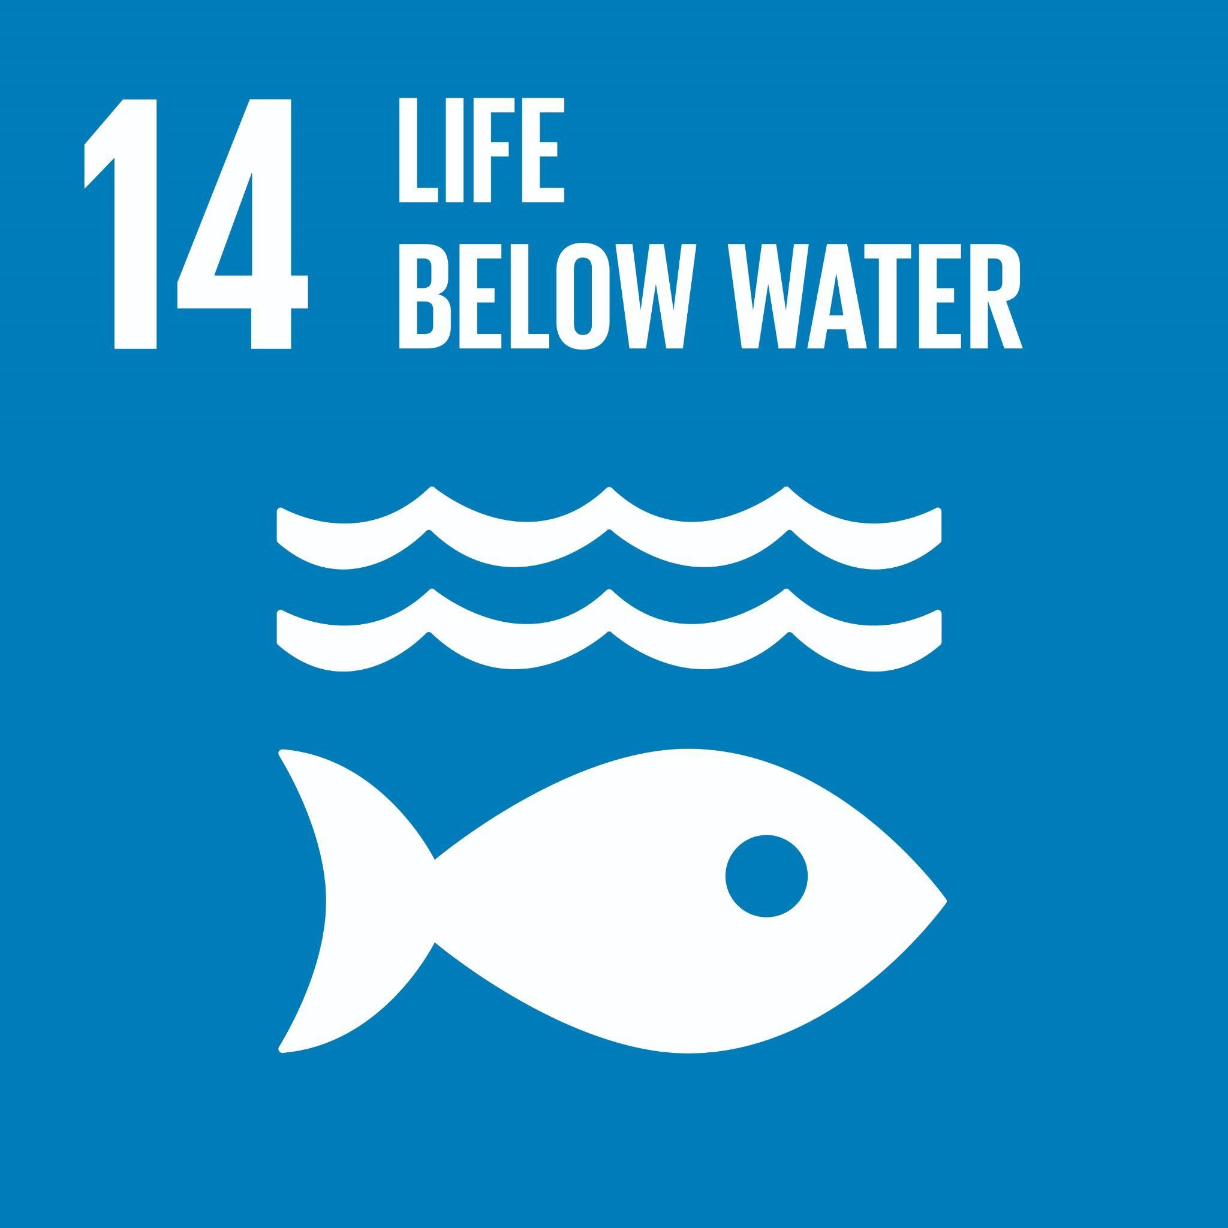 | Conserve and sustainably use the oceans, seas and marine resources for sustainable development  Global Examples: fishing and fisheries, ocean and freshwater pollution, coastal laws and water regulation, water conservation, aquatic ecosystem health
Goal 15: Life On Land  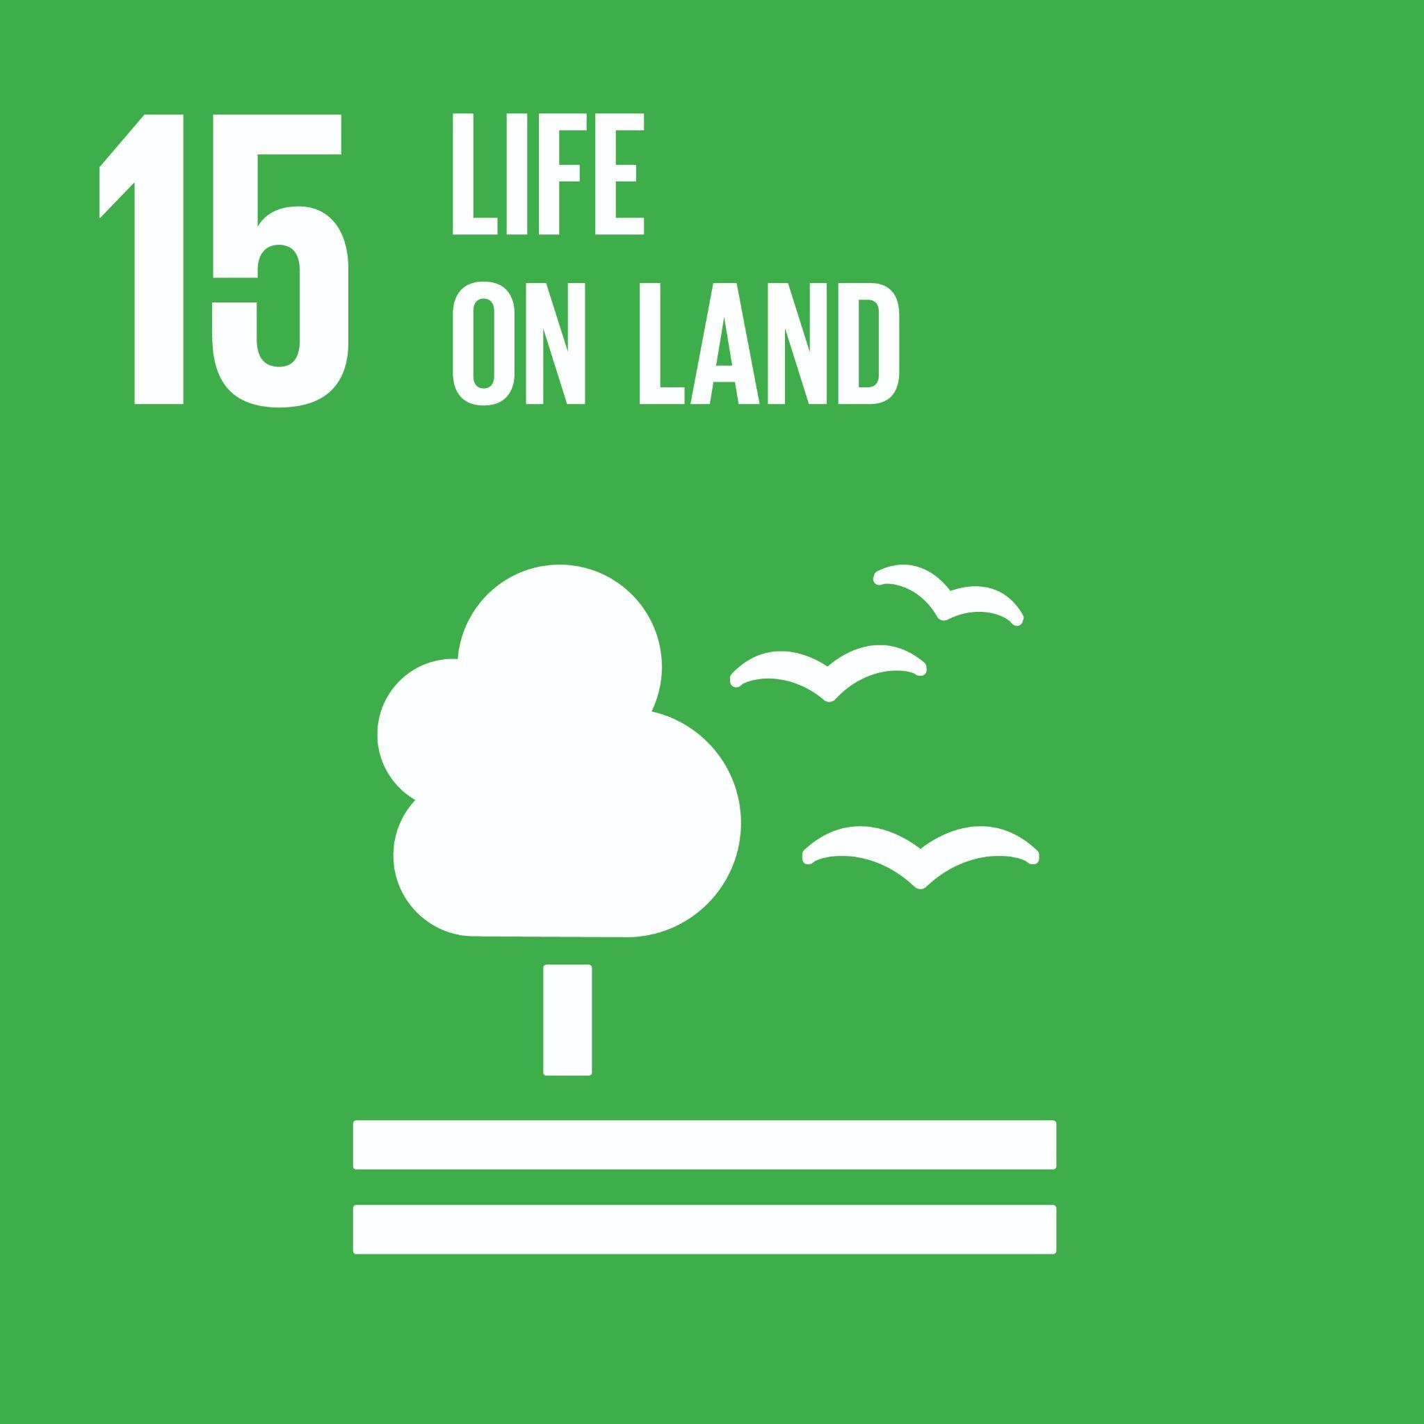 | Protect, restore and promote sustainable use of terrestrial ecosystems, sustainably manage forests, combat desertification, and halt and reverse land degradation and halt biodiversity loss  Global Examples: forests, wetlands, mountain and alpine ecosystems, sensitive ecosystems, biodiversity, soil health, endangered species, invasive species
Goal 16: Peace, Justice, and Strong Institutions   | Promote peaceful and inclusive societies for sustainable development, provide access to justice for all and build effective, accountable and inclusive institutions at all levels  Global Examples: violence, corruption, government spending, public engagement, equity, advocacy, governance, leadership, laws and regulations, civic engagement, policy, accountable and transparent institutions, ethical institutions, responsive and inclusive decision making, ESG, data usage and transparency, transparency in financial reporting, environmental disclosure, codes of ethics
Goal 17: Partnerships for the goals  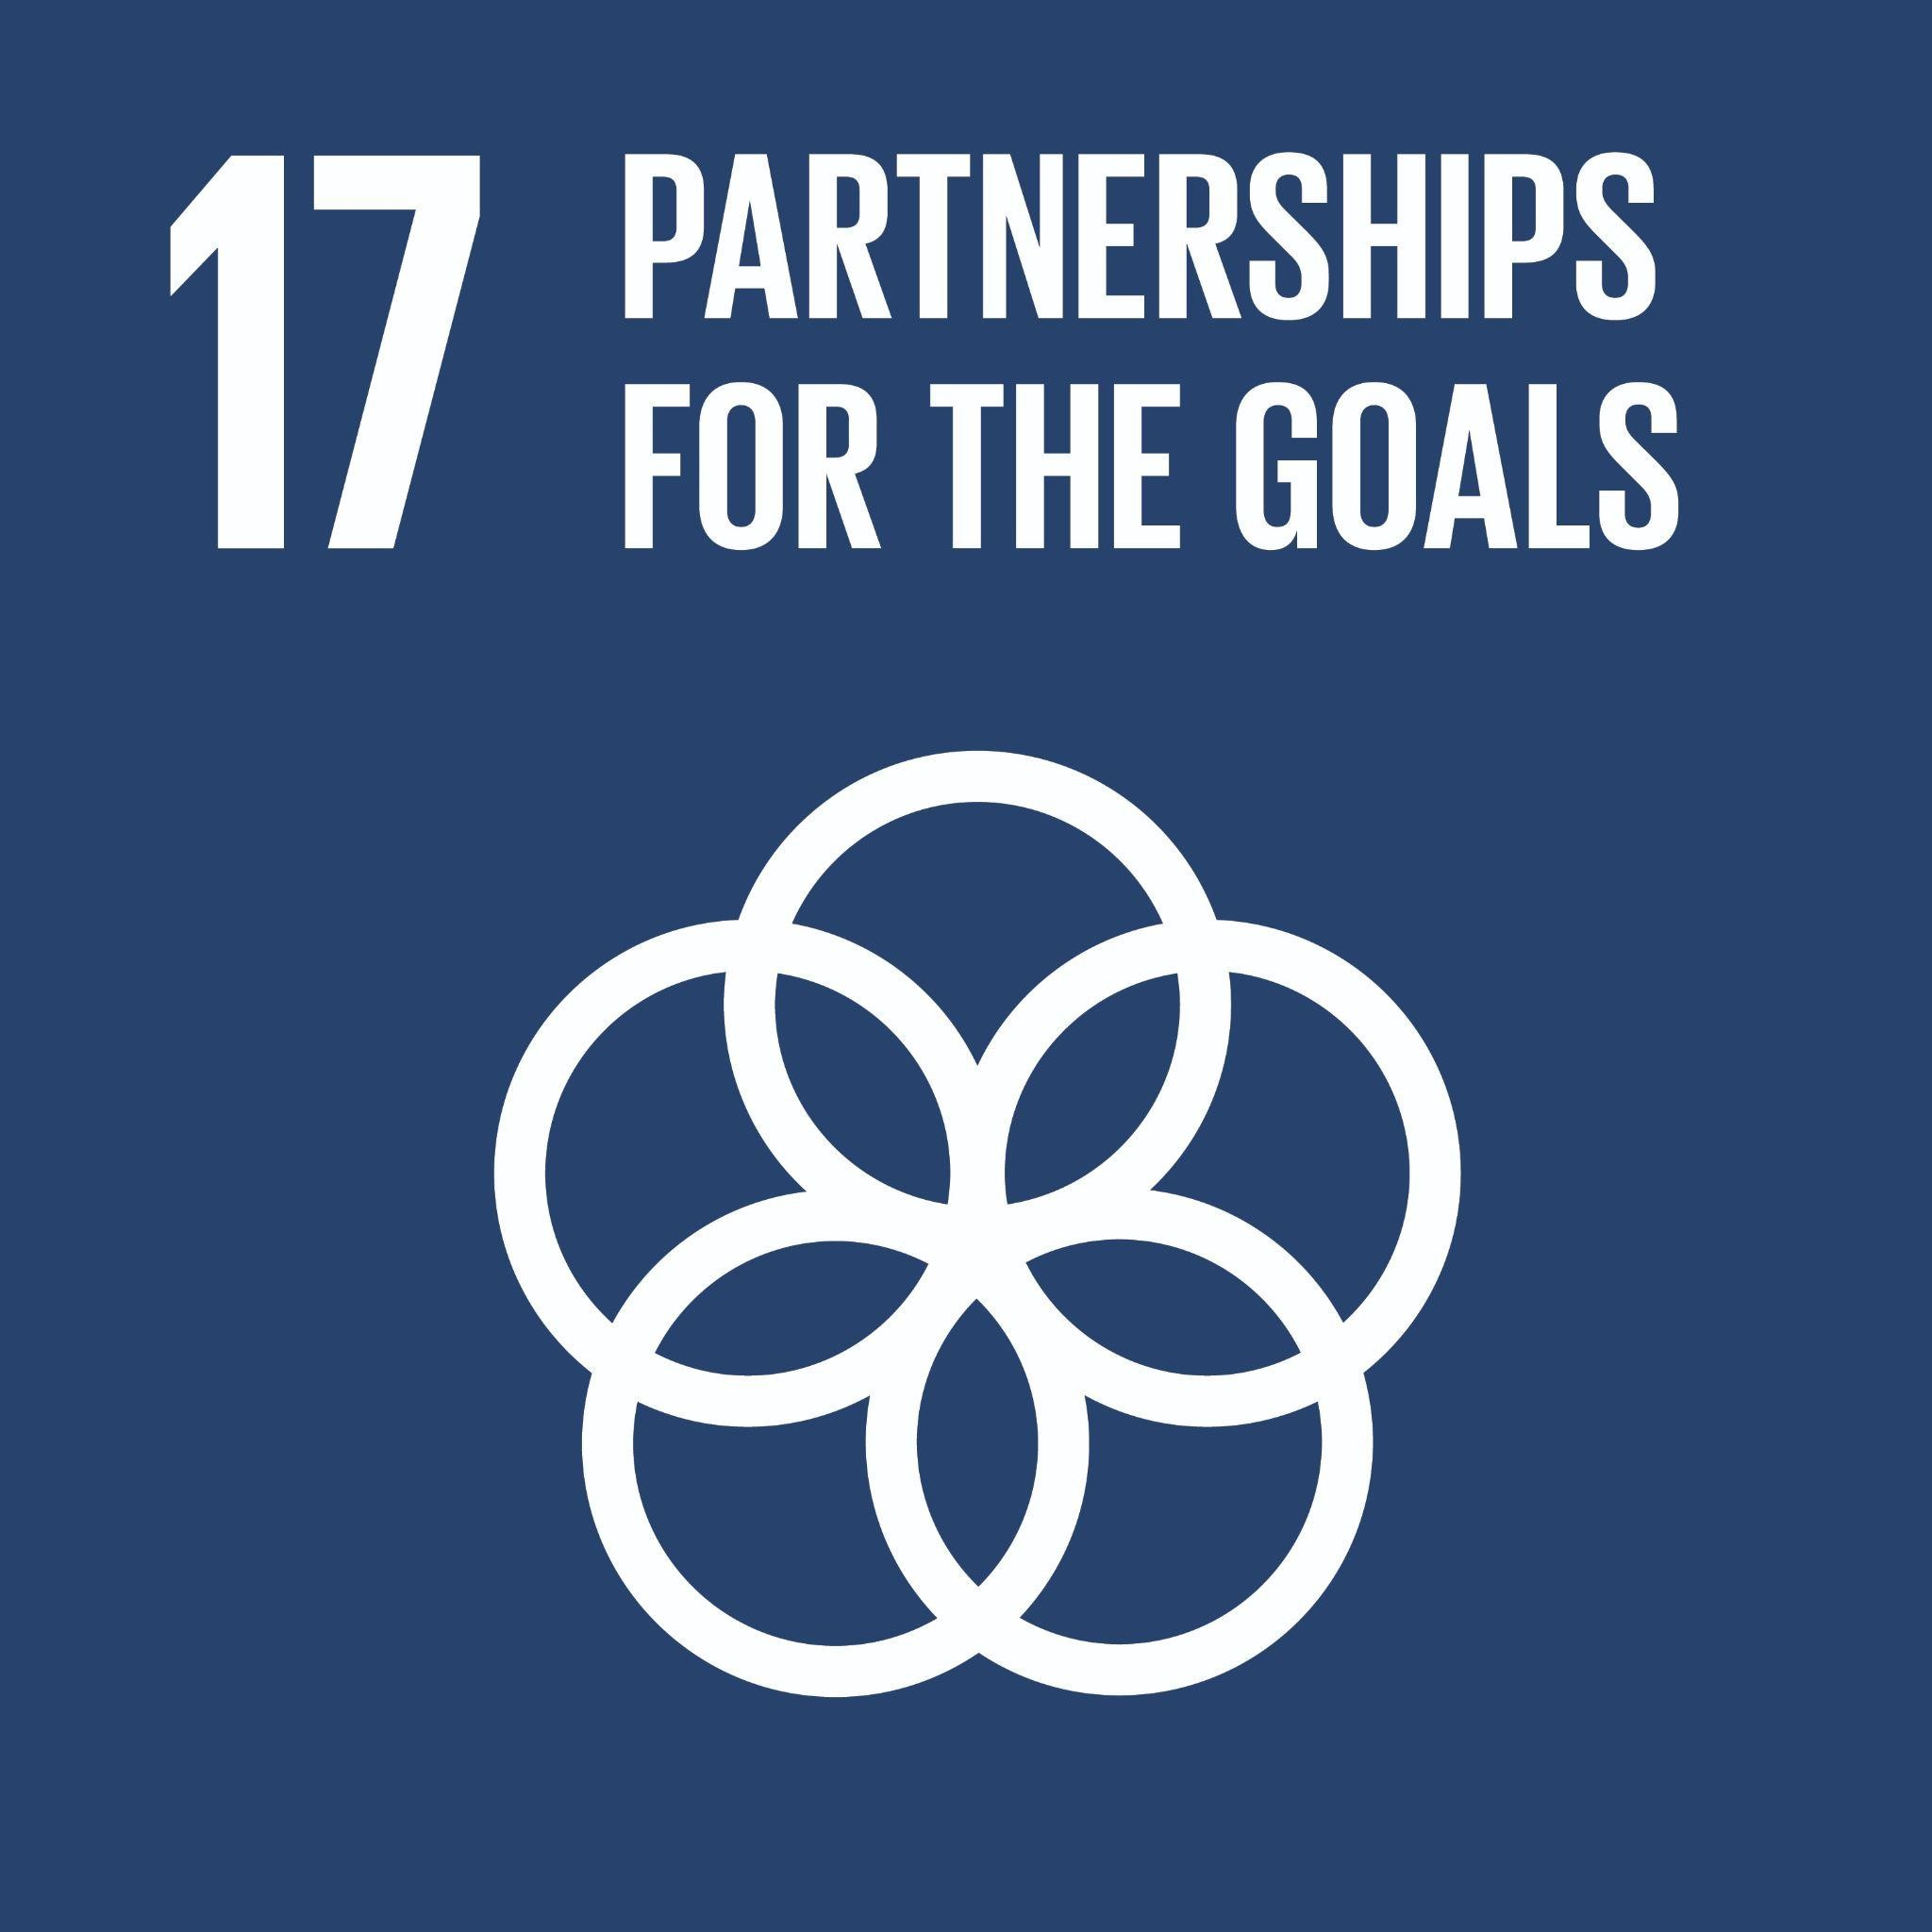 | Strengthen the means of implementation and revitalize the Global Partnership for Sustainable Development  Global Examples: international cooperation, trade, taxes, access to technology, data collection and sharing, cross-sector collaboration, cooperation, collaboration, partnerships, collective action, inter-disciplinary

ASSESSMENTS
Summary
Component | Weight
Assignments | %
Group project | %
Midterm exam(s) | %
Final exam | %
Class participation | xx%
Total | 100%

Details of Assessments
[Explanation of each category in the Summary of Assessments above. Please note that midterm and final exam must be in-person for courses in the FTMBA, MBAN, MM, B+MM, and MMDD programs. To confirm, exams may be online, e.g. in Canvas, but students must be physically present and invigilated. If UBC cancels in-person exams for campus closures (e.g. inclement weather), refer to the Exam Disruption section of the 24W RHL Instructor Resource Guide found here (log in to The Hub before clicking) to review our internal Sauder policy, capacity and procedures for remote options. ]

LEARNING MATERIALS
Required: [books, reading package, etc.]
Estimated cost of required materials: $xxx
Additional materials recommended but not required:

NO DISTRIBUTION OF RECORDINGS
There is no distribution of recordings of class. Classes are designed as and are intended to be in-person. Your attendance is expected. If you are unable to attend, the policy regarding missed classes described in this syllabus applies. It is your responsibility to ensure that you have the materials you need for missed classes.

Course-specific Policies and resources
Use of GenAI
[A statement on the use of generative AI must be included. We recommend that you use the following policy. If you choose to alter this policy or to write your own policy, please try to ensure that you are reducing opportunities for academic misconduct, supporting student equity, and generally able to provide evidence if misconduct does occur.
Note that separate instructions on attribution / citation have been distributed for your reference along with this syllabus.]

Generative Artificial Intelligence (GenAI) technologies are widely available and are increasingly intertwined with teaching and learning. The term “GenAI” refers to the following tools as well as any other similar models that create content using sophisticated learning algorithms: ChatGPT, Claude, Copilot, Gemini, Llama, DeepSeek, and many translation tools. GenAI also refers to such tools that may be integrated into other services like Notion, Canva, and Grammarly.

Sauder considers it essential that 1) students develop proficiency with GenAI; and 2) students are able to learn and practice the foundational critical thinking skills, unaided by GenAI, that are essential to a university education. To achieve both of these goals requires a mix of assessments that use GenAI and those that do not. Therefore each assessment will include GenAI instructions that are best suited to its learning objectives and that uphold Sauder’s commitment to academic integrity. Your instructor will specify, for each assessment, which one of the following usage rules is in effect.
- GenAI is Permitted, with attribution. Your instructor will explain what form of attribution, or what citation format, is required. [OPTIONAL: Your instructor will also explain how GenAI may be used if/when it isn’t fully permitted.]
- GenAI is Prohibited, in a controlled environment. Your instructor will provide a controlled environment for the assessment, such as an exam using lockdown browser or a pen and paper classroom activity.
- GenAI is Required, as part of the assessment. Your instructor will provide instructions describing how GenAI is expected to be used (including instructions regarding attribution/citation, if applicable).
- [REMOVE D UNLESS YOU NEED IT.] GenAI is Discouraged, for a low-stakes formative assessment. Students are expected to work on the assessment without GenAI assistance, e.g., in order to practice or increase knowledge/skills on course content. [NOTE: If you must alter the GenAI policy, the suggestion is to alter D to suit your pedagogical needs, while still upholding Sauder standards.]

After review, if it is determined by the instructor that submitted work likely violates the Use of GenAI policy and/or the specific usage rule, the work may receive a zero and may be subject to further misconduct measures set out in the UBC Academic Calendar.

[OPTIONAL: Only include if the course includes group work.] GenAI and groups/teams: Group work is an important part of this course, however, it introduces additional challenges around GenAI use. Therefore, whenever GenAI is permitted for a group assessment, the group must hold a discussion, with all members present, when beginning the work. During this discussion the group must agree on whether, how, and by whom GenAI tools will be used (to be documented in a shared file or email). All group members are expected to then communicate honestly with their group about their own use of GenAI. If it is determined that GenAI was used in a way that violates the assessment’s rules, the entire group may be held responsible.

Missed or late assignments, and regrading of assessments
Late submissions will not be accepted and will receive a grade of zero. [This is standard for RHL courses.]
[Enumerate other policies on missed or late assignments, and regrading of assessments.]

Academic Concessions Policy
[Include a description of how the course responds to cases of valid academic concessions. The policy on academic concessions is contained in Senate Policy V-135. This is a university-wide policy and applies to students and instructors in all faculties. While consistency in the interpretation of what constitutes valid grounds for academic concession is expected, there will necessarily be variation in the way in which academic concessions are applied in each course. As the instructor, you are responsible for determining how academic concessions will be applied. This could include, for example, the provision of a supplemental midterm exam, reweighting of missed coursework to other course components, etc. See paragraph 9(a) of Policy V-135.
Ideally, there should be a reasonable approach to missed coursework that does not place an undue administrative load on instructors. For example:
- students could be permitted to miss a threshold number of minor assessments (e.g. clickers, quizzes, participation, attendance) without consequence. For example, to lessen the administrative load of excusing each individual i-clicker, an instructor may choose to automatically drop x number of lowest clicker scores for all students at the end of the semester; or
- designating minor assessments as “practice only” during the add/drop period to account for students who register after classes have commenced.]

Requesting Academic Concessions
If you experience unanticipated events or other circumstances that constitute valid grounds for academic concession as defined by UBC’s Academic Concession Policy, complete and submit the Academic Concession Request & Declaration Form. Concessions are time-senstive and the online form should be submitted within 48 hours of the missed deadline. Upon submission, your request will be recorded in the RHL and you will also receive an email with further insturctions. Please read this email carefully and be sure to also refer to the relevant course syllabus for each concession tht you have requested. Please know that you should continue to work on the coursework for the course(s) which you submitted a concession fo. You should anticipate being asked to submit work or write an exam as soon as the circumstances affecting your ability to fulfil your academic responsibilities are resolved.

Other Course Policies and Resources
[Include the following policies and resources as appropriate.
- Policies on assessment due prior to students joining the course (i.e., during the add/drop period).

Code Plagiarism
Code plagiarism falls under the UBC policy for Academic Misconduct. Students must correctly cite any code that has been authored by someone else or by the student themselves for other assignments. Cases of "reuse" may include, but are not limited to:
  - the reproduction (copying and pasting) of code with none or minimal reformatting (e.g., changing the name of the variables)
  - the translation of an algorithm or a script from a language to another
  - the generation of code by automatic code-generations software
An “adequate acknowledgement” requires a detailed identification of the (parts of the) code reused and a full citation of the original source code that has been reused.
Students are responsible for ensuring that any work submitted does not constitute plagiarism. Students who are in any doubt as to what constitutes plagiarism should consult their instructor before handing in any assignments.

[Note that course policies must be reasonable and fair. For example, it is not reasonable to award zero to a student who missed an assignment due to registering into the class during the add/drop period. Policies cannot be punitive; only UBC’s President is authorized to impose discipline, and only after a finding of misconduct. For example, a grade deduction of 10% of the course grade for poor contribution to a group project when the student’s group members would have each earned 7% would be considered punitive. Unreasonable or punitive policies are appealable to the Dean’s Office and the Senate’s Committee on Appeals on Academic Standing.]

Policies applicable to Courses in the Robert H. Lee Graduate School [DO NOT MODIFY]

Attendance
[Information for instructors: In order to enforce this policy, instructors must keep an accurate record of attendance.]
Excepting extenuating circumstances, students are expected to attend 100% of their scheduled class hours. Absent students limit their own academic potential, and that of their classmates, and cause unnecessary disruption to the learning environment. Students missing more than 20% of the total scheduled class hours for a course (including classes held during the add/drop period) without having received an academic concession will be withdrawn from that course. Withdrawals, depending on timing, could result in a “W” or an “F” standing on the transcript.

Punctuality
Students are expected to arrive for classes and activities on time and fully prepared to engage. Late arrivals may be refused entry at the discretion of the instructor or activity lead. Students arriving later than halfway through a scheduled class will be treated as absent for that class.

Electronic Devices
Devices such as laptops, tablets, and cell phones are not permitted to be used in class unless directed by the instructor for in-class activities. Students who do not follow the School’s policy in this regard may be required to leave the room for the remainder of the class, so that they do not distract others. Research shows that students’ use of laptops in class has negative implications for the learning environment, including reducing their own grades and the grades of those sitting around them.

Citation Style
Please use the American Psychological Association (APA) reference style to cite your sources.

Details of the above policies and other RHL Policies are available at: http://www.calendar.ubc.ca/vancouver/index.cfm?tree=12,199,506,1625

University Policies and resources [do not modify this paragraph]
UBC provides resources to support student learning and to maintain healthy lifestyles but recognizes that sometimes crises arise and so there are additional resources to access including those for survivors of sexual violence. UBC values respect for the person and ideas of all members of the academic community. Harassment and discrimination are not tolerated nor is suppression of academic freedom. UBC provides appropriate accommodation for students with disabilities and for religious observances. UBC values academic honesty and students are expected to acknowledge the ideas generated by others and to uphold the highest academic standards in all of their actions. Details of the policies and how to access support are available on the UBC Senate website at https://senate.ubc.ca/policies-resources-support-student-success.

Respect for Equity, Diversity, and Inclusion
The UBC Sauder School of Business strives to promote an intellectual community that is enhanced by diversity along various dimensions including Indigeneity (including identification as First Nation, Métis, or Inuit), race, ethnicity, gender identity, sexual orientation, religion, political beliefs, social class, and/or disability. It is critical that students from diverse backgrounds and perspectives be valued in and well-served by their courses. Furthermore, the diversity that students bring to the classroom should be viewed as a resource, benefit, and source of strength for your learning experience. It is expected that all students and members of our community conduct themselves with empathy and respect for others.

Academic Integrity
The academic enterprise is founded on honesty, civility, and integrity. As members of this enterprise, all students are expected to know, understand, and follow the codes of conduct regarding academic integrity. At the most basic level, this means submitting only original work done by you and acknowledging all sources of information or ideas and attributing them to others as required. This also means you should not cheat, copy, or mislead others about what is your work. Violations of academic integrity (i.e., misconduct) lead to the breakdown of the academic enterprise, and therefore serious consequences arise and harsh sanctions are imposed. For example, incidences of plagiarism or cheating may result in a mark of zero on the assignment or exam and more serious consequences may apply if the matter is referred to the President’s Advisory Committee on Student Discipline. Careful records are kept in order to monitor and prevent recurrences.

COPYRIGHT [OPTIONAL]
All materials of this course (course handouts, lecture slides, assessments, course readings, etc.) are the intellectual property of the instructor or licensed to be used in this course by the copyright owner. Redistribution of these materials by any means without permission of the copyright holder(s) constitutes a breach of copyright and may lead to academic discipline and could be subject to legal action. Any lecture recordings are for the sole use of the instructor and students enrolled in the class. In no case may the lecture recording or part of the recording be used by students for any other purpose, either personal or commercial. Further, audio or video recording of classes are not permitted without the prior consent of the instructor.

ACKNOWLEDGEMENT
UBC’s Point Grey Campus is located on the traditional, ancestral, and unceded territory of the x^{w}məθk^{w}əy̓əm (Musqueam) people, who for millennia have passed on their culture, history, and traditions from one generation to the next on this site.

COURSE SCHEDULE
(Subject to change with consultation)

Class | Asynchronous or Synchronous | Date | Topic | Readings or Activities | Assessments due
1
2
3
…

