Improving Infection control in the Orthodontic office
after the COVID-19 Pandemic

To
Dr. Saunders DDS, MSc. (Ortho), FRCD(C)
Owner of Ancaster Orthodontic Clinic
433 Wilson St. W
Ancaster ON

Student: Shahd Khudher
Professor: Dr. Erika Paterson
Course: English 301
University of British Columbia

Jul. 17, 2021

Table of Content
- Introduction:
- Description and background …………………………………………………2
- Purpose of this report ………………………………………………………...
- Scope of the issue ………………………………………………………........
- Body: Data & Plan
- Current guidelines and regulations …………………………………………
- Conflict between regulatory bodies …………………………………………
- Risks and prevention ………………………………………………………...
- Solutions and process of upgrade ……………………………………………
- Planning and methods ……………………………………………………….
- Visual analysis and data…………………………………………………
- Conclusion:
- Summary of the findings ……………………………………………………
- Suggestions and recommendations …………………………………………
- References ………………………………………………………………………..
- Appendix ……………………………………………………………………………
- Figures ………………………………………………………………….
- Figure a.
- Figure b. 1 & 2
- Figure c. 1 & 2
- Figure d. 1 & 2

- Introduction
- Description and background:
Orthodontic offices usually have an open concept clinic set up where all dental chairs are in one big room and practitioners treat patients in the same place. This environment is not functional in situations like the COVID-19 pandemic, where isolation and disinfection need to be on high levels. There is no doubt that public health and the regulated bodies of the dental and dental hygiene professions have strict guidelines and rules for infection control. To protect both employees and patients, prevent contamination and the spread of diseases, the previous guidelines were affected greatly by the COVID-19 pandemic. This proposal will be addressed to Dr. Saunders to implement the changes needed in Ancaster Orthodontic clinic to improve infection control.
Statement of the Problem: In clinical settings, a great deal of attention is given to follow the guidelines of infection control. The air quality, in particular is a crucial factor; dental offices and especially orthodontic clinics tend to generate aerosols that could carry viruses and pathogens for several hours. With many diseases that could transmit through contact or air, an open concept clinic is not ideal, however dealing with a highly contagious infection that displayed a high mortality rate throughout the globe, requires stricter steps and updated measures.
- Purpose of the report:
The best solution would be to transform the open-concept clinic into closed operatories or require a different layout for future clinics. Ideally, dental offices should consist of separate closed treatment rooms that are sealable if required. However, the fast pace of the orthodontic clinic imposed the open concept practice. Solutions to the issue in the currently operating clinics would be using sealable partitions, medical air purifiers & reducing the number of individuals in the clinic.
- Scope of the issue:
To determine the feasibility of the proposed solutions and transformation of orthodontic clinics to more safe practice during the pandemic, I intend to explore the following areas of scrutiny:
- What are the current requirements for clinical setup workplace and the updated guidelines?
- What are the available products that could help the transformation of the clinical space?
- What is the cost and is it reasonable to transform or maybe move to a new facility?
- How to implement staff training and plan working timetables to avoid a high number of workers at the same time?
- Look into forming policies and quality assurance maintenance.
- Body: Data & plan
- Current guidelines and regulations:
The dental environment or clinic is constantly operating under risk of transmission of disease. This is due to the close proximity between patients and operators and the generation of aerosols from dental procedures, as well as many other factors.
Since the start of the COVID-19 pandemic in March of 2020, there have been a vast range of changes to the dental practice guidelines. The requirements of the clinical setting and equipment as well as the procedures performed are regulated to reduce the spread of the disease. For example, the need to use certain respirators by dental professionals (Special masks used to protect against the transmission of viruses and bacteria, like the N95 & KN95). Also, the need to wear isolation gowns, protective goggles and face shield. All this together is under the required PPE (Personal Protective Equipment) needed to protect both patients and operators. These is also the need to different equipment that the clinic must have now to control the quality of air, like air filters or purifiers, the exchange rate in a sealed clinic is specified according to surface area and procedures performed. Other sterilization devices now must be used frequently during the day with quality monitoring (daily, weekly and monthly). The list of ever-changing guidelines to keep up with the pandemic updates is available on the College of Dental Hygienists of Ontario (CDHO) as well as the Royal College of Dental Surgeons of Ontario (RCDSO).
The number of people in the clinic is also now regulated, since COVID-19 transmits through air droplets and close proximity, it is crucial to practice social distancing and only logical not to pack the clinical setting. This is of great impact on Orthodontic offices due to the open concept of the clinic and the presence of more than one patient in one room during procedures. There is a full list of requirements to be taken in consideration prior to starting any clinical day. They are all available in the clinic book and accessible to everyone.
- Conflict between regulatory bodies:
In any dental office (general, orthodontic or any other specialty), the main regulated professionals are dentists and hygienists. Both are represented by their regulatory bodies, the CDHO & RCDSO. These colleges are responsible to set the foundation of guidelines and maintain the quality of practices. Each professional is ONLY to follow the regulations of their college. At the very beginning of the pandemic, there were some discrepancies in when, how or what to use of PPE or what to follow in the clinical setting. Generally, the clinic owner is a dentist, hygienists could own clinics but only for general set up and not specialty like orthodontics, so rules and regulations would be according to RCDSO; although some dentists showed great support to their hygienists and provided what’s needed for their requirements, but there are others who struggled to find a common ground. This created a gap in the communication and jeopardized both the safety of people and the license of professionals. However, now that there is more understanding to the situation we are dealing with, there is less conflict and better work environment. Link to both colleges websites are available in the reference list.
- Risks and prevention:
As explained, the risk of acquiring highly infectious diseases is one of the highest in the dental clinical setting. The close working environment and nature of procedures require high quality monitoring and protection. It is very costly to maintain these standards in a normal day, but when the pandemic threatened the PPE reserve, the abovementioned regulations were challenging to follow, however, consequential on a bigger magnitude if not carefully considered. Prevention is key to survival in such times.
- Solutions and process of upgrade:
This is a very tricky step, it involves two main components, the upgrade or purchase of the different required equipment and devices, and the training a preparation of staff to follow. Some orthodontic offices have built in systems that cannot be enhanced, so the need to purchase new ones is a must.
At our clinic, the following changes need to take place:
- Providing and sourcing the required PPE’s for staff.
- The HVAC system needs to be tested to ensure the quality of air exchange in the clinic.
- Purchasing air purifiers and other devices to ensure the safety of clinic atmosphere.
- Sealing the operating unites according to the specified standards.
- Providing the required sterilization needs.
- Finally training staff for both operating new equipment and following the new guidelines.
- Planning and methods:
Arranging for specialists to test the HVAC system should be done before the office could operate again, the need to upgrade & installation could require a week or two. Arranging to deliver the newly bought equipment and installation also could be done during that period with the help of staff, this will allow training and familiarity at the same time. The staff training process should also include stressing the completion of the required courses of infection control guidelines.
When the clinic is ready to operate, special consideration needed to scheduling and the number of people in the clinic.
Policies should be updated, log books and instruction guides should also be completed and monitored. The results of the survey sent out to our staff and other dental staff is explained in the visual data section, this will help collaboration and implementation. Allocating an infection control officer that is in charge of monitoring the process of following the guidelines is one of the aids to facilitate the transition.
Timeline
The whole process will need around 2-3 weeks of preparations, however, when the clinic is finally in working mode, there is a need to an ongoing updates and reassessment shall things need to be changed. A monthly meeting could be helpful to recap on the changes and note any new ones. At the end of each week, a casual gathering to encourage staff and listen to any suggestions or struggles could enhance the spirit and maintain the quality.
Limitations
The challenges to secure the proper equipment alongside the execution of the plan to meet the timeline is the biggest limitation to the plan, however, it could be reduced if we prepare ahead of time and explore all options. Limitations to the ground on which the data are drawn from, is only evident if one considers the sample to be convenient due to the majority of population is from the group of the involved individuals in the process. Also, the majority of the sample is dental hygienists; dentists should be included as well. However, this could be refuted easily with the inclusion and randomization of selection.
- Visual analysis and data:
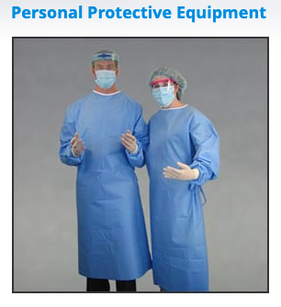
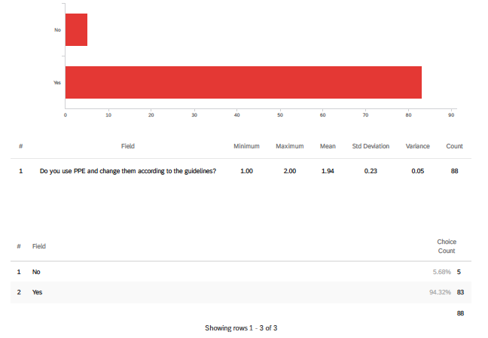
The results of survey were impressing, the sample quality is strong, considering the size, randomization and relevant population. The proper PPE needed by the dental staff in the pandemic is shown below, this should be changed according to the requirements and guidelines. About 95% reported adhering to this rule. Noted in the graph.
Figure a. PPE of the dental staff and adhering to its use.

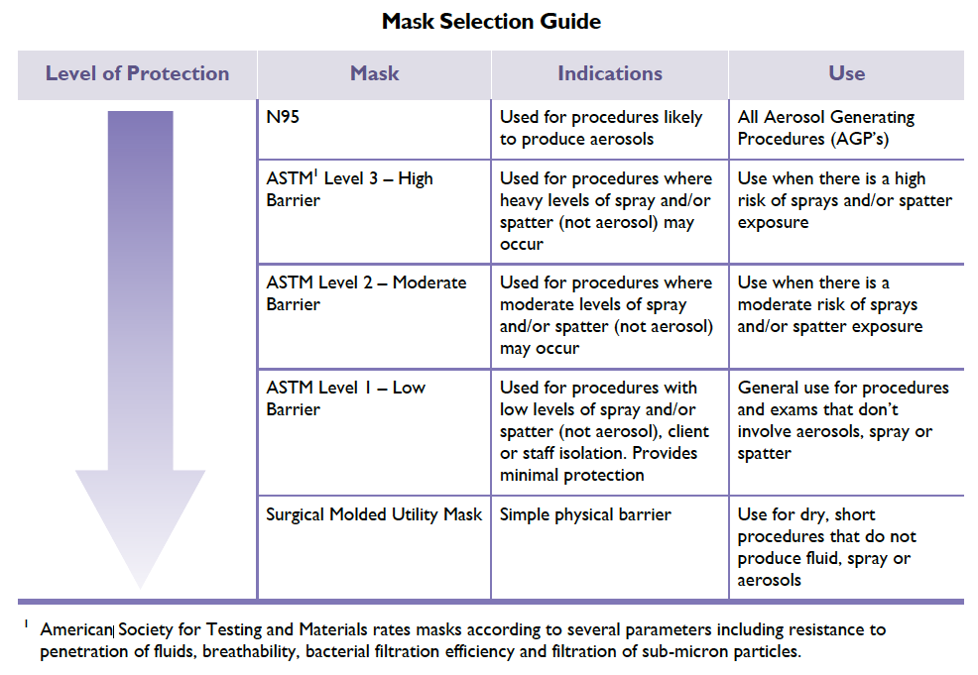
The following is an idea about the guidelines mandated for hygienists:
Figure b. 1
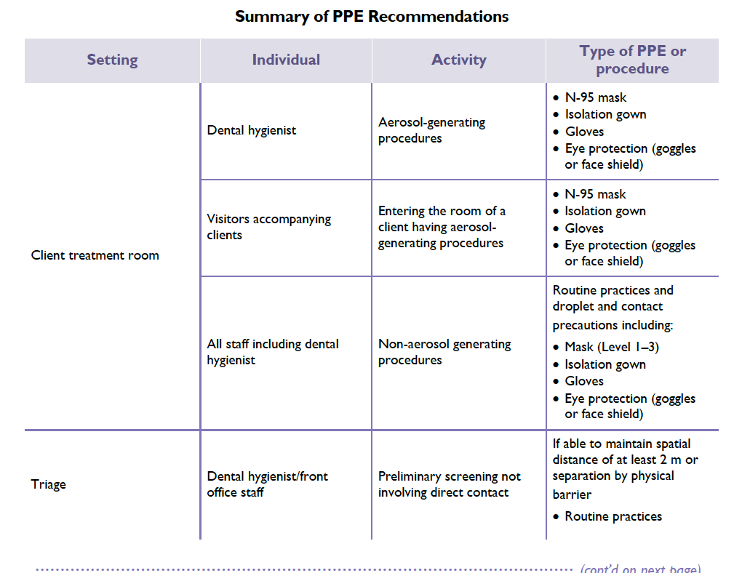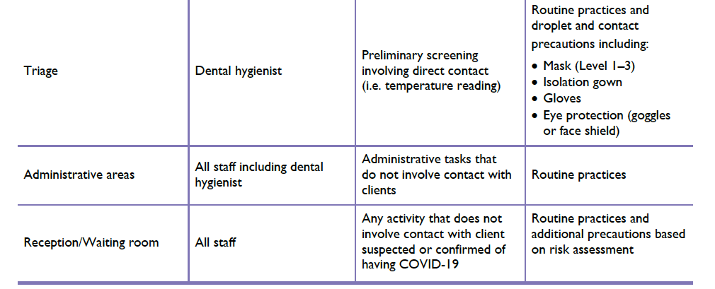
Figure b. 2
The results of the percentage of staff being trained and brought up to the required standard were a bit surprising, only 68 – 74 % (figure c. 1 & 2) reported receiving the proper training. This is a defect we could use to our advantage when planning the change process, the need to focus on training our staff is a factor in our success.

Figure c. 1: staff training on new equipment and devices.
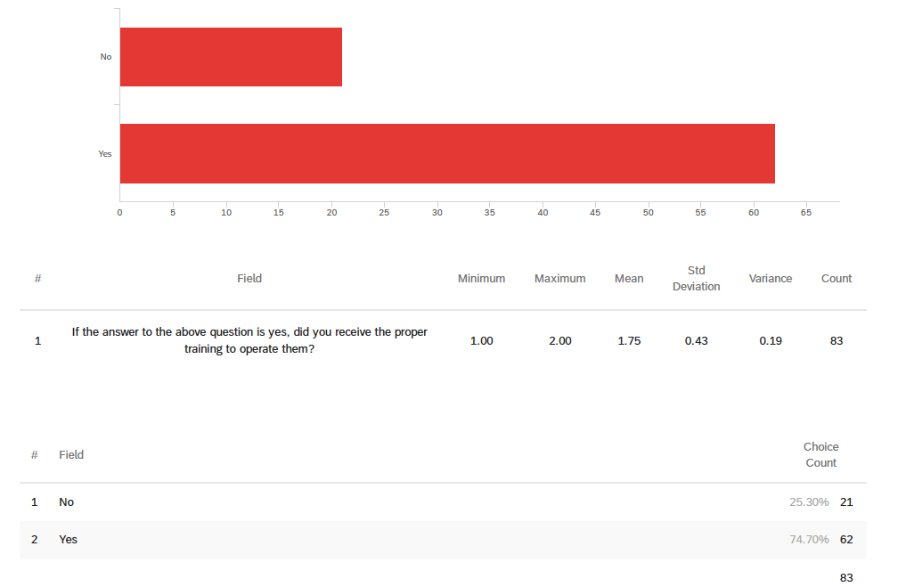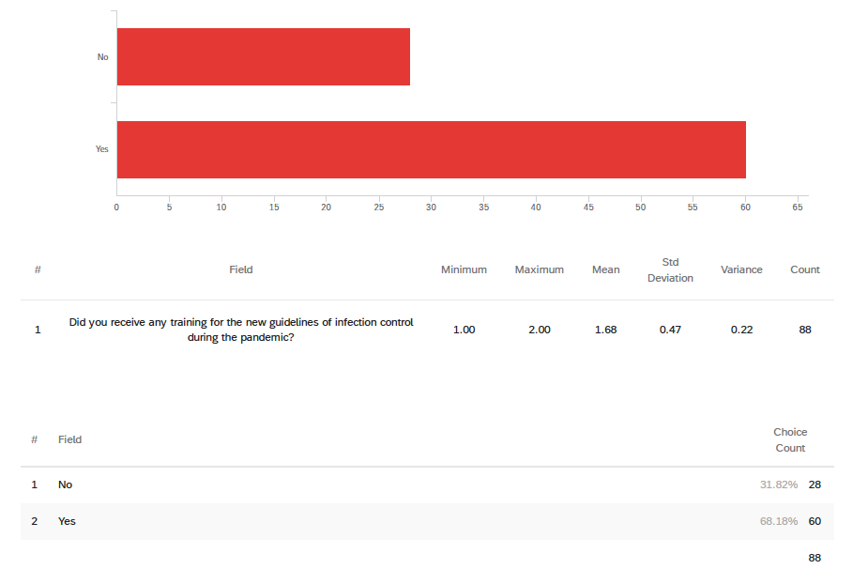
Figure c. 2: Staff training on the new guidelines.

The satisfaction of staff is a vital part in carrying on the whole process. Providing a respectful and comfortable working environment reduces stress and encourages production. The conflict mentioned between the regulatory bodies put so many hygienists and dentists in Ontario at a dilemma of which direction to take. In my opinion, the fairness of judging the situation as well as equipping the employees with the right training will be of benefit to all, the clinic and the public.
The following graphs show the level of difficulties and satisfaction of the dental staff.
Figure d. 1 the difficulties of performing daily tasks in the orthodontic clinic. 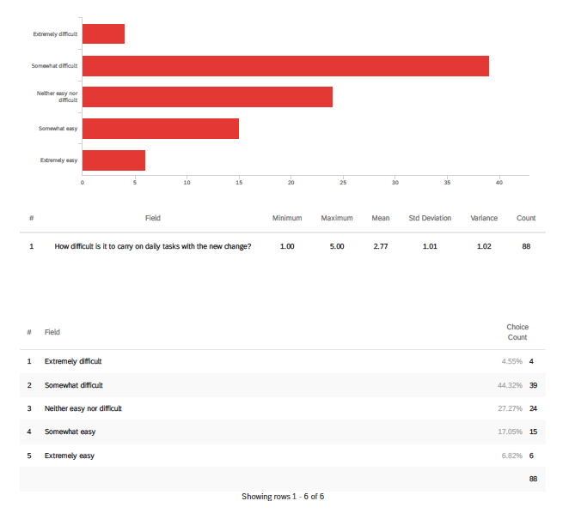

Figure d. 2 the satisfaction of staff with the current infection control implementations.
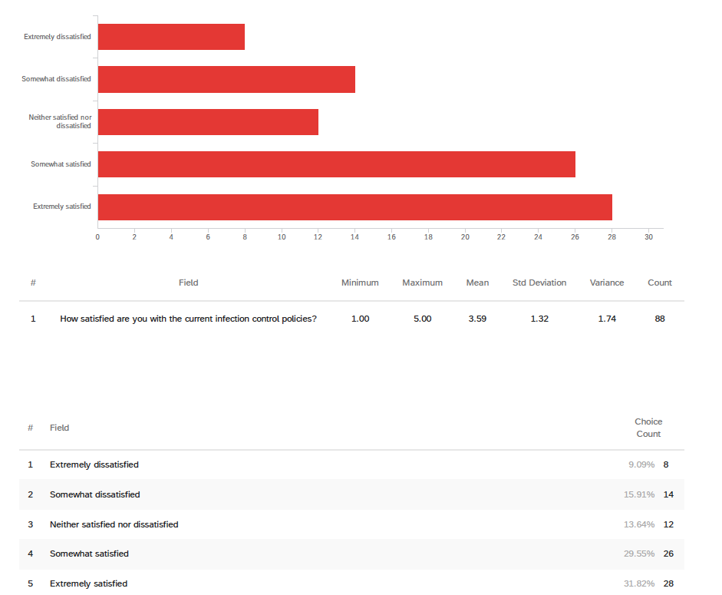

- Conclusion:
- Summary of the findings:
The COVID-19 pandemic reshaped several aspects of our life and affected many practices. Special light was shed on the medical and clinical practice sectors. Updating our practice in orthodontics seems imminent to ensure the safety of clinicians and patients at any cost and in any time. It is clear that a change is needed to avoid jeopardizing the health of the public and minimize any setbacks in the future.
Below is a list of the main points of this report:
- The set up at the orthodontic clinic is not functional during the COVID-19 pandemic. Therefore, we need to implement some changes as per the guidance of the regulatory bodies and public health.
- The planning and implementation need both collaboration and cooperation of the involved parties.
- Maintenance and monitoring are constantly required.
- The survey results yield surprising data when it comes to training the staff, more consideration is needed.
- Suggestions and recommendations:
- Training the staff and providing the proper work environment is key to the success of the business.
- The newly required PPE’s are expensive and very stressful to wear, the need to have shifts divided between staff might reduce this burden.
- Scheduling needs to meet all the aspects of preparing the clinic and booking times for certain procedures.
- Finally, the communication needed between both regulated professionals to reduce the conflict is crucial.

References
College of the dental hygienists of Ontario CDHO https://cdho.org/my-cdho/practice-advice/covid-19
Canadian dental hygienists association CDHA https://www.cdha.ca/cdha/News-Events_folder/Safety_Alerts/Coronavirus__COVID-19/CDHA/News-Events_folder/Safety_Alerts/Safety_Alerts.aspx
The Royal college of dental surgeons of Ontario RCDSO https://www.rcdso.org/en-ca/rcdso-members/2019-novel-coronavirus
Public Health Ontario https://www.publichealthontario.ca/

Appendix
Survey questions:
- Did you receive any training for the new guidelines of infection control during the pandemic? Yes/No
- Were there any changes implemented in the office? Yes/No
- Is the number of patients/staff present in the clinic is according to the guidelines? Yes/No
- Is there any new equipment installed in the office? Yes/No.
- If the answer to the previous question is yes, did you receive the proper training to operate them? Yes/No
- Do you use PPE and change them according to the guidelines? Yes/No
- Do you use barriers and change them according to the guidelines? Yes/No
- Is patient and staff temperature being taking upon arrival to the clinic? Yes/No
- Do you have an infection control officer in the office? Yes/No
- How difficult is it to carry on daily tasks with the new change? Not so difficult/somehow difficult/extremely difficult
- How satisfied are you with the current infection control policies? Somehow satisfied/could be improved/extremely satisfied
- Notes and suggestions:

