Dental Debridement

Parenthetical:
Dental Debridement is the (removal of deposits off teeth) done in a dental clinic by professionals.
Sentence:
Dental Debridement is the action of cleaning and removing debris like plaque and tartar off the tooth surface by dental professionals.
Expanded:
Sentence Definition: Dental Debridement refers to the removal of deposits off the tooth surface by dental professionals.
Etymology: The term Dental debridement dates back to the 19th century (originated from the French word debrider) which translates to – remove the bridle from- and bridle is derived from a Germanic origin.¹
Operating Principal & Required Conditions: Plaque and calculus “tartar” accumulates on tooth surface; it hardens and forms an attachment that is not easily broken or removed by our daily brushing. Dentists and dental hygienists use specialized dental equipment and instruments, this is performed at the dental clinic and usually referred to as Dental Cleaning. The dental hygienist could use different tools and instruments like the manual ones and mechanical (sonic operated) called scalers, the removal includes deposits on the tooth surface above the gumline and below. These deposits usually cause gingivitis “gum inflammation” which leads to periodontitis “inflammation of the bone” if left untreated.
Contrast: Unlike medical debridement which means the removal of dead and hard tissue from a wound.
Negation: Dental Debridement is not the removal of tooth tissue or other parts of the mouth, but only the removal of the harmful deposits.

a.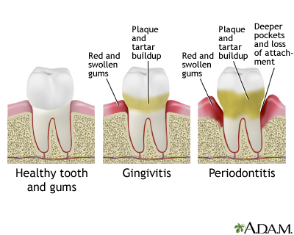 b. 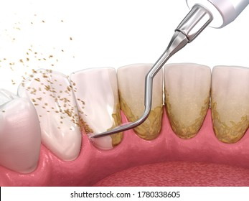
Figure 1 a. shows the effect of plaque and calculus on tooth health, b. shows the debridement of calculus.²

- 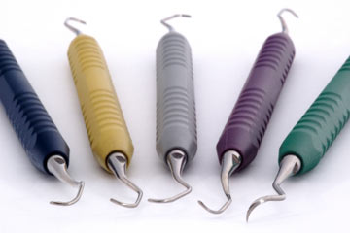 b. 

Figure 2 a. shows manual dental scaler, b. shows a sonic scaler.²

Reference
Definitions from Oxford Languages. (2021) Oxford University Press. Retrieved from: https://languages.oup.com/google-dictionary-en/

Kapner M, Norwalk CT, VeriMed Healthcare Network, Zieve D, MHA, Conaway B, the A.D.A.M. Editorial team. (2020) Gingivitis. Mount Sini Health Library. Available from: https://www.mountsinai.org/health-library/diseases-conditions/gingivitis

