**Targeting waste management at Zero Waste Scotland’s**

**Circular Economy Accelerator Programme**

Prepared for:

Adrian Bond

Programme Manager: Recycling

Edinburgh, Scotland

Prepared by:

Shuge Luo

English 301 Student

December 16, 2020

CONTENTS

ABSTRACTn

INTRODUCTIONn

METHODOLOGYn

SUVEYn

INTERVIEWn

DATA SUMMARY AND DISCCUSTIONn

Demographic Characteristicsn

Fields people active inn

Do people know about Recycling?n

POTENTIAL SOLUTIONn

Communicate with local companies n

APP SOLUTION n

WORKS CITED4

APPENDIX4

APPENDIX A: INTERVIEW5

# Introduction

Zero Waste Scotland is a not-for-profit environmental organization, funded by the Scottish Government and European Regional Development Fund. The organization focuses on various subjects and fields including food waste reduction, sustainable custom behavior, etc.

The ultimate goal of Zero Waste Scotland is to provide practical support to encourage the growth of the circular economy in Scotland. There are a few branch programs focus on different areas of work: The Circular Economy Accelerator Programme aims to increase the resource efficiency of Scotland, further support community-based organizations to build on existing local resources. Business support Service and Investment fund are targets to support those who are looking to develop circular business models.

Waste has a significant negative impact on the environment, climate, and human health. Although waste management in Scotland has improved considerably in recent decades, over a quarter of municipal waste is still end up on landfill and less than half of them is recycled or composted.

In the Accelerator Programme, Zero Waste Scotland attempt to increase resource efficiency and come up with ways to deal with recycling performance. However, waste management is a bigger story involved in user, customer, stakeholder, server, and government. With China refusing to be the world dumping ground, North America and Western Europe are push step on the stage where they examine their waste management technic and take efforts to improve the local waste management system.

The problem is that the waste management system doesn’t always work out in the way that we expect. Some research has shown that due to principles of supply and demand, primary goods (goods produced with raw materials) are unlikely to be displaced by recycled goods (goods produced with the recycled materials). Majority of recyclable garbage ended up on the landfill due to the lack of accessible market for recycled goods. However, as for customers, recycling is marked as doing good for the environment though it leads to an increase in consumption at the end of the day. In other words, we are adding materials to the environment with recycling.

In this report, we will are going to investigate the effectiveness of the waste management and examine how to provide a design mobile application as a potential solution to tackle this problem.

# Methodology

## Survey

The data analyzed in this paper is from the Survey administered by Shuge Luo from 2019 to 2020. The survey was completed by 229 local people living in Edinburgh through Google sheet. All the data come from the survey has been generated to Visual graph, but there are still some comments which been collected as extra materials for supporting the potential solution.

## Interview

The interview data is from the interview with three people living in Edinburgh. The Interview including some general questions about recycling, reuse, and reduction. To discover overall opinion about the pollution issue the planet is dealing with today and how recycling, reduce, and reuse can help. The second part involving the test for recognizing if an item recyclable or not.

**DATA SUMMARY and Discussion**

## Demographic Characteristics

Data obtained from the survey indicated that age is relatively normally distributed. For those engaging in environment-friendly life, adolescent and adult are the two main groups who usually see themselves as responsible to life. The largest Age group was adults which accounted for 66.4% of survey responses. respondents ages ranged from under 12 to over 60 years old. Majority of respondents were aged 19-59, which is likely to be the potential main user base. Taking adolescents and adults as the biggest audience, an app could be the best way to benefit them and improving waste management.

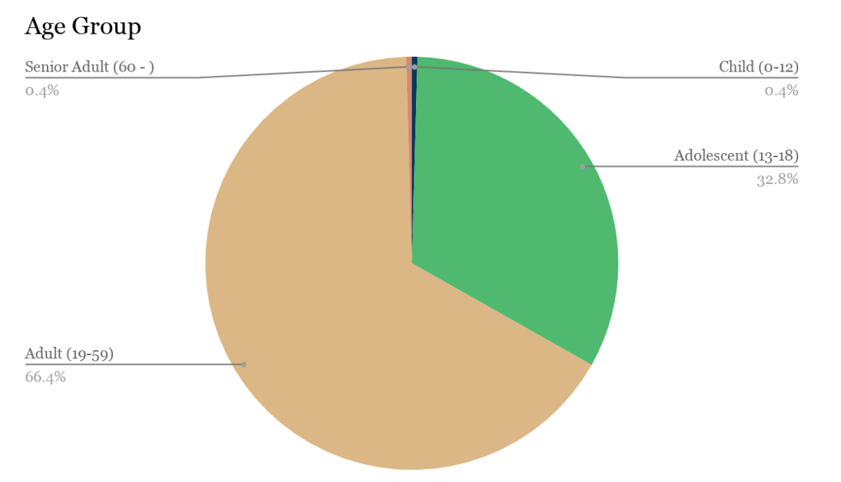

## Fields people active in

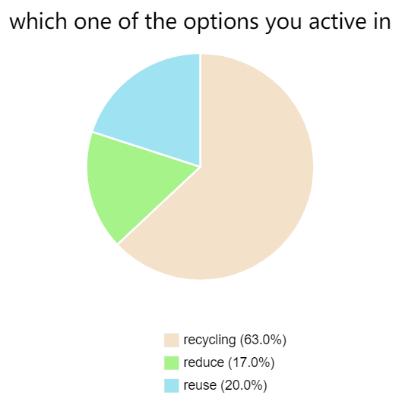

17% of survey takers think they are active in Reducing. Within the 17%, 40% of their answer about what would be the most important function are focusing on recycling functions; 6% of them think the most important function would be reducing the plastic packaging. Only 7/229 people are focusing on reducing.

The problems in waste management which include reducing, reusing, and recycling is essential codes addressed by this survey. Zero Waste Scotland should put reduce in the first place because we find in our survey only 17% of takers active in reducing. Making recycling easier still needs to be considered since it is the most common way people got involved in.

One comment below our survey strikes me “Awareness! If recycling becomes super easy, there is no incentive to reduce our massive overconsumption.” The comment reminds the potential problem that people might tend to take recycling as a long term way to solve the waste problem consequence of the neglection of their responsibility to the garbage they consumed.

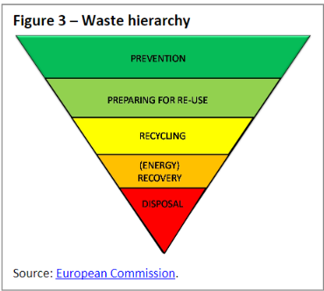

The 'waste hierarchy' in EU law functions as a guiding principle for waste management and set an order of priority in waste management where Preventing waste generation is the top aim. If waste cannot be prevented, it should be reused or be recycled. Consider about most of our survey takers even not conscious of the importance of reduction and reuse, Zero Waste Scotland should provide various systems to remind them and encourage them to reduce and reuse. At the same time, they don’t drop the recycling function away considering it is still an Indispensable part of waste management.

Associate possible interventions: 1. App with a scanner helping user differentiate the disposable item and suggest user buy something that will last longer

2. Map would tell users where to purchase bulk, package-free foods

**Do people know about Recycling?**

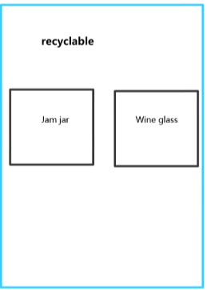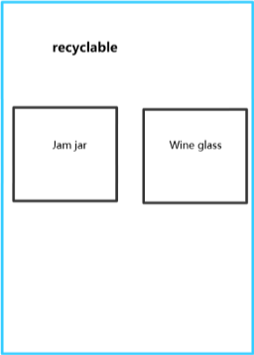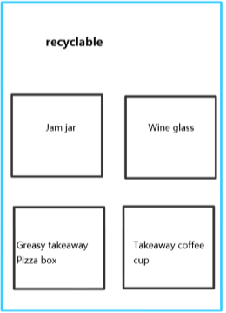

Uncertainties about the composition of products turn out to be time-consuming and annoying for people used to move and think so fast nowadays. In the interview, we made four cards with the name of different household waste, then asked participants to choose the right bin to place them(Participant 1 2 3). In the process, all of them put wine glass into the recyclable bin because they thought all glass can be recycled. However, the wine glass is made out of toughened glass containing chemicals that cannot be recycled with glass bottles and jars. If wine glasses come into the recycling stream, it can cause damage to the machine and contaminate the stream. On the other hand, people’s constant focus on recycling over reduction and reuse. Misunderstand of recycling set a mindset that recycling is a long-term way to solve environmental problems. We’ve all been brainwashed into accepting a story: that if we all just get a few containers and separate our waste, it will be taken by some nice people who will magically make it go away without any negative consequences. This encourages people to consume more and generate more waste.

# Potential solution

Communicating with local companies:

Some many companies and organizations have contributed to one or several good practices encouraging people to reuse or remanufacturing. For example, UK’s first student-led cooperative The Shrub, another stakeholder such as Edinburgh Re-makery, The Tool Library, The Forge are engaged in the contribution of the circular economy to create opportunities for a new lifestyle. However, at the point of development, organizations need a more extensive range of customers to build sharing communities and be involved in the activities especially for those companies who are promoting sharing as a way of reducing our environmental impact. Zero waste Scotland could cooperate with those organizations to achieve a full range of engagement.

Educating the public

Since Scotland’s government has ambitious targets for reducing waste by 2025, the Scottish Government will introduce regulations to drive separate collection and treatment of a range of resources to maximize their reuse value. Zero Waste Scotland could bring updated information into the campus in the form of various activities that encourage students to learn more about the current policies on reuse and allow them to come up with ideas that could eventually land on the desk of the officer. At the University of Edinburgh, the Department for Social Responsibility and Sustainability works to enable the University to understand, explain, and deliver social responsibility. It is a good chance to introduce them to some local environmental-friendly organizations like “The Tool Library” to help in promoting sharing tools as a way of reducing environmental impacts.

All of the above can be achieved through application design:

The business model relies on municipalities. While the app will provide necessary local recycling information free of charge, municipalities must pay a fee to have specific details included in the app. This can include mapping a specific product to a specific recycling bin, or a third-party location such as a pharmacy or shopping mall. At the same time, Zero Waste Scotland could track the footprint of recycling from all users; building a database can be referenced by the government as promoting environmental policies.

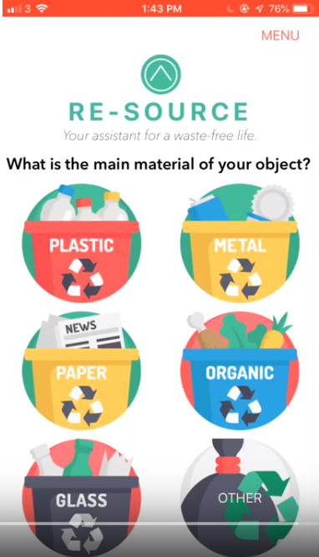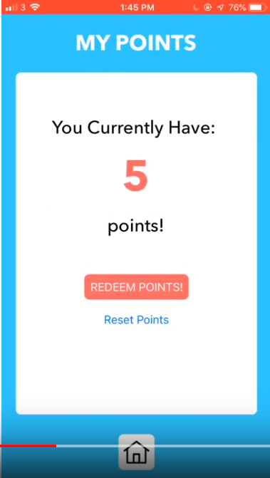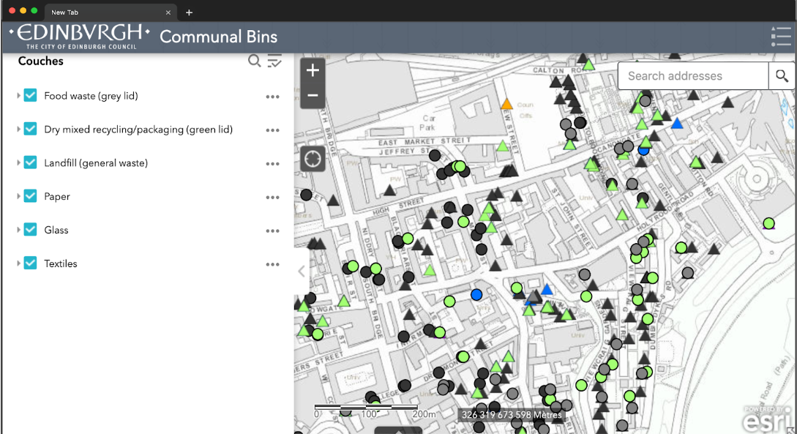

The app mainly focuses on the function of recycling and leads the user to the website where a wide range of reduction and reuse activities and advice are presented. In our prototype, A useful animated interactive guide to what materials are recycled in the local area and where. Users can tap items to find out more information about them and see where they can be taken nearby.

Customers could scan product packaging to obtain a ‘green score.’ However, the point system does not aim to encourage recycling; there is a unique reward system. From the beginning, each user is set with 1000 waste space, five green scores from users’ scan of one recyclable item will cut the total point to 995. When the waste score reaches a lower level such as 700, users are reward with a coffee cup. The idea is to remind people that although recycling can be helpful to the environment, it cannot decrease the waste place like landfills where over half of unrecyclable garbage end up there.

Recycle Points allows the user to view a real-time map of "Recycling & Waste Points" with-in their local area and filter by type and materials. The locations are updated and remotely administrable by their council in real-time, so they will not be in the know about their local areas. (P3) Data-driven, networked urbanism is the key mode of production for smart cities to transform Scotland into an efficient circular economy. Cities are becoming ever more instrumented and networked, their systems interlinked and integrated, and vast troves of big urban data are being generated and used to manage and control urban life in real-time.

# WORKS CITED

1. Circular economy package Four legislative proposals on waste: https://www.europarl.europa.eu/EPRS/EPRS-Briefing-573936-Circular-economy-package-FINAL.pdf

2. Waste Management Planning: https://ec.europa.eu/environment/waste/plans/index.htm

Appendix:

Interview 1

A: interviewer

B: interviewee from Italy age:22 male

(): supplement after the interview from interviewee

[]: the action of the interviewee

A: ok the first question is…Have you been confused by which bin to put your used garbage in?

B: I…you know…always confused in which bin put my rubbish

A: for example?

B: for example…umm…for example… the paper for pizza, if it is dirty or not… it will change something…I don't know….or any unusual garbage

A: like what?

B: chair (some package of food with half of paper and half of plastic)

A: When you find yourself hovering indecisively over a set of trash bins, would you put the garbage in the recycling bin or general bin?

B: I am thinking… if I am not sure, I will put it in the general bin

A: Do you have any apps to help you do recycling or reuse?

B: No, I don't have any apps

A: Do you like to have an app to help you recognize if it is recyclable?

B: Actually, I prefer to ask someone else in person rather than download an app for recycling

A: Have you used Google to search if the garbage is recyclable?

B: No, as I said before, I just like to ask someone else

A: If there is a recycling help app, would you prefer quickly scanning items or searching by category?

B: searching by category (Because once you know the bottle of coke is recyclable you know the bottle for other beverage is recyclable)

Interview 2

A: interviewer

B: interviewee from: Germany age:21 female

(): supplement after the interview from interviewee

[]:the action of interviewee

A: ok the first question is…Have you been confused by which bin to put your used garbage in?

B：yes,sure. But I think there was more when I was about 14 or 15. but I think you got to use to it. The more you recycling, the more you just…relize what is recyclable

A: So can you give a example?

B:I don't know how to call it, the thing over there [point carboard]

A: Can you show me?

[move to carboard and point the item "Strong Foil"]

B:I ask my mom for that, and I knew which bin should put it in

A: When you find yourself hovering indecisively over a set of trash bins, would you put the garbage in recycling bin or general bin?

B: I think I probably will Google it before

A:Do you have any apps to help you do recycling or reuse?

B:No, I never thought about it. Is already an app for that?

A: Yes, why didn't you download an app for that?

B: I never thought about using an app because I didn't know the exist of those apps. But, Honestly I don't think I will use apps because …yeah, when I not sure about whether recycle or not, I will google it or ask my mom. It more you need to handle when you put it on your phone for the app..ok.. So I think you can just Google it

A: Have you used Google to search if the garbage is recyclable?

B:Yes

A:If there is a recycling help app, would you prefer quickly scaning items or searching by category?

B:in this case I think I will scan the items with code to see if it is recyclable

Interview 3

A:interviewer

B:interviewee from:Malaysia age:19 female

(): supplement after the interview from interviewee

[]:the action of interviewee

A: ok the first question is…Have you been confused by which bin to put your used garbage in?

B：Yes, because like back my contry..back in Mayasia, the recycling bins are categorized by color, so different color means you can recycle different things. Sometimes I have other things to remember so I don't really focus on what color is recycle for which item. So sometimes because that confusion I tend to throw away in the normal bins

A: When you find yourself hovering indecisively over a set of trash bins, would you put the garbage in recycling bin or general bin?

B:If I am confused that paticular things is should be recycle in which bins I will just throw it in normal bins. It not cool but it is easier

A:Do you have any apps to help you do recycling or reuse?

B:No, actually I am not even aware there are apps help us recycle. But if I know that app, I will definetly download it

A: Do you prefer using Google or download an app for that?

B:Honestly an app, because using app, it is like specially use for that

A:If there is a recycling help app, would you prefer quickly scaning items or searching by category?