**An Introduction…**

The purpose of this assignment is to formulate three different types of definitions of the same technical term. The definition types include a sentence, parenthetical and expanded definition. The term I have chosen is vitrification. My target audience is a group of young environmental science students who seek sophistication in specific fields of science that incorporate the process of vitrification. The goal of the following definitions is to provide a baseline of understanding to these students, which would assist in their further studies of this multi-faceted and ever-progressing term.

**VITRIFICATION**

**Parenthetical Definition**

Vitrification (the process where liquid shifts into a solid state, by which materials bond to become dense and nonabsorbent) is an essential component of preservation of various forms.

**Sentence Definition**

Vitrification technology is the final stage of temperature changes in the maturation of a clay piece, it has improved the success of cryopreservation of eggs, embryos, and sperm and is used in the disposal and long-term storage of nuclear waste or other hazardous wastes.

**Expanded Definition**

The process if vitrification occurs uniquely in several different fields of science; three of which are briefly explained below:

**Vitrification of Embryos (Fertility)**

During the vitrification, an embryo or egg is cooled off by *thousands*of degrees per minute.

Until recently, the only method for freezing oocytes (or unfertilized eggs) was a slow-freezing method. This worked okay for freezing sperm or embryos. However, for eggs, the slow freeze process had many problems. Before vitrification, the old slow-freezing method of oocytes, or unfertilized eggs, led to the formation of ice crystals (Gurevich, 2016).

These crystals break down the egg. To help minimize the amount of ice crystals, scientists would remove some of the water, though it is impossible to remove all the water. When the eggs were thawed, they were damaged and frequently unusable. Fertilization and pregnancy rates for these slow-frozen eggs were low. With vitrification, the freezing process is so fast that ice crystals don’t have a chance to form. Vitrification has made egg freezing a much more viable option for women and pregnancy rates seem higher. However, research is ongoing (Gurevich, 2016).

Reasoning:

* To extend childbearing years
* To preserve fertility before cancer treatment
* To avoid medical conditions that may impact fertility in future
* To freeze embryos after IVF (in-vitro fertilisation)
* To assist egg donor banks (Gurevich, 2016)

[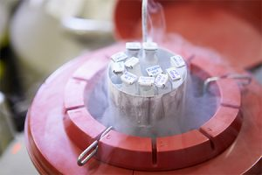](http://www.reprodiag.com/wp-content/uploads/2015/10/lab-services-img.jpg)

Figure 1. Frozen Sample of Banking Sperm. Adapted from Reproductive Diagnostics, 2016.

**Vitrification of Clay (Pottery)**

In the production of ceramics,vitrification is responsible for its impermeability to water. It is the process of melting that clays and glazes go through as they are fired to maturity (Peterson, 2016).

In a fully matured clay body, the spaces between refractory particles are completely filled up with glass, fusing the particles together and making the clay body impervious to water, which brings about hardness and durability. In other words, this gradual process enables the materials to most easily melt, dissolve, and fill in the spaces between the more refractory particles, which also promotes further melting, as well as compacting and strengthening the clay body (Peterson, 2016).

Reasoning:

* The glaze was becoming too vitreous and might begin to melt off the sides of the pot.
* The clay body is still too porous; you need to vitrify it by firing it at a higher temperature (Peterson, 2016).

[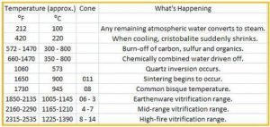](https://www.google.ca/url?sa=i&rct=j&q=&esrc=s&source=images&cd=&ved=0ahUKEwjVj9qykr3PAhUB-mMKHRflAIcQjRwIBw&url=http://pottery.about.com/od/temperatureandmaturation/tp/tempclay.htm&psig=AFQjCNHxfhsxfaq2UH8-iks0CFDre0ZMNg&ust=1475532844061349)

Figure 2. How Temperature Changes Clay. Adapted from Peterson, 2016.

[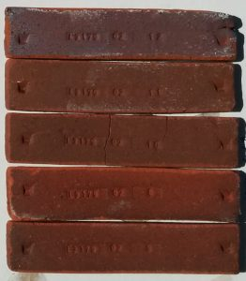](https://digitalfire.com/4sight/images/pictures/pyhcibowun.jpg)

Figure 2b. Newman Red clay fired test bars at a range of temperatures. Adapted from Hansen, 2015.

**Vitrification of Nuclear Waste**

Waste is mixed with glass-forming chemicals in a furnace to form molten glass that then solidifies in canisters, thereby immobilizing the waste. Treatment and conditioning processes are used to convert radioactive waste materials into a form that is suitable for its subsequent management, such as transportation, storage and final disposal (World Nuclear Association, 2016).

Reasoning:

* Minimise the volume of waste requiring management via treatment processes.
* Reduce the potential hazard of the waste by conditioning it into a stable solid form that immobilises it and provides containment to ensure that the waste can be safely handled during transportation, storage and final disposal (World Nuclear Association, 2016).

[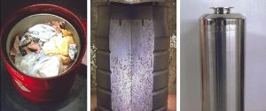](http://environmentalresearchweb.org/cws/article/news/30499)

Figure 3. Vitrification of Nuclear Waste. "Low-level waste such as gloves and clothing worn by workers at nuclear plants is placed in a drum before being super-compactified for storage (left), while intermediate-level waste such as fuel cladding is encapsulated in concrete (middle). High-level waste, comprising fission products and transuranic elements, is vitrified, put into stainless-steel flasks (right) and stored in engineered vaults." Adapted from Norman, 2007.

**Works Cited**

Peterson, Beth. Definition for Vitrification in Pottery. About.com.19 Aug. 2016. http://pottery.about.com/od/potterygloassary/g/vitrify.htm. Web. 26 Sept 2016.

Peterson, Beth. How Temperature Changes Clay. About.com. 19 Aug. 2016. http://pottery.about.com/od/temperatureandmaturation/tp/tempclay.htm. Web. 26 Sept 2016.

Hansen, Tony. Newman Red Clay. Digitalfire Reference Database. 2015. https://digitalfire.com/4sight/material/newman_red_clay_1071.html. Web. 26 Sept 2016.

Gurevich, Rachel.VeryWell.com Vitrification of Embryos, Eggs, and Sperm. 16 Feb. 2016. https://www.verywell.com/egg-freezing-and-vitrification-1960186. Web. 26 Sept 2016.

Reproductive Diagnostics. 2016. http://www.reprodiag.com/faqs/. Web. 1 Oct 2016.

Treatment and Conditioning of Nuclear Waste. World Nuclear Association. Sept 2016. http://www.world-nuclear.org/information-library/nuclear-fuel-cycle/nuclear-wastes/radioactive-waste-management.aspx Web. 26 Sept 2016.

Norman, Paul. A New Dawn for Nuclear Power. Environmental Research Web. 16 July 2007.  http://environmentalresearchweb.org/cws/article/news/30499. Web 1 Oct 2016.