Recommendations for increasing and maintaining student participation in the creative writing student association

Submitted to: CWSA Interim Director Cara DiGirolamo

Created by

Sidney Singh

Table of Contents

**Abstract** 2

Introduction to CWSA 3

History of the CWSA 3

Revisions relevant for the Report 3

Former CWSA Structure 4

Current CWSA Structure 4

CWSA Sandbox 4

Overview of Problem and Purpose of Report 5

Methods 5

Scope 5

**Data Section** 5

Observations during Research 9

**Conclusion** 10

Recommendations 10

Works Cited 12

# **Abstract**

The Creative Writing Student Association (CWSA) “serves to represent the needs and concerns (UBCCreativeWriting.com) ” of their members. Membership is automatic to students enrolled in the following programs:

* Undergraduate major in Creative Writing
* Master of Fine Arts in Creative writing on campus and Optional Residency
* Master in Theater and Creative Writing
* Master of Film Production and Creative Writing
* Master of Children’s Literature.

This report contains recommendations on how to increase and maintain student participation in the CWSA.

Primary sources included a survey to the entire membership, interviews with the CWSA executive and social committee. Secondary sources include the information provided on the UBC Creative Writing website, the official BFA and MFA handbook, the CWSA Sandbox and historical posts on the UBC Creative Writing Forum. Recommendations are also supported with academic research and articles that pertain to student participation in general or related topics.

# Introduction to CWSA

## History of the CWSA

Created in 2010 (ibid) the CWSA is intended to represent the needs and concerns of the membership. In the 2020-2021 Winter Term the CWSA constitution went under an historic revision. These revisions were intended to increase equity within CWSA and update the organization for the new post pandemic world. These revisions went into effect in the 2021-2022 Winter term.

Historically, members of the Executive Committee were tasked with planning social events along with duties as faculty liaisons. These events included OutWrite or Locution which are monthly informal student readings hosted by BFA and MFA students respectively. Revisions to the constitution allowed for the creation of a separate social committee to facilitate social events.

## Revisions relevant for the Report

The following revisions are the most pertain to this report.

* Revision to article 5 which enabled the creation of the CWSA social committee.
* Revision to article 6 which allowed students enrolled in the Master of Children’s Literature degree to become CWSA members.
* Revision to article 8.3 which allows multiple BFA students to assume roles in the Social Committee. This revision also stipulated that is the Chair’s responsibility to engage interest in volunteering and if not, possible elected representatives will assume additional responsibilities.
* The creation of section 8.2.2 which allows CWSA to form ad-hoc committees if needed.

These revisions allow for more members of CWSA to participate. Ensuring an ample number of participants seeking to fulfill volunteer positions will allow the CWSA to flourish in the future.

## Former CWSA Structure

Chair

Secretary

MFA Representative

BFA Representative

Figure

## Current CWSA Structure

Figure

Executive Social Committee

Chair Secretary- if needed

Secretary OutWrite Hosts

MFA Representative Locution Hosts

Optional Residency

Representative

BFA Representative

Ad-hoc committees can be formed if needed

# CWSA Sandbox

The CWSA Sandbox canvas course was created to inform membership about the structure of the CWSA and various Creative Writing events. It also contains information about other creative writing related opportunities hosted by the Department. Currently is it managed by members of the Executive Committee with plans to have a CWSA Social Media Manager to resume responsibility for the course.

# Overview of Problem and Purpose of Report

In order for CWSA to optimize the creation of a new social committee there must be consistent participation in the organization. This year there were some challenges in searching for new members for volunteer and paid roles in the CWSA. Understanding what events members are attending and who is attending is integral to maintaining consistent participation.

# Methods

Research included a survey distributed through a secure UBC mailing list and interviews with the Executive and Social Committee. 15 surveys were completed along with one interview with Optional Residency Representative Sonia Di Pladico and Social Committee member and OutWrite host Micah Pyre.

# Scope

1. What events are the membership attending?
2. Do they review the CWSA sandbox?
3. What inspires current CWSA Executives and Social Committee members to assume these positions?

# **Data Section**

A 12-question survey that included, multiple choice, rankings and optional text boxes was sent to the CWSA membership through a secure UBC email. 15 surveys were completed.

7 participants self identified as Master of Fine Arts students, 6 as Bachelor of Fine Arts students and 1 as a Master of Creative Writing and Theatre student. There were no surveys completed by MACL or Master of Creative Writing and Film Production students.

86% of respondents reported they have attended a CWSA event whereas 62 % admitted to not attending a CWSA meeting.

86% of respondents reported they have attended a CWSA event whereas 30% reported to have attended a CWSA meeting.

79% of respondents answered they attended CWSA events “to meet fellow students and socialize.”

77% of respondents reported they learn about the CWSA through email with 23% of respondents selecting the “other” option.

85% of respondents reported to never visiting the CWSA Sandbox Canvas course.

50% of respondents reported to attended writing related events outside of CWSA. There was an optional text box if respondents wanted to share.

Written responses included UBC events, and other readings, book launches and interviews. One respondent recommended an event similar to the Scanadivan Studies “fika” where students are able to chat informally and meet with other students.

85% of respondents reported that the frequency of reminders of CWSA events is “just right.”

Respondents were asked to check the following opportunities that interested them.

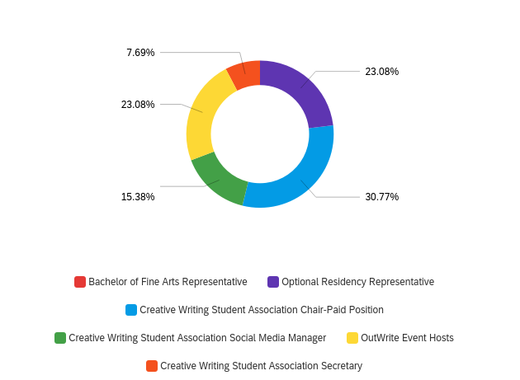

Figure

The options included:

* Bachelor of Fine Arts Representative
* Optional Residency Representative
* Creative Writing Student Association Chair-Paid Position
* Creative Writing Student Association Social Media Manager
* Creative Writing Student Association Secretary

3 respondents each checked off the Optional Res Representative, CWSA Chair Position and OutWrite Event Hosts as opportunities of interest.

Respondents were asked to rank preferred CWSA communication channels. 9 respondents ranked email as their first preference for communication with CWSA.

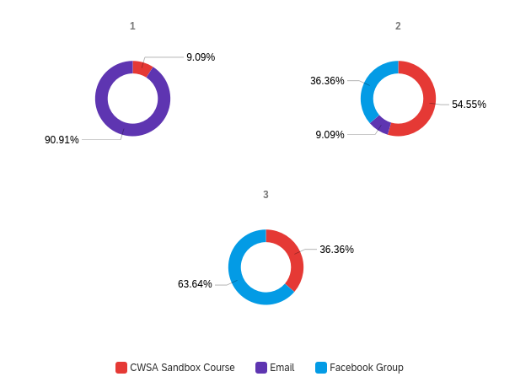

Figure 4

This concludes data of interest from the survey.

# Observations during Research

To understand the role of CWSA better I reviewed documents created by either the CWSA or the Creative Writing Department. Below are a few notes.

* The acronym CWSA is also shared with the Canadian Women’s Studies Association. This association has a close connection with UBC and will appear if UBC CWSA is typed into a search engine.
* The 2021 MFA Handbook lists the CWSA Chair as a possible Work Learn experience.
* The 2021 BFA Handbook mentions the CWSA and references the BFA Representative as a possible volunteer position. The emails for the CWSA Chair and BFA Rep are provided.
* The CWSA Sandbox under the Social Committee subsection states there can be “an unlimited number of volunteer positions that any CWSA member can hold. Anyone can join or show up (to a social committee meeting) and we encourage you to do so.”
* There is a diverse array of social media channels the CWSA uses to maintain communication. This includes, BFA and MFA mailing lists, a BFA Facebook group, an MFA Facebook group and the UBC Creative Writing Forum. The Facebook group and forum also contains information about events external to the CWSA and UBC.

# **Conclusion**

The surveys demonstrated that members want to participate in CWSA. There is interest in the CWSA volunteer and paid positions. Members are interested in socializing with other Creative Writing students. Creating more informal opportunities for members to socialize with one another may help in finding new volunteers. The membership of CWSA covers a variety of degree programs thus creating a comprehensive communication may help in reaching members. Researching further required into CWSA member’s social media preferences could help connect members to one another. The recommendations may inspire thought and discussion on member participation.

# Recommendations

* Creating a comprehensive and clear website to outline the role of CWSA, the Executive Committee and Social Committee. This initiative may help in advertising the Association better among the wider UBC community and students enrolled in various Creative Writing programs at UBC. Content can be exclusively focused on the CWSA.
* Emulating the presentation and design of other student organizations at UBC. Notable examples include the English Student Association (ESA) and Arts Undergraduate Society (AUS). The ESA and AUS have clear and concise websites and webpages that effectively inform readers of their organization purpose and goals. These organizations also have a People page where Executive members have a short biography and picture of themselves. Increasing visibility online may help with introducing the CWSA to its members and encouraging participation.
* Considering appointing an Arts Undergraduate Representative and or a Graduate Student Society representative in order to promote and represent CWSA to the wider student body. Researching the possibility of this including this position may help in establishing the CWSA to other student organizations on campus. This may lead to the creation of more writing related cross department social events further solidifying the CWSA position at UBC.
* Clarifying the role of the student representatives as a faculty liaison. Ensuring both the representative and the CWSA membership understand which concerns can be addressed to the faculty and other appropriate channels.
* Researching efficient social media channels for CWSA. Platforms such as Tik Tok or Instagram may help spread awareness in a quicker and more fashionable manner. Further research is needed on this subject as CWSA encompasses students from a diverse array of backgrounds. Research from the Pew Research Center demonstrates social media preference among different age groups and other identify categories (Pew Research Center).
* Promoting a current social committee member to Social Head to oversee the development of social events. Head will not have to be responsible for the creation of every social event but instead approve and be aware of what events bear the CWSA name. Allowing any member of CWSA to head and create a social event is an innovative engagement strategy. A CWSA Social Head could be responsible in recruiting and encouraging members to propose and run their own social events. The Head could also support members by helping with advertising and facilitating these social events. The Social Head can act as an “elder” to encourage students who attend social events to become active in the CWSA.

In Jonathan Bishop’s study on increasing participation in online communities he recommends that elders or active participants in a community can “nurture novices in the community so that, [they] can see that those who are new to a community are treated well (1888).” This advice can apply to the Social Head as well.

* Drafting creative, informal and low-cost social events for members. The surveys indicated that members attend CWSA events to socialize with other another. Proposing innovative ideas for social events may help in meeting more members and finding volunteers. A few can include “chat and campus walks,” “meetings in coffee shops.” Online events could include Chats and Writes on different platforms.
* Specifying which events and opportunities are hosted by the department and which were projects facilitated by the CWSA student body. Ascertaining which events are products of the CWSA will help inspire members to participate in the organization.

# Works Cited

Afzal Tajik, Mir, and Abdul Wali. “Principals’ Strategies for Increasing Students’ Participation in School Leadership in a Rural, Mountainous Region in Pakistan.” *Improving Schools*, vol. 23, no. 3, 2020, pp. 245–263., https://doi.org/10.1177/1365480220923413. Accessed 17 Nov. 2021.

Bishop, Jonathan. "Increasing Participation in Online Communities: A Framework for human– computer Interaction. "*Computers in Human Behavior*, vol. 23, no. 4, 2007, pp. 1881-1893.

Cristall, Sydney. “Program Grows to School of Creative Writing after Senate Approval.” *The Ubyssey*, The Ubyssey, 11 Aug. 2020, https://www.ubyssey.ca/news/school-of-creative-writing/.

“Demographics of Social Media Users and Adoption in the United States.” *Pew Research Center: Internet, Science & Tech*, Pew Research Center, 26 Apr. 2021, https://www.pewresearch.org/internet/fact-sheet/social-media/?menuItem=4abfc543-4bd1-4b1f-bd4a-e7c67728ab76.

“Undergraduate Student Opportunities: UBC Creative Writing.” *Creative Writing*, School of Creative Writing, https://creativewriting.ubc.ca/undergraduate/opportunities/.

University of British Columbia. *MFA Student Handbook 2021-2022*, https://creativewriting.ubc.ca/wp-content/uploads/sites/4/2020/04/CRWR-MFA-Handbook.pdf. Accessed 16 Nov. 2021.

University of British Columbia. *BFA Handbook 2021 Final*, https://creativewriting.ubc.ca/wp-content/uploads/sites/4/2019/11/BFA-Handbook-2021-.pdf. Accessed 16 Nov. 2021.