**3 – 2 – 1 Assessment**

*3 Things you didn’t know before*

*2 things that surprised you about this topic*

*1 thing you want to continue doing with what you’ve learned*

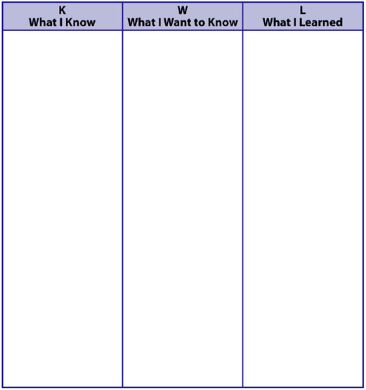

**Know, Wonder, Learn (KWL)**

**Basketball**

NAME:

PEER CHECK - SHOOTING (B.E.E.F.)

|  |  |  |
| --- | --- | --- |
| Check List Name:___________________ | Completed on a line  (√) | Completed at a hoop  (√) |
| Balance:  • hips facing target  • feet shoulder width apart  • shooting foot slightly in front  of non-shooting foot  • balance on balls on feet  • knees bent  • buttock out and back straight |  |  |
| Elbow:  • elbow lined up above toe & knee  • elbow at a 90° angle |  |  |
| Eyes: • look at target (hoop) |  |  |
| Follow-through:  • extend elbow and legs simultaneously  • snap wrist  • put hand in the “cookie jar” |  |  |