Call for Children’s Art
SPARK 2019 will bring together students and ECE professionals for an exciting conference about young children on May 10-11, 2019 at UBC. For more information, please visit https://blogs.ubc.ca/sparktheearlyyears2019/

To include children's artistic creations as part of the conference, we would like to invite you to submit any non-prescribed artistic expressions and free art projects by children up to 8 years. These could include children’s paintings, drawings, three-dimensional items such as puppets, clay, wood, recycled/upcycled art, and assorted materials constructions and any related pedagogical narrations.

These creations will be framed and/or displayed during the conference. Attendees will be welcomed to comment on the art and these comments will be included when the art is returned to the artists. Photographs of the art will also be uploaded to an online gallery on the conference website.
Please send the artwork before April 10th to: SPARK ECED Conference,
1304-2125 Main Mall, Vancouver, BC, Canada, V6T 1Z4.
Email spark.theearlyyears@ubc.ca if you have any questions or need support with mailing artwork.
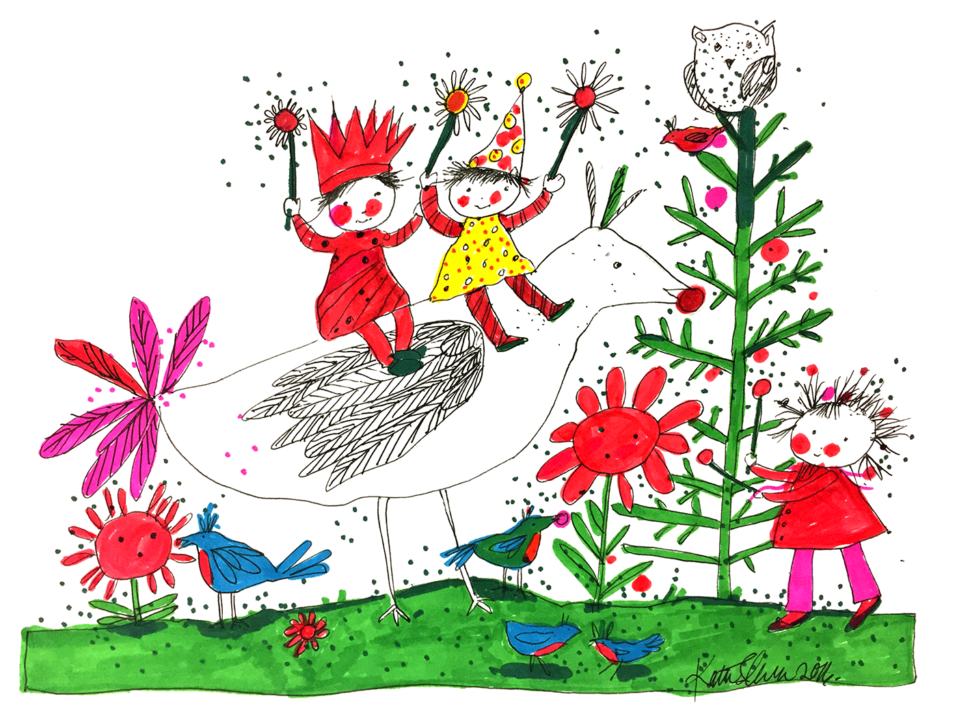
Please fill out the attached information sheet and submit with the artwork.

SPARK 2019 | CALL FOR ARTWORKS INFORMATION SHEET

Child’s name: ______________________________________________________________
Age: _____________________________________________________________________
Name of centre/school: ______________________________________________________
Any notes/narratives/children’s voices/title related to the artwork:

Name of organization: ___________________________________________________

Address: ________________________________________________________________
________________________________________________________________________
________________________________________________________________________
Email: ___________________________________________________________________
Phone: ___________________________________________________________________

I have received assent received from child to submit and display artwork
I have received verbal consent from parent/guardian to submit and display artwork
I have received a request from the child/parent for the artwork to be returned

Name of person submitting artwork: __________________________________________

