Increasing Social Media Engagement
for Great Dane Coffee
By: Sydney Dunn
Date: August 3rd 2020
Recipient: Andrew McKee

Table of Contents

I. Introduction

- description of Great Dane Coffee
- Background on social media and business
- description of Great Dane’s social media
- Purpose of the report
- description of data sources
- scope

II. Data section

- introduction to Instagram as a platform
- general feed
- instagram stories feature
- advertising opportunities
- Preliminary research
- Numbers
- initial survey responses
- effective Instagram for a business
- Changes
- types of posts on main feed
- types of stories
- changes in engagement numbers
- Feedback

III. Conclusion

- general summary
- recommendations moving forward

Introduction

Description of Great Dane Coffee

Great Dane Coffee is a small independent coffee shop located on the north end of the University of British Columbia’s Vancouver campus. Since opening its doors in 2011, Great Dane has become increasingly popular with students, faculty, staff, residents, and visitors of campus. This success has allowed the shop to continue to grow, expanding to a second space to provide additional seating. During the academic year, between September and May, the small shop is always bustling. They take pride in the quality of their coffee and the pastries and sandwiches made in-house daily.

Social Media for Business
Social media platforms like Instagram contribute significantly to a business defining its brand. Research conducted by Khallad Kamal and Özge Eren indicates that engagement with a business’ social media encourages the consumer’s purchase intention and brand awareness (Kamal, 709). This goes even further to state “using social media as a marketing tool increases the chance of increasing brand awareness and increase the consumer engagement with the brand” (Kamal, 709). This means that how a business like Great Dane Coffee portrays itself on Instagram and social media is how consumers will recognize the business and connect with it.

Great Dane Coffee’s Social Media

Great Dane Coffee can be found through their website (greatdanecoffee.com), on Facebook, and Instagram. They are most active on Instagram posting photos of Lady the great dane for which the shop is named, as well as new pastries and of course their coffee. For the most part, the photos take advantage of the beautiful bright space.

Purpose of this Report

This report has been designed to explore how the quality of Great Dane Coffee’s social media content, specifically on Instagram, can impact engagement from their followers and by extension contribute to the success of the business. A strong social media presence has the potential to connect Great Dane Coffee to the larger Vancouver community and make it a destination for coffee lovers and not just students.

Description of Data Sources

The data employed in this report includes statistics taken from Great Dane’s Instagram such as number of followers, likes, comments, and direct messages. By observing how the account’s followers respond to different posts it can be understood what kind of content the most successful moving forward will be. Additionally, a survey of staff and customers has been conducted to generate feedback regarding the Instagram page.

The Scope

To evaluate the impact of Great Dane Coffee’s social media platform, the following areas of study have been used.

- How does a consistent style impact engagement?
- Can responding to followers directly and more frequently increase traffic?
- How do changes to the social media platform impact business?
- What are the impacts of consistent posting and advertising?

Analysis of Data

Introduction to Instagram

Instagram is a social media platform owned by Facebook designed for sharing photos and other visuals. It has been widely adopted by businesses and creatives to connect with their consumers. An account can post photos or videos while tagging people or places that are featured and provide a description. Instagram’s “stories” feature allows for shorter term posting. For businesses, Instagram provides a variety of promotion options. This allows businesses to share their posts as advertisements on people’s feeds or as stories. Businesses can even adjust their target audiences through options like location, demographics, interests, behaviours, lookalike audiences, automated targeting, and even custom audiences (Instagram).

Preliminary Research

Instagram Numbers
On July 20th, Great Dane Coffee had 1,265 followers on Instagram. Many of these followers are fellow dog owners and staff. Others include coffee related accounts like Bows X Arrows coffee whose beans are regularly used by the shop. The remaining followers are presumably customers who are interested in keeping up to date with Great Dane Coffee. It should equally be noted that this number of followers has increased rapidly since July to be 1,394 as of August 3rd.

Posts on Great Dane Coffee receive a variety of engagement ranging from as little as 30 or 40 likes to nearly 200. The most popular or well-liked posts feature Lady the great dane and/or staff members (see figures 1 and 2). Moderately liked posts include promotions of different drinks or products (see figures 3 and 4). The least liked posts tend to be the more heavily staged photos (see figure 5).

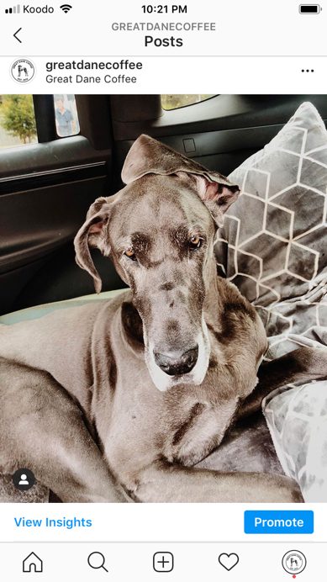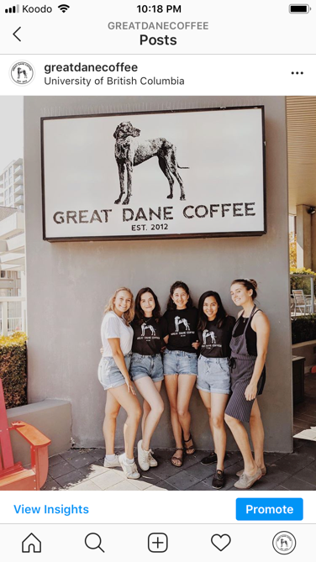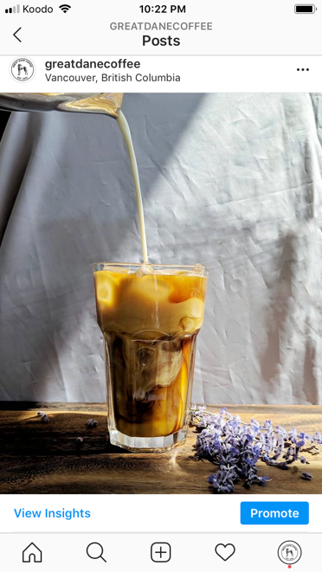
Figure 1 Figure 2 Figure 3

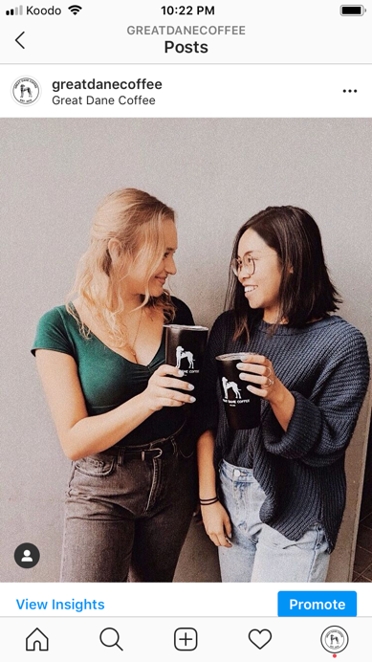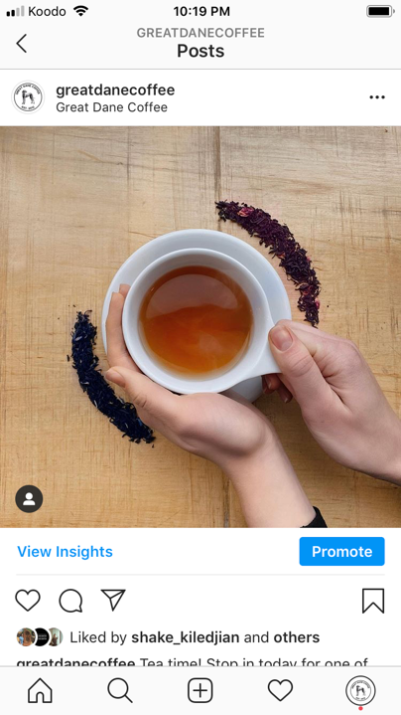
Figure 4 Figure 5

Survey Results
Respondents were asked to complete a survey including seven questions, some multiple choice and some short answer. Of the respondents, 62.5% said they currently follow Great Dane Coffee on Instagram while 87.5% said they had been to Great Dane Coffee (75% regularly, 12.5% only once or twice). Over 90% of respondents identified as being or having previously been a UBC student.

When asked why they like Great Dane Coffee, many respondents described the friendliness of staff and the overall atmosphere of the shop. Others mentioned their favourite beverages, the quality of the espresso, and event their favourite pastry or sandwich. Others mentioned the dog.

When asked for their thoughts about Great Dane’s Instagram, 37.5% said they have not given it any thought, 12.5% said they really enjoy it, and the remaining 50% responded with “none of the above” or “not applicable.”

Regarding the kind of content they wanted to see, respondents mentioned seeing more day-to-day things including staff bios and featured pastries. Others suggested photos of the dog and information posts about coffee.

The majority of respondents indicated that do not generally think to follow a business on Instagram. Others use the platform to check out a business they have never been to and indicate this is an effective was to check hours of operation and assess the overall feel of the place.

Changes and Adjustments

Over the past couple of weeks, Great Dane Coffee has been posting less frequently. As opposed to posting on multiple days in a row, posting has been kept to once every week or two to provide more general updates. These posts included a feature about the beans currently being used and some of the pastries available that day. The photo with the most engagement was of Lady and reached 218 likes while the lowest was 60, still higher many similar posts previously (see figures 6 and 7).

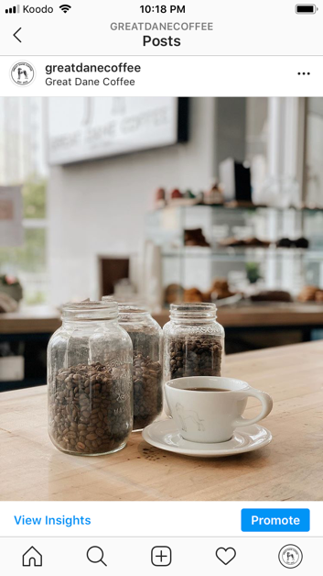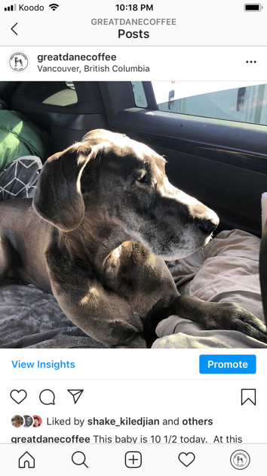
Figure 6 Figure 7

Feedback

As mentioned above, over the past couple of weeks Great Dane Coffee has seen an increase in both followers and engagement with content. Additionally, Great Dane Coffee has been featured on multiple occasions on an Instagram account called “UBC Battle of the Beans” which is serving to rank various coffee shops on the Vancouver campus. On this account Great Dane Coffee has been praised for its sandwiches and oat milk latte.

Conclusion

Summary

In looking at the survey responses and other data pulled directly from Great Dane Coffee’s Instagram, the followers are responding well the changes being made in the content. However, it is important to recognize the circumstances and timing that may have impacted this increase in engagement.

-explore how covid-19 may have impacted this
-what do we know about great dane’s branding

Recommendations

-continue with a variety of content (fun staff stuff, the dog, informational coffee content)
-develop a schedule/plan for posting (fewer posts per week, more thought out, stories can be used actively)
-timely responses to customer questions

