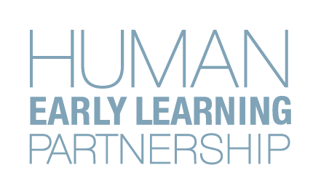
Building Community Partnerships to Foster the Wellbeing of Young Children and Families
Principal Investigator: Martin Guhn, PhD., Human Early Learning Partnership, UBC
Information Sheet

The Questionnaire
In collaboration with parents/caregivers, early child development professionals, researchers and policy makers, researchers at the Human Early Learning Partnership (HELP) at the University of British Columbia (UBC) have developed a questionnaire for parents/primary caregivers of 12-24 month old children. This questionnaire, the Toddler Development Instrument (TDI) asks questions related to contextual factors that influence early child development, such as daily routines, family-child interactions, and available parental/caregiver and community supports.

The purpose of the TDI is to better understand the early life experiences of toddlers and their families and to elicit further systems of support for families and communities.
Participation
We are inviting all parents/primary caregivers of children age 12-24 months to participate in this pilot implementation by completing a copy of the TDI. You will also have the opportunity to provide feedback on your thoughts about the TDI and your experience filling it out. Your feedback is greatly appreciated and will help shape the content and administration of the TDI questionnaire in your community.
Details
To participate, please speak to [Community Contact (Role, Contact Information)]

To thank you for your time and participation, parents/caregivers will be given the opportunity to enter a draw for a $50 gift card upon completion of the TDI questionnaire.

If you are interested in learning more about this study, please contact Kira Koepke, TDI Research Project Coordinator, HELP at tdi@help.ubc.ca.

