THE UNIVERSITY OF BRITISH COLUMBIA
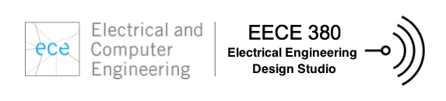

Solar Panel Alignment and Protection System

prepared by

Project Team L2B8

Michael Halpenny-Mason
Feng Qiu 22120125.
Wei Fan 38110110.
Weng Fei Yu 24486110
Reginald Pollock

in Partial Fulfillment of the Requirements for

EECE 380 – Electrical Engineering Design Studio

Date submitted: 10 Mar 2014

Abstract

The objective for this ORBCOMM Solar Panel Positioning System project was to utilize satellite to communicate with Q4000 microprocessor based sensors and actuator to maximize the efficiency and longevity of a solar panel array. Adhering to budge of sixty dollars, the project was designed and structured with three physical components, a sundial, a rain sensor and a solar panel actuator module. The project required extensive investigation into measurement methods and sensor/actuator design. In addition to this, each component required the development of a custom made application for the ORBCOMM subscriber communicator along with shell scripts implemented in the ECE servers. The end result of the design and implementation process was a system that can accurately measure sun position throughout the day along with current precipitation levels. The system uses an actuator to orient the solar panel with the sun. In the event rain is detected, the system reverts to its close position, shielding the solar panels in a while rain is present. The solar panels reopen automatically once the rain sensor has decided the rain has stopped. By achieving high efficiency operation of the solar panels throughout the day while protecting the panels’ intense precipitation, the system meets all objectives set by the instructors and customer.

Table of Contents

Abstract ii
List of Figures iv
List of Tables v
Glossary vi
List of Abbreviations vii
1 INTRODUCTION 1
2 SYSTEM DESIGN 2
2.1 Objectives 2
2.2 Sensor System: Problem Definition and solution 2
2.3 Actuator System: Problem definition and solution 2
2.4 Discussion 3
3 IMPLEMENTATION 4
3.1 High-level design implementation 4
3.2 Sensor Implementation 4
3.3 Actuator Implementation 6
3.4 Software Implementation 10
3.5 Discussion 11
4 INTEGRATION AND TEST 12
4.1 Objectives 12
4.2 Sensor and Actuator Integration and testing 12
4.3 Code Integration and Test 12
4.4 Discussion 14
5 CONCLUSIONS AND RECOMMENDATIONS 15
Conclusions 15
Recommendations 15
REFERENCES 16
Appendix 17

List of Figures

Figure 1: Solar Panel Array 1
Figure 2: Overall Block Diagram 4
Figure 3:Sun Dial Structure (left) and its Sub-assembly 5
Figure 4: Time laps of shadow movement on light sensor 5
Figure 5: LDR divider circuit 5
Figure 6: Rain Wheel and optical encoder 5
Figure 7: Funnel to capture Rain (right) and optical encoder (left) 6
Figure 8: Optical Encoder Circuit 6
Figure 9: Actuator and its corresponding parts; Closed (left) and open (right) 7
Figure 10: Motor Controller with L298n H-Bridge 8
Figure 11:PWM Servo Driver Circuit 9

List of Tables

Table 1: Actuator Testing Results 13

Glossary

Weather Station | - Module that includes the Sun sensor, Rain sensors and ORBCOMM subscriber-communicator
Actuator Station | - Module that the solar panels are mounted to which includes the positioning system, protection mechanism, and ORBCOMM subscriber-communicator
Azimuth | - Angular measurement in a spherical coordinate system.
PWM | Pulse Width Modulation, a modulation technique that conforms the width of pulse.

List of Abbreviations

IEM | - Integer in E-mail Message
PWM | - Pulse Width Modulation

1 INTRODUCTION

This report investigates the design, implementation and testing of the ORBCOMM Solar Panel Positioning System developed for EECE 380 project one, in 2014. This system was developed utilizing systems of engineering practices throughout its conception and implementation in order to effectively address all elements of the technical problem we attempted to solve.
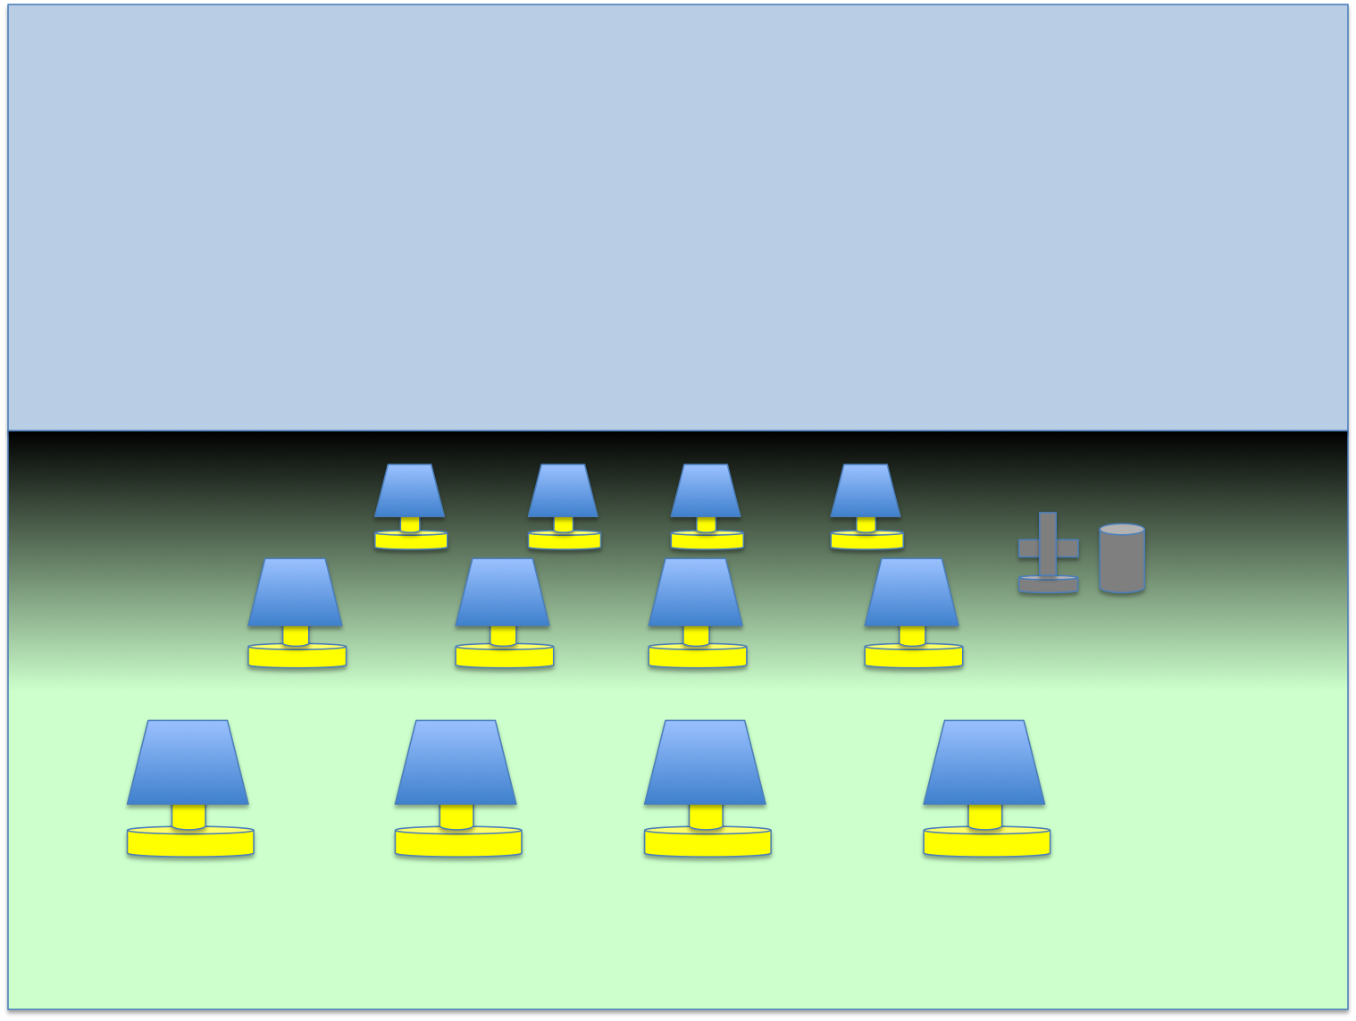
The technical challenge presented was to maximize the efficiency of a single solar panel or an array of solar panels (shown in Figure 1) using a single, centralized control system. Keeping the solar panels in-line with the sun would effectively maximize their power output[1] and therefore their efficiency. This was made more difficult by the additional need to protect the solar panel from harmful precipitation (such as acid rain due to proximity to a polluted city). As degradation and weathering of the solar panels reduces their effectiveness[2], our system was required to protect the longevity of the solar panels by preventing weather damage (and thereby maximize long term return on investment in the solar array). Although the ORBCOMM network in conjunction with the ORBCOMM subscriber-communicator allowed for fast wireless communication, the primary challenges associated with design problem related to three objectives: Data collection, Data routing, and system Actuation.
Figure 1: Solar Panel Array
Data collection was the first objective of the system. It was necessary to measure multiple weather/climate variables in order to determine the appropriate response from the actuation system.
Data routing from the weather station was the next the key objective that allowed a single weather measurement station coordinate one or many solar panel actuators at various location. The data routing needed to utilize the ORBCOMM system an be done fast enough to have the system responsive to changing weather conditions
Our last objective was to provide the appropriate physical response to changing weather conditions in order to both align the solar panels and protect them from harmful precipitation.
The remainder of the project report is dived up into the following sections investigating the development of this project:
  - Section Two discusses the System Design
  - Section Three discusses Implementation
  - Section Four discusses Integration and Testing
  - Section five discusses Final Conclusions Future recommendations

SYSTEM DESIGN

Objectives
The objective of our system design was to clearly define the technical problems involved in meeting our overall objectives; namely, relevant data collection, data routing, and effective system actuation. The system was developed in modules, with each subsystem aiming to address one objective independently. Taking abstract requirements such as “maximize efficiency of solar panels” and turning them into clear technical problems such as “measure and position a panel to the correct azimuth angle” is one of the most important jobs we do as engineers. This section summarizes our process of problem definition for each of the design modules.

Sensor System: Problem Definition and solution
In Order to maximize the efficiency of the solar panels, our needed to keep to solar panels facing the sun throughout the day. It was determined that the vertical position of the sun stays relatively constant throughout the day however the horizontal position, or azimuth angle, does not. The azimuth angle is necessary to know which direction the solar panels would be at maximum efficiency, and would be one of the climate conditions our system would have to adapt to. Therefore our first data measurement was determined to be the azimuth angle of the sun, with a precise enough reading that the position of the sun could be determined to within a few degrees throughout the day.
In order to meet our second requirement of protecting the panels from harmful precipitation, a second measurement needed to be taken. Specifically a rainfall intensity sensor needed to be implemented as our system would have to detect harsh weather such as intense rain. This lead us to conclude the second needed measurement needed was rain fall intensity or volume per minute, with a fast enough response time that such conditions would be detected within a few minutes of the onset of rain.
Finally all this data needed to be transmitted in a usable format and in a short enough time span that the data would be relevant and useful to a responding actuator. Therefore we determined our system would have to transmit accurate data every 15 minutes or less, such that weather information would arrive at an actuator within a half hour of being measured ensuring an appropriate and timely system response.

Actuator System: Problem definition and solution
Our application required our actuator to perform two actions. First, it must be able to align a polar panel to sixteen distinct directions throughput the day to archive maximum efficiency of the solar panels. Secondly, there must be a panel to cover the solar panel in the event of intense weather where damage can occur, which will close when required a hinged cover with an attached motor on a timer could quickly and easily control the protecting screen and was therefore determined to be the ideal solution to that design problem.
It was determined that both of these physical responses would have to be controlled by the Q4000 micro controller in the ORBCOMM subscriber communicator, not only meet requirements set by the instructors, but to allow the system completely wireless connectivity with the other subsystems via the satellite network. Data routing was accomplished by using the messaging feature on the ORBCOMM system along with a a server based bash script to automate message relaying. Therefore the actuator needed to be able to receive and process specific messages sent to it via ORBCOM, and so we determined our design solution would also include a command processing capability for the actuator.

Discussion
The translation of the overall system requirements from the customer/instructors to a clearly defined series of technical problems allowed us to then outline our specific sub-system requirements. Doing this broke our overall task down to multiple module-based goals and allowed us to develop the overall block-diagram of our system (see figure 2). The successfully defined sub-systems allowed us to complete the entirety of the project in a timely and modular manner while always working towards our top level performance goals. A rigid plan based on the defined design solutions allowed fast progression through the modules and a smooth integration that allowed time for bug fixes and performance testing.

IMPLEMENTATION

High-level design implementation
The implementation of the overall system design system was structured upon the following high-level system (shown in the block diagram below)
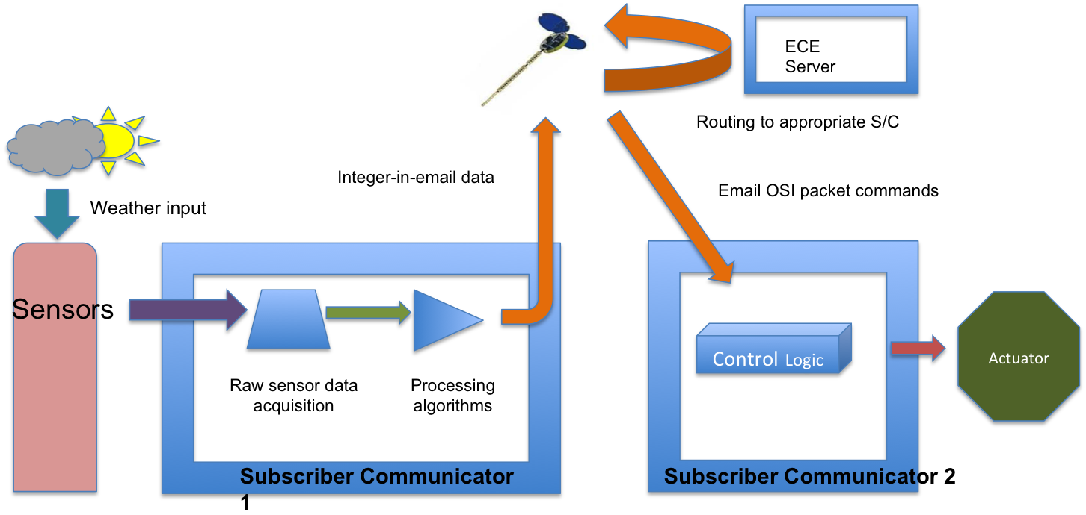
Figure 2: Overall Block Diagram

Sensor Implementation
3.2.1 Sun Position Sensor
The design of the sun position sensor follows the sun dial concept in which a shadow is casts in accordance to azimuth of the sun throughout the day. The shadow then triggers a light dependent resistor (LDR) at a specific position on the sun dial which gives the position of the sun at that particular time. As shown in Figure 1, the light sensor structure was designed to follow the equatorial sun dial model. The design was chosen because it is saves space and gives a more accurate of the sun’s position. All 8 LDRs are connected in parallel to a multiplexer which acts as a switch which constantly updates the light intensity of all the LDRs.
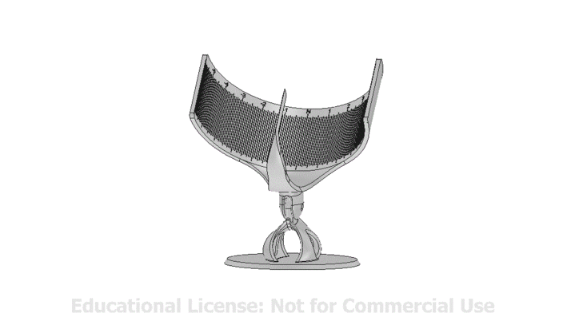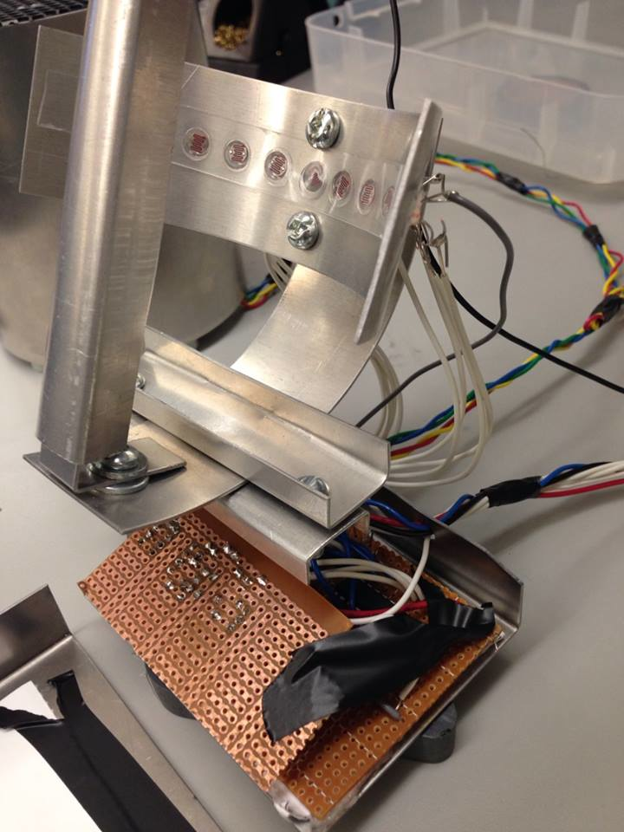
Array of 8 LDR sensors
Multiplexer circuit
Figure 3:Sun Dial Structure (left) and its Sub-assembly

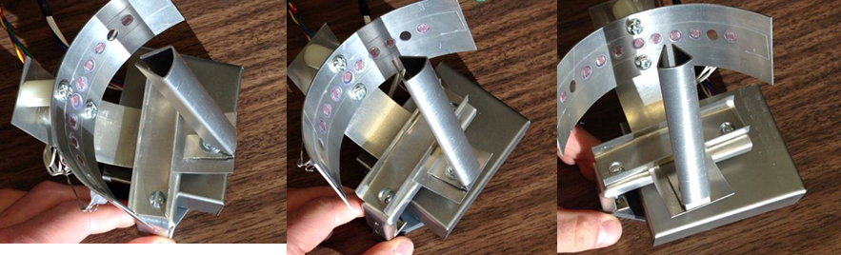
Figure 4: Time laps of shadow movement on light sensor
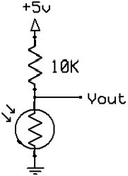
Photo resistors can have high resistance as a few mega ohms (MΩ) in the dark and a relatively low resistance as low as a few hundred ohms in the light. Based on the schematic diagram shown below, the circuit is technically acts as a voltage divider in which Vout changes as the resistance of the LDR changes. So as a shadow casts onto the LDR, it gives a higher resistance hence giving a higher voltage reading of that particular LDR as the current remains constant. The voltage readings of each LDR on the sundial are then fed to the microcontroller and compared. The lowest voltage reading indicates the shadow, hence the position of the sun.
Figure 5: LDR divider circuit

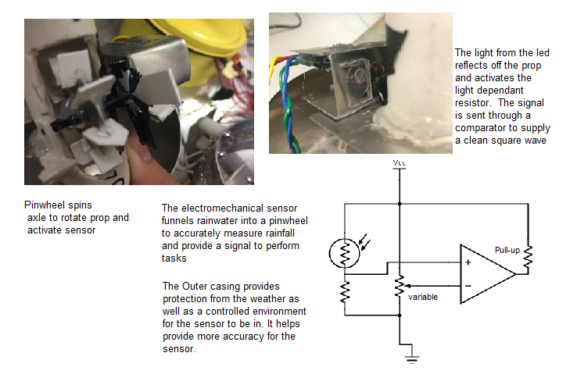
3.2.2 Pin Wheel Rainfall Sensor
The upper part of the PVC pipe is attached with a funnel and a turbine wheel is attached into a PVC pipe to determine the intensity of the flow of water. As more water is accumulated in the funnel, water pressure at the wheel position increases which results in higher wheel spin speeds, giving the measurements of rain intensity.
Figure 6: Rain Wheel and optical encoder

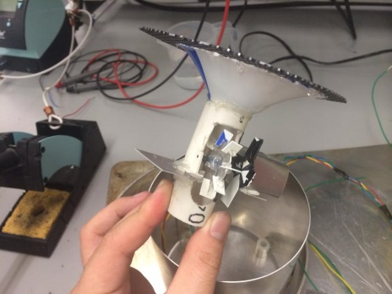
Figure 7: Funnel to capture Rain (right) and optical encoder (left)

Based on Figure 5, the sensor unit or optical encoder consists of a red LED adjacent photoresistor (LDR) attached in a voltage divider configuration. When the wheel spins, the fins of the wheel will reflect LED light onto the photoresistor, creating a voltage change that is then converted to a 1/0 logic signal with the below circuit resulting in a square wave. A higher wheel speed gives a higher frequency and smaller period of the square wave. Opaque black tape is used to minimize reflection of the surroundings and to only focus the fin of the wheel.

Figure 8: Optical Encoder Circuit

Actuator Implementation
The design of the actuator is based on providing the best performance of the solar panels. The actuator consists of three main parts: body of the solar panels, panel alignment system and the servo system.

3.3.1 Actuator Body
Instead of having a pulley system or a sliding door mechanism, the opening and closing of solar panel in Figure 7 was designed to fully utilize the surface area of the solar cells. The servo was attached at the top of panel 1with its lever being attached to panel 2. This save unwanted space and also gives a perfect balance when it rotates.

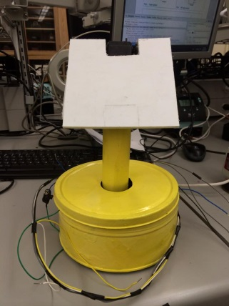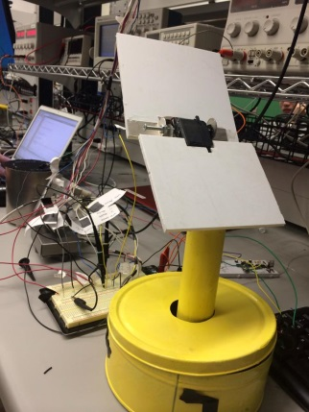
Panel 1
Panel 2

Servo
Figure 9: Actuator and its corresponding parts; Closed (left) and open (right)
3.3.2 Panel Alignment System ( DC motor)

Driver (CW/CCW)ww

Microcontroller (Q4000)
DC motor

Potentiometer + Voltage Divider

Figure 8: The block diagram of panel base alignment system.

Since a pulse width modulation (PWM) wave could not be produced from the Q4000, a closed-loop feedback system is implemented onto the DC motor which is coupled with a potentiometer as shown in Figure 8. With 5 Volts being supplied, a voltage divider was also used to limit the voltage from the potentiometer as the analog input pin of the Q4000 can only take up a voltage of 3.5 Volts. At rotation angle of 0 degree, the potentiometer gives out a voltage of 0.1 Volts and at its maximum rotation angle of about 300 degrees, it gives out a voltage of 3.2 Volts. The voltage values were collected with its corresponding angles desired so that it can be calibrated with every LDRs sensor.

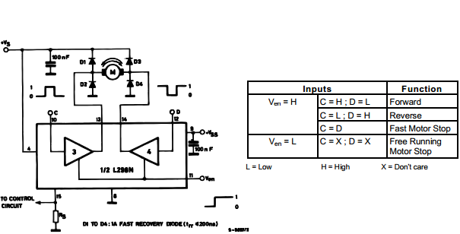
Figure 10: Motor Controller with L298n H-Bridge

In the code, a sun position integer value will be assigned based on the photoresistor sensor’s position. With the feedback system, the Q4000 will constantly update the alignment of the solar panels. From Figure 9, it produces output at digital pins Dig_6 and Dig_7 with logic 1 and 0 to move clockwise, 0 and 1to move counter clockwise and halt at 0 and 0 respectively. The DC motor will rotate clockwise or counter clockwise until it matches the corresponding values from the sensor. The switching of the motor direction was assisted with the use of a L298 H-bridge chip. A tapping motion of the DC motor was also introduced in the code to prevent overshooting as well as twitching of the motor.

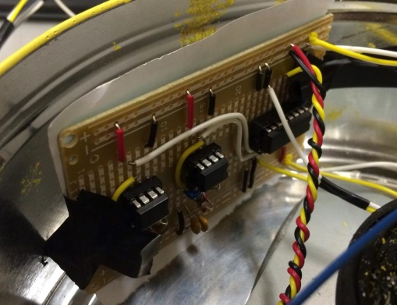
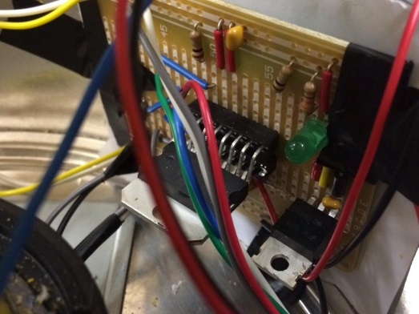

Figure 10: Motor driver circuit with H-Bridge IC (left) and servo circuit (right)

3.3.3 Servo System
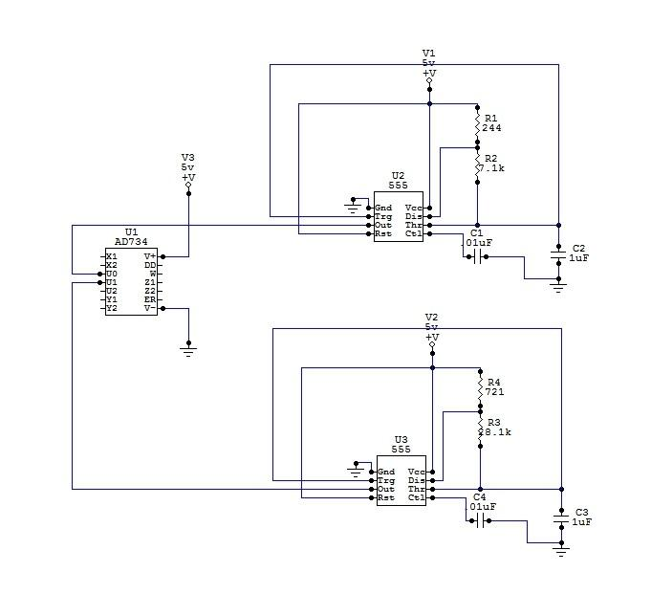
A servo was used as the primary activation unit for the solar panel protection system. A servo rotates and holds specific angle based on the PWM (Pulse Width Modulation) present at its signal input. Two astable oscillator circuits were built to provide two different PWM signals (one for each position) based on a LM555 timer and a multiplexer for selecting which signal would drive the servo. This application requires one timer generate a 50HZ signal with 1ms pulse width to drive the servo to a position of 0 degrees (which closes the solar panel). Conversely, the other timer will generate a 50HZ signal with 2ms pulse width for the servo rotates to 180 degree which opens the solar panel. Both signals are routed through the multiplexer allowing a 1-bit signal to choose the output signal into the servo. As an additional feature, after the solar panel is in position, the multiplexer is then disabled for power saving concern. See Figure for the servo diver circuit.

Figure 11:PWM Servo Driver Circuit

Software Implementation
The three main software elements that had to be developed to meet the specifications of the project were the weather station data source code, the server shell scripts, and the actuator source code. These three coding solutions needed to be compatible with the IEM messages to either create, rout, or process them respectively.

3.4.1 Weather Station Source Code
The weather station source code (see appendix A) processed the analog data provided by the instrumentation and sent it in IEM format to the ORBCOMM server. This included archiving messages in the event they could not be sent at the time of generation because the satellite was out of view.
The two sets of data from each weather sensor were pre-processed in two different methods called getSunPosition() and getWheelSpeed(). Each utilized iterative loops to capture either the peak voltage (and therefore sun position) or rain wheel speed by measuring the period of rotation. After processing, the methods would return an integer value corresponding to the sun position or rain wheel speed. In the event the either of the algorithms could not determine either a valid sun position or a non-zero wheel speed they would report an error value (-2 or 0) so that any post post-processing could identify erroneous data and omit it.
Upon capture and conversion of the weather data to integer form, the method sendSensorData() would package the return values of the getSunPosition() and getWheelSpeed() in an ORBCOMM message along with a time stamp and message number. In the event that the satellite was not in view, a special archive field in the body of the IEM would hold a number corresponding to the number of previously archived messages.

3.4.2 Server Shell Script
The server shell script (see appendix B) functioned as the ‘switch station’ for the overall system. Along with generating a log file to include all messages relayed via ORBCOMM, it would temporarily store the body of the IEM message received from the weather station in a file called orb.txt before sending it to the actuator station. This sequence of course would only occur in the event the data was not empty.

3.4.3 Actuator Source code
The actuator source code (see appendix C) used a series of iterative functions to control a DC motor driver and servo control circuit based on an integer input from an IEM message. This started at a method called parseCommandMessage() that would, upon receiving a satellite message, look for weather data and if found, would update the actuators using a method called updateActuators(). This method included a array mapping function that was utilized during the testing and calibration of the design.

Discussion
The overall design and implementation of the project has met all the objectives as listed in the early phase of the project. The sensors and actuators performed as it expected. Initially, there were problems with the panel bases alignment system as it overshoots and twitches as it reaches the desired positions. However, it was solved in the code. If a Pulse Width Modulator (PWM) wave can be produced from the Q4000, a servo will be preferred choice instead of the DC motor as it the implementation will be much easier and it will stop at various positions accurately. In conclusion, there were no outstanding unresolved issues that might affect the project.

INTEGRATION AND TEST

Objectives
Integration and test were the most essential process of this design, the goal was to test each module of the design and verify its functionality, performance and reliability, and in doing do ensure any problems could be fixed before integration.
Integration aimed to combine all subsystems together ensuring the various sub-systems could function correctly together and meet overall system performance goals.

Sensor and Actuator Integration and testing
The design includes the rain sensor, the optical sensors and the actuator. Before combining every component together, each module had been tested .
4.2.1 Rain sensor and optical sensors
Sensors are important measurements of the design, the more precise data obtain from sensors will bring better performance and results. Each module will be tested before combining everything together. Optical sensors were tested based on code. By applying flash light to each optical sensor, the program will out an array that indicates the position of the light. Rain sensor was tested in similar method, water flow in the tube will cause the wheel rotate which the sensor will detect the spin. By applying different amount of water the program will output the precipitation intensity depend on the spin frequency.
4.2.2 Actuator
The actuator is separated into two parts, the rotating motor and folding servo. The motor has two input signals that indicates rotating direction and one output signal that represents the position or angle of the motor. All input signals takes signal ‘1’ or ‘0’ which equivalent to 3.5V or 0V, and the feedback signal outputs a voltage. The test requires simulated signals from power supply to see if the motor is rotating correctly and voltmeter is used to observe the feedback voltage as a linear function.
The servo is used to fold the solar panel to prevent damages from heavy raining or bad weather. The build in servo driver circuit takes one input signal and one enable signal. Both signals takes signal ‘1’ or ‘0’ as well and these signals are also generated from power supply to test is the servo is functioning correctly.

Code Integration and Test
Code testing was done in the same modular fashion as the hardware. Each of the methods discussed in section 3 produced terminal outputs of their return values that served as the basis for trouble shooting each sub-system. Calling the methods individually in the repeating switch case called TIMER allowed us to test each sub-system.

Verification of the sensor code would be done in two steps- the first step would be the simulation of weather condition, either through a point light source at a known position relative the sun sensor, by or pouring water over the rain sensor. We would then verify that the logger terminal was showing the desired integer that corresponded to the simulated weather condition. Repeating this allowed both calibration and bug fixing for all the weather station source code. Once the sensors were producing values within their respective allowable range of precision[1].
Verification of the ORBCOMM communication was done by again producing terminal outputs at the logger port to confirm either the contents of the generated IEMs, the sending of an IEM or receiving an IEM from the ORBCOMM network. However because a large portion of the communication was done using a shell script, the automated email reading was verified by manually sending emails to a Gmail account and then verifying they were read and sent back.
Actuator verification was verified by ‘hard coding’ integer inputs to the control methods and physically verifying that the motor system responded accordingly. Below was the table used to verify the functional response of the system to method inputs.

Table 1: Actuator Testing Results
Sun Position Integer Value | Actuator position (degrees) | Sun Position Integer Value | Actuator position (degrees)
0 | 0 | 35 | 85
5 | 12 | 40 | 92
10 | 24 | 45 | 108
15 | 38 | 50 | 120
20 | 51 | 55 | 132
25 | 61 | 60 | 140
30 | 73 | 65 | 156

Discussion
The overall performances in test and integration worked out nicely. Because of the amount of researches done online and the enough simulations using Multisim before building each module, most of the circuits functioned fine once they were assembled. We encountered many minor and simple problems which can be easily solved. There are also some highlighted problems we have met.
While integrating the actuator and the optical sensors together, the optical sensors were taking voltage values, but the code had digital outputs. Therefore, instead of creating vast variables that connects specific sensor voltages with motor feedback voltage, we applied two array with the same length to simply map the values and it turned out functioning correctly.
Also the rain sensor was not measuring the rain intensity accurately. The reason was the code written for ORBCOMM did not allow user to use interrupts. Meanwhile, the rain intensity measurement was based on counting the spins of the wheel in a certain period of time. However, we were able to use a floating time period to the measurement which the results are within large error. Even through the problem can be improved by using external timer circuit, It can not be done due to the time and budget limitation.

CONCLUSIONS AND RECOMMENDATIONS

Conclusions
We were able to accomplish this OBCOMM solar panel positioning system as we originally designed at the beginning of the project. Each group member was able to complete their individual hardware and software parts assigned to them as weekly scheduled and as required by the designs. We spent the last week to integrate the codes and components together and everything functioned well as planned. Most of the components used were from the kits package from EECE 281 course. Hence, our budget was controlled under sixty dollars.

The project has successfully fulfilled all the requirements set by the instructors, both by avoiding the use of external microprocessors and developing the design with systems engineering. Our sundials can determine the position of the sun accurately with various azimuth angles, while the actuator response correspondingly with the expected results. Also our rain sensor can sensitively detect the present of rain falls, commanding the solar panels to close rapidly and to reopen once the rain has stopped. On the other hand, we were still able to receive integer-in-email messages (IEMs) the week before the deadline, however the email can no longer be processed after then, which might be caused by the clogging of the server path between the OBCOMM and the ECE server. As a result, we were able to identify, trouble shoot and solve issues arose throughout the process of designing and integrating of the entire project, while the results and functionalities are satisfactory.

Recommendations
Due to the limitation of the materials that we had access to, we can only use a medal box to conceal all the circuits. However in real life cases, the casing should have been water proofed, so the circuits would be damaged by precipitation. Even though the solar panels will close when it rains, it would be better if we use water proof materials to build them, in case the closing system failed unexpected. Also with larger budget, we can use real solar panels to generate and supply power for the circuits, instead of using a simulator. Therefore no external power source will be needed, which saves the future suspense of the project and enhance its sustainability. The power can also be stored using batteries that can be used during cloudy days.

In addition, to upgrade the functionality of our project, we can improve the rain sensor to measure the flood rate and the amount of rainfall. By adding a timer to count the number of spins of the wheel within a period, in order to calculated the flood rate and the amount of precipitation.

REFERENCES

[1]

[2]

[3] - Servomotor. n.d. In Wikipedia Retrieved March 3, 2014, from http://en.wikipedia.org/wiki/Servomotor

[4] - L298N Motor Controller Theory and Projects. n.d. In Bristolwatch Retriever June 2011, from http://www.bristolwatch.com/L298N/

[5] - "Photo Resistors," resistorguide.com, [Online document], [2014 Feb 14], Available at HTTP: http://www.resistorguide.com/photoresistor/

Appendix

We were told this explicitly by our TA and it presented many more design challenges that we overcame

