Criteria/Objective of Assignment

The objective of this assignment is to gain a greater understanding of the importance and composition of definitions. Furthermore, this assignment aims to demonstrate how an appreciation of audience and purpose is required, while differentiating between the levels of definition.

Audience/Purpose Profile:

The intended readers of this material are second-year and third-year International Relations Theory students. Before they can actively engage in theory, they will require a solid understanding of the terms and concepts that constitute major theoretical paradigms. These definitions are intended to provide an *introduction* to this academic field, so they offer general (but comprehensive) views of the concepts and terms.

1: **international institutions**

Parenthetical definition:

(International norms and rules)

Sentence definition:

International institutions are sets of norms and rules devised by states to order and constrain their behavior in the international system.

Expanded definition:

**International institutions** are sets of norms and rules devised by states to order and constrain their behavior in the international system. The term international institutions is an amalgam of the words international, or “global,” and institution, which, in this context, means “customs or “practice.” The modern concept of international institutions dates to the League of Nations, establishment in 1918, which instituted international law to constrain countries (Kennedy 903-904). International institutions consist of a set of three types of norms and rules: constitutive, regulative, and procedural, which affect the international system, actors, and, their activities (Duffield, 7-8). Constitutive norms and rules, like sovereignty, formalize units within the international system, such as states. Regulative norms and rules seek to regulate the behavior of actors in the international system, through provisions in international treaties. Procedural norms and rules govern formal and informal relationships between actors. International institutions form the basis of international organizations, such as the UN, WHO, and ASEAN (Figure 1).

2: **Empiricism**

Parenthetical definition:

(Testable knowledge)

Sentence definition:

Empiricism is a theory of knowledge that holds that all knowledge should be based on testable, conclusive evidence.

Expanded definition:

**Empiricism** is a theory of knowledge that holds that all knowledge should be based in testable, conclusive evidence. The term empiricism is derived from the ancient Greek word *empeiria*, or “experience” (Quinton). Early Enlightenment scholars, such as John Locke and Robert Boyle, conceived and articulated this principle in the 18th century. The core component of empiricism is the belief that “all knowledge of real existence must be based on the [quantifiable] senses or self-consciousness, that is, on experience” (Meyes, 2). Rationalism, on the other hand, states that knowledge can also be gained through non-sensory experience (Figure 2). Empiricism has been influential in informing philosophies of science and it underpins positivist theories in international relations theory (Dunne et al, 353).

2: **Deterrence**

Parenthetical definition:

(Defensive persuasion)

Sentence definition:

Deterrence is the capacity to persuade an actor not to initiate a particular action because the perceived benefits are offset by the expected costs and risks.

Expanded definition:

**Deterrence** is the capacity to persuade an actor not to initiate a particular action because the perceived benefits are offset by the expected costs and risks. Originating the mid-1800s, the term deterrence entered common usage in 20th century and is derived from the Latin word *deterrent* (“deterrent,” def, n.d). Within international relations theory, deterrence is a term that describes a policy which can be “directed at preventing an armed attack against a country’s own territory or that of another country” (Huth, 27). Deterrence is often linked to cost-benefit analysis: in the Cold War, contested by the United States and the Soviet Union, the possession of nuclear weapons by both parties increased the cost of war and reduced the likelihood of conflict (Figure 3; Brown and Arnold, 297).

Appendix

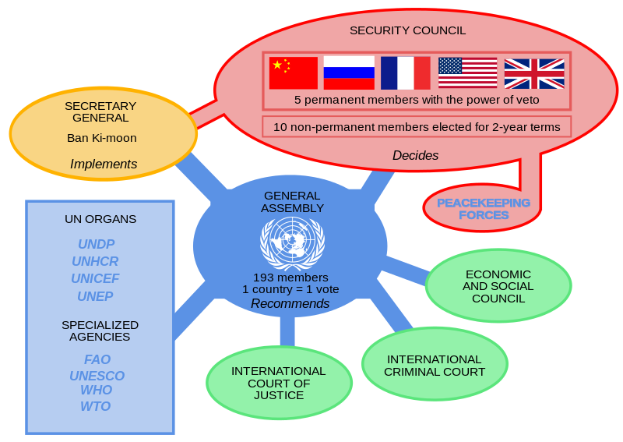

Figure 1: Institutions and organization of the United Nations. *Historicair*. Wikimedia.org. Translated by Jowwww. 1 Nov. 2011. Web. 26 Jan. 2016.

https://commons.wikimedia.org/wiki/File:UN_Institutions.svg



Figure 2: Stephanie McMillan. “Empiricism.” StephanieMcMillan.org. 18 Oct. 2012. Web. 26 Jan. 2016. http://stephaniemcmillan.org/comic/empiricism.

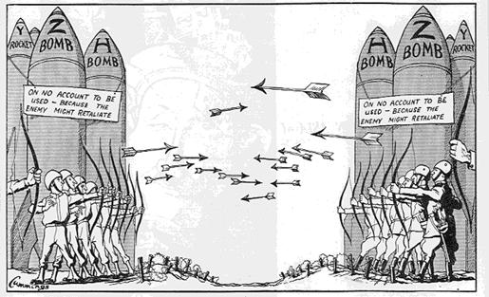

Figure 3: Unknown. Mr. Wiggin’s History Class. Web. 26 Jan. 2016. http://mrwigginshistoryclass.com/home-page/modern-world-history/unit-11-cold-war/11-1-origins-of-the-cold-war/

Works Cited

Brown, Andrew and Lorna Arnold. “The Quirks of Nuclear Deterrence.”International Relations 24.3 (September, 2010): 293-312. Sage Journals. Web. 26 Jan. 2016.

Deterrent. *Oxford Dictionaries*. Oxford University Press, n.d. Web. 27 January 2016.

Duffield, John. “What Are International Institutions?” *International Studies Review*

9.1 (Spring, 2007): 1-22. JSTOR. Web. 26 Jan. 2016.

Dunne, Tim, et al. *International Relations Theories: Discipline and Diversity*. 3rd ed. Oxford: Oxford University Press, 2013. Print.

Huth, Paul K. “Deterrence and International Conflict: Empirical Findings and Theoretical Debates.” *Annual Review of Political Science* 2 (June, 1999): 25-48. Annual Reviews. Web. 26 Jan. 2016.

Kennedy, David. "The Move to Institutions." *Cardozo Law Review* 8.5 (1986-1987): 841-988. HeinOnline. Web. 26 Jan. 2016.

Meyers, Robert G. *Understanding Empiricism*. Durham: Acumen, 2006. *ProQuest ebrary*. Web. 26 January 2016.

Quinton, Anthony. "empiricism." *Encyclopædia Britannica*. Web. 2016. Web. 26 Jan. 2016. http://www.britannica.com/topic/empiricism.