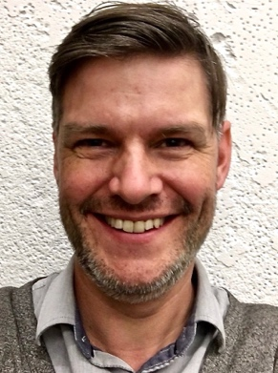 **Tim Tweedale**

#410 – 175 Broadway East

Vancouver, BC

V5T1W2

604-715-2130

[timtweedale@gmail.com](mailto:timtweedale@gmail.com)

_______________________________________________________

|  |  |  |  |  |  |
| --- | --- | --- | --- | --- | --- |
| **Objective** | To obtain a position as Teacher-on-Call with the Vancouver School District that will allow me to apply my teaching skills and expertise in student education and allow me to grow and develop as a teacher. | | | | |
| **Teachable Subjects** | *Specialty*: Music (Instrumental and Theory), Guitar, Ukulele, Country, Blues  *Competence:* English, Literature, Social Studies, Humanities | | | | |
| **Highlights of Qualifications** | * 15 years teaching individual music lessons to children and adults * 10 years of teaching music at camps, workshops, seminars * Enthusiastic * Excellent communication and teamwork skills * Teaching that emphasizes developing well-rounded students * Highly organized with a strong work ethic * Knowledge of computers, music technology, notation software. | | | | |
| **Education** | Anticipated August 2017  2015  1995 | **Bachelor of Education** – University of British Columbia,  Vancouver, BC  **Bachelor of Music –** Vancouver Community College  Major in composition  **High School Diploma** ­– Point Grey Secondary School | | | |
| **Teaching Practicum** | 2017-2018 | 10 week: **Gladstone Secondary School** – Vancouver, BC | | | |
| **Concert band / Jazz band / ukulele class**   * Directed Rehearsals in classroom and concert settings. * Developed lesson and unit plans for bands, choir, guitar, theory,   And historical/cultural components.   * Helped prepare and present the Winter Holiday 2017 concert   3 week CFE - TBA | | | | |
| **Career Related Experience** | 2002–present | | **Private Music Instructor** (guitar, dobro, lap steel, pedal steel, banjo, ukulele) Vancouver, B.C. | | |
| * Individual instruction to children and adults * Preparation for concerts, recordings, college entrance exams | | | | |
| 2002-2003 | | **Performer** in **VCC Gamelan Ensemble** Vancouver, BC | | |
| * Rehearsed, performed, recorded, attended gamelan festival   2001-2002 **Performer in VCC Latin Jazz Orchestra** Vancouver, BC   * Rehearsed, performed, arranged, composed | | | | |
| 2001-present | | **Studio Musician** Vancouver, BC  . | | |
| * Hired to rehearse, arrange, produce, perform on professional and semi-professional recording * Highlights include performing on two albums by Sarah MacDougall (The Greatest Ones Alive, Grand Canyon), both of which won WCMAs | | | | |
| 2002-present | | **Touring Musician**  Vancouver, BC | | |
| * Performed in several successful touring bands * Toured in UK & Ireland, Continental Europe, United States * Toured across Canada, playing folk and bluegrass festival circuit | | | | |
| **References** | Karen V. Lee, Ph.D.  UBC Lecturer /Faculty Advisor  UBC  Faculty of Education  2125 Main Mall  Vancouver. B.C.  V6T 1Z4  604 837 1016  kvlee@mail.ubc.ca | | | Mike Braverman  School Advisor  Gladstone Secondary  4105 Gladstone St, Vancouver, BC V5N 4Z2  (604)418-9172  mbraverman@vsb.bc.ca | CFE sponsor - TBA |