



**Instructor and TA**

**User Guide**



**1.** **GETTING STARTED 3**

**2.** **CLAS USER INTERFACE 4**

**3. UPLOADING AND MANAGING VIDEOS 5**

3.1. FILTERING AND SORTING VIDEOS 7

******4. RECORDING A VIDEO DIRECTLY INSIDE CLAS 7**

******5. DOWNLOADING VIDEOS 9**

**6.** **ANNOTATING VIDEOS 9**

6.1. EMBEDDING LINKS IN ANNOTATIONS AND COMMENTS 10

6.2. VIDEO ANNOTATIONS 10

6.3. CREATING THREADED ANNOTATIONS/COMMENTS 11

**7.** **VIEWING OTHER PEOPLE’S ANNOTATIONS 12**

**8.** **MODIFYING YOUR OWN ANNOTATIONS 13**

**9. SEARCHING 13**

**10.** **ANONYMOUS VIEW AND ACCESS 15**

**11.** **SELF-REGISTER AND SELF-SUBSCRIBE 16**

**12. QUOTA 17**

**13. EDIT VIDEO METADATA INLINE 17**

**14. INSTRUCTOR CONSOLE SECTION 18**

**15.** **CREATE A COURSE (LINKED WITH SIS) OR VIDEO COLLECTION 19**

**16. SHARE CLAS TO EXTERNAL USERS VIA SELF-ENROLLMENT CODES 22**

**17.** **EMBED CLAS IN ANOTHER SITE (CONNECT, WP, MOODLE, ETC.) 25**

17.1. EMBED CLAS INTO CONNECT 26

17.2. EMBED CLAS INTO UBC BLOGS 28

**18. HELP 29**

 GETTING STARTED

**1**

**SOFTWARE:**

Recommended Web browsers:

Chrome

Upgrade to the latest version

Firefox

Safari

Internet Explorer (IE) – Upgrade to the latest version (11) and ensure Compatibility View is turned off (Under Tools -> Compatibility View Settings).

**LOG IN:**

1. Log in with your CWL directly through the CLAS website: <https://clas.ubc.ca>

Some departments may have a customized version of CLAS

* Faculty of Arts: <https://clas.ubc.ca/prod>
* Faculty of Education: <https://clas.ubc.ca/ed>
* Faculty of Medicine: <https://clas.ubc.ca/med>
* Sauder School of Business: <https://clas.ubc.ca/sauder>
* Research Purposes: <https://clas.ubc.ca/experiments>
* Demo/Sandbox sites: <https://clas.ubc.ca/demo>

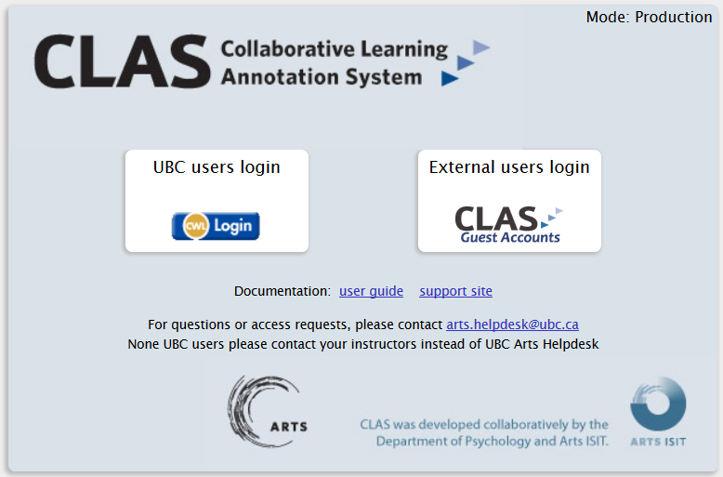

 CLAS USER INTERFACE

**2**

The page to interact with the uploaded videos will look as follows:

**Video List**

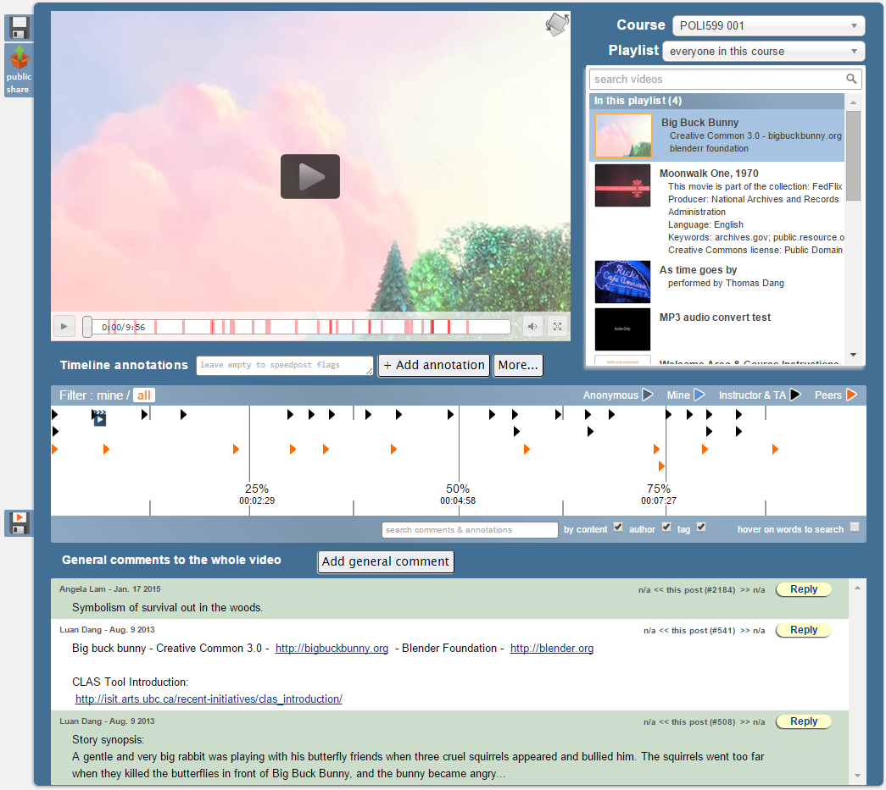

**Comments**

**Trends**

**Provide general comments on the video**

**Video**

**Annotation View**

**Video List -** This option allows you to select and play the video you wish to view and annotate. Once you select the video you wish to view, click on the play button to start the video (Note: it may take a few minutes for the video to load).

**Trends –** The trend line indicates where annotations have been provided in the video. Places in the trend line that are extremely bright indicate there is a high concentration of annotation notes.

**Add General Comments –** This option allows you to provide comments on the video as a whole rather than a specific segment of the video.

**Search** **–** This allows you to search annotations and comments for key words, tags, and author’s names.

At any point in time, you may hover the cursor over the video to bring up the video options. These options include stopping/pausing the video, adjusting the volume, video scrubbing, and viewing the video in full screen mode.

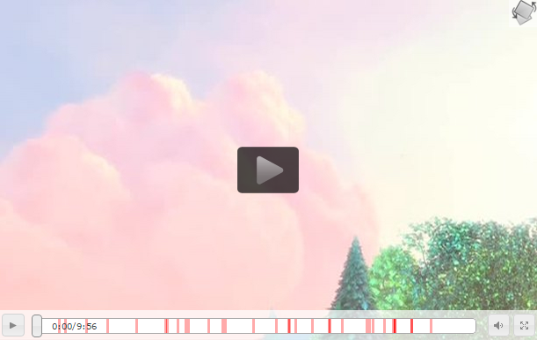

Fullscreen

Scrubbing

Volume

Starting/Stopping

# UPLOADING AND MANAGING VIDEOS

**3**

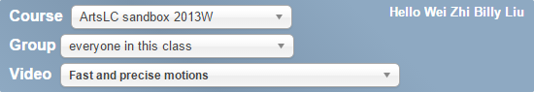

Username



Click on **upload & manage videos**, and then click on **browse** to locate the file you want to upload from your computer. You can upload most major video formats as well as mp3 audios (for lecture recordings).

**Note:** MP3 audios will be automatically converted to a video with an “audio only” screen. Only mp3 uploads are supported at the moment. For other audio formats (wav, ogg, wma, etc.), please convert them beforehand to a video before uploading to CLAS.

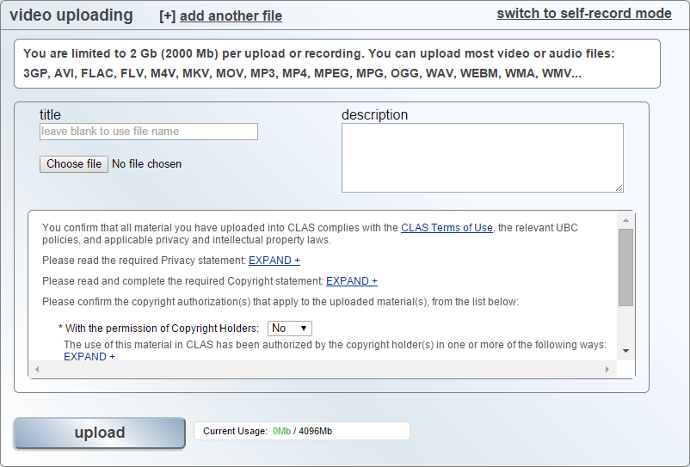

A spinning wheel will appear indicating that the video is uploading. Remember not to close the browser or press the back button at this point. After the video is finished uploading, it may take up to a few hours to convert, depending on the file size. It usually takes approximately 1 hour to convert a 100MB video. The file will appear in the list of videos once it is done converting.

Now, you will need to assign the videos to your class by clicking on the drop down menu and choosing the correct group to assign to.

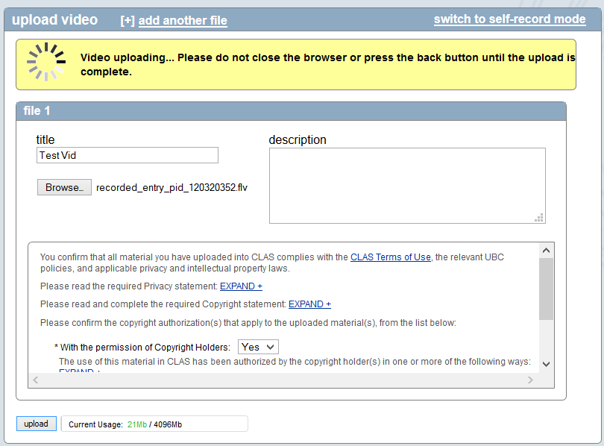

## 3.1. FILTERING AND SORTING VIDEOS

In the **Admin tab**, you can filter the videos by **Course** as well as by the **Groups** that have been created.

**Filter by group**

**Filter by course**

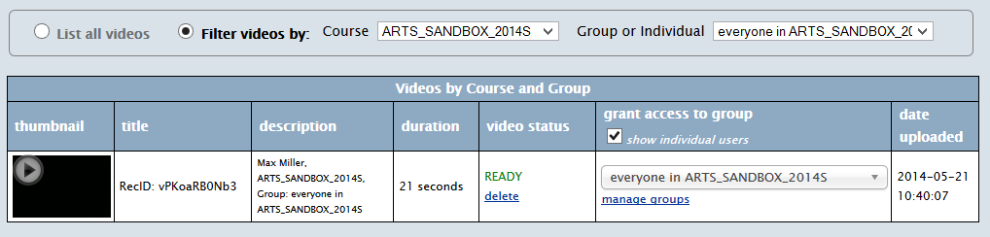

Under the “Grant Access to Group” menu, you can choose which group to make your video available to. You can also choose to make it available only to certain people within the group, such as TA- and instructor-only. Videos that have not been assigned to a group will appear in a separate “Videos Unassigned to Groups” column.

# RECORDING A VIDEO DIRECTLY INSIDE CLAS

**4**

In the Upload & Manage Videos tab, there is a built-in recording widget that allows users to record a video directly within CLAS and have it automatically uploaded to the video management page. *(Note: This self-record functionality works on all platforms—iPad, mobile devices, etc.)*





**Switch between file upload and self-recording**

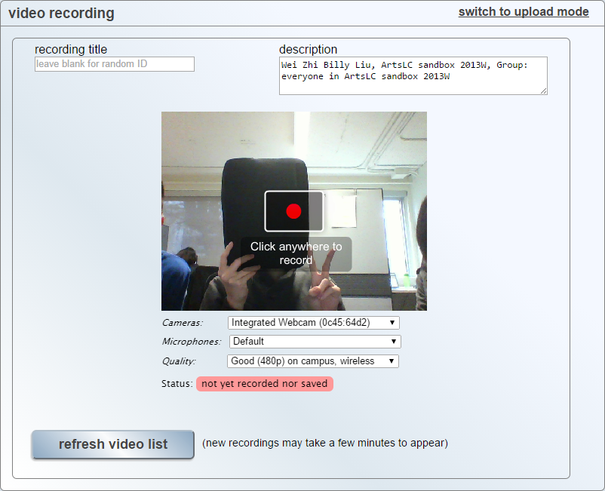

**Automatic metadata added to the title and description to shorten recording workflow**

**REQUIREMENTS:**

* Upgrade to Flash 11.9+ (<http://get.adobe.com/flashplayer/>)
* On iPhone/iPad, enable microphone access for your browsers (settings 🡪 privacy 🡪 microphone)

# DOWNLOADING VIDEOS

**5**

Users with admin access can download the original formats of the videos within CLAS.

(***Note:*** *Students cannot download videos unless granted admin access.)*

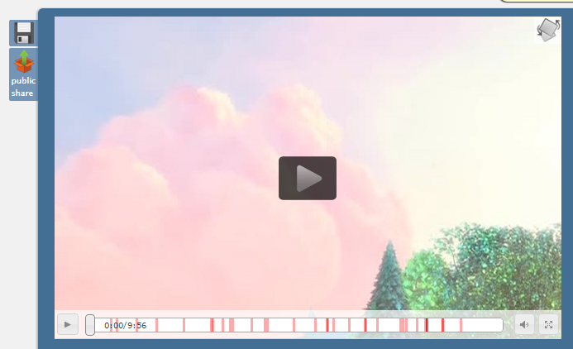

# ANNOTATING VIDEOS

**6**

Click on the “Add Annotation” button and a window will appear on the right side of the video. You can pause the video while annotating or you may leave the video playing.

**Private Option**

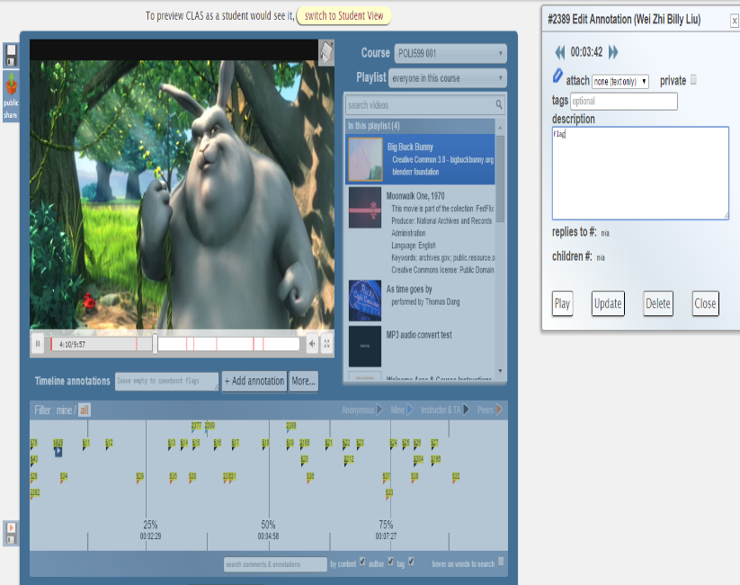

**Adding tags**

**Text/Video Annotation**

**Annotation Notes**

**Annotation Button**

*An arrow mark (blue color) will be made at the place you first pressed the annotation button.*

**Tags –** You can attach a unique keyword or term to allow it to be found later by browsing or searching for the tag.This feature will also allow you to search for all videos that may be tagged with this unique keyword or term.

**Private –** Check marking this box will make your annotations not accessible by other students.

**Text/Video Annotation –** You can select to add a text annotation or a video annotation

**Description –** This box is where you can provide annotation notes.

**Save** **–** Make sure to save your annotations!

## 6.1. EMBEDDING LINKS IN ANNOTATIONS AND COMMENTS

Web links added in annotations or general comments are now automatically turned into a clickable link. The link will open in a new window.

* **Note:** The link must start with **http://**

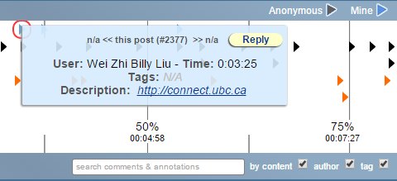

## 6.2. VIDEO ANNOTATIONS

Annotations and comments can be added as **videos** in addition to text. When adding an annotation or comment, choose “video” to record a video of yourself directly within CLAS.

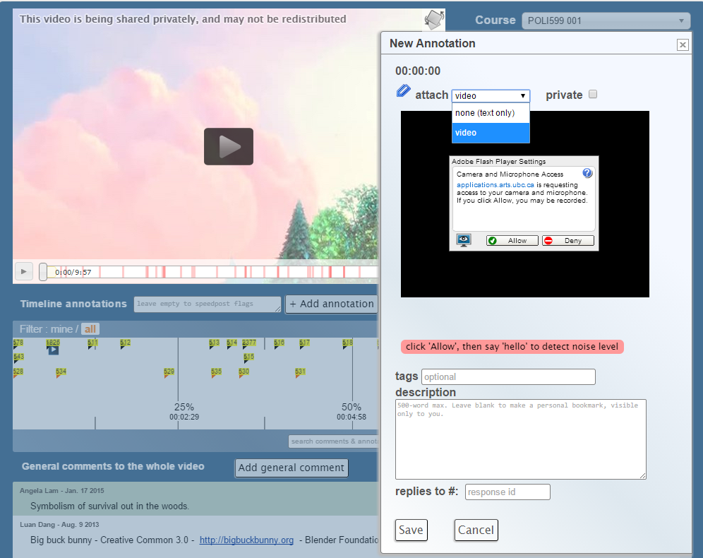

## 6.3. CREATING THREADED ANNOTATIONS/COMMENTS

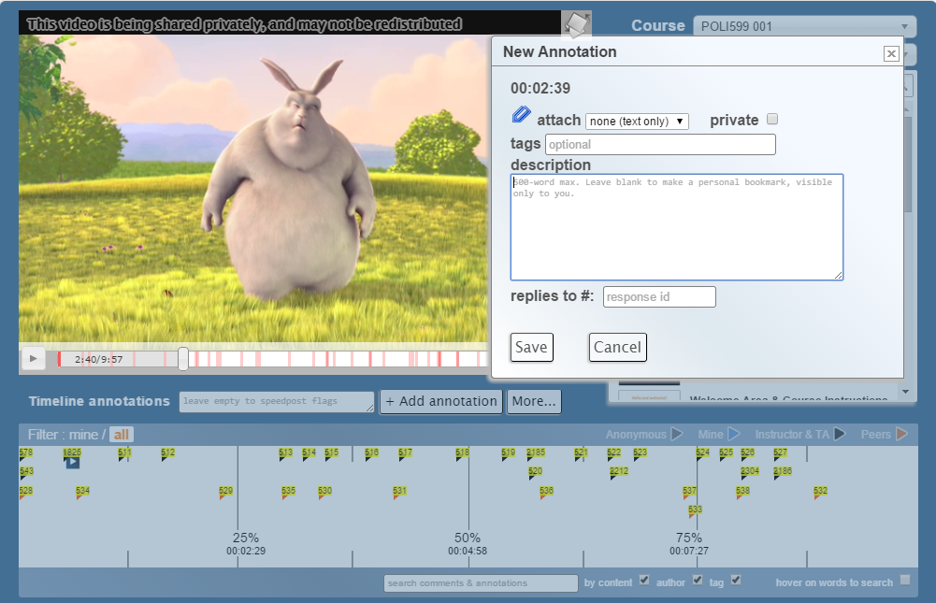

**Response ID**

To create threaded annotations or comments, find the **response id** of the original annotation/comment you are replying to (i.e. #9743) and enter it in the “**replies to #”** field of your annotation or comment.

To find the **response id**, hover over an annotation or comment.

**7**

 VIEWING OTHER PEOPLE’S ANNOTATIONS

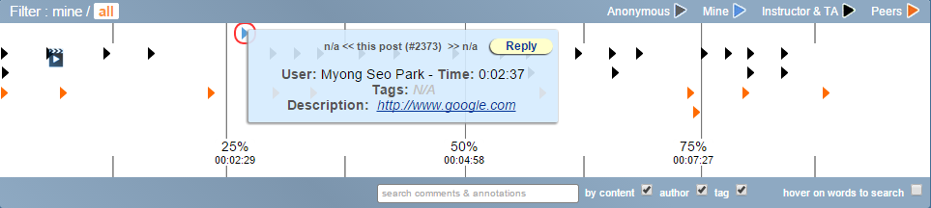

**Annotation Legend**

**Annotation View** – You can change the annotations you want to review by selecting between **“mine” or “all”**

* “Mine” 🡪 your annotations
* “All” 🡪 everyone’s annotations

Click on any annotation and the annotation information will appear on the right hand side.

The color of the annotation arrow indicates the user’s status:

* **GREY** – anonymous annotations (if feature is enabled)
* **BLUE** – your annotations
* **BLACK** – Instructor/TAs
* **ORANGE** – peers (students)

# MODIFYING YOUR OWN ANNOTATIONS

**8**

To modify your own annotations, click on the blue annotation arrow and it will appear on the right hand side.

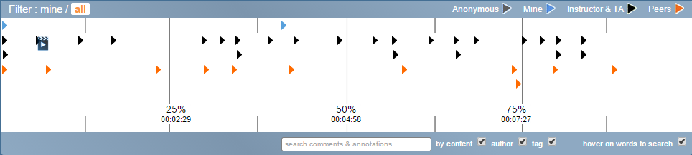

**Your own annotations**

**EDITING OPTIONS:**

1. Start and end time of annotation: click on the fast forward or rewind buttons beside the “start” times
2. Tags and description: simply remove or add content
3. You can delete your annotation by clicking on “delete”, or save the updated changes by clicking on “update”.

# SEARCHING

**9**

When the “Auto-Search” function is checked, users can hover over a specific word within the annotations and all the comments and annotations that have used the same word will be highlighted in green. Partial matches are highlighted in a lighter green.

* You can also choose to search either by content, author, or tags, both using the *manual search* box or the *auto search*.

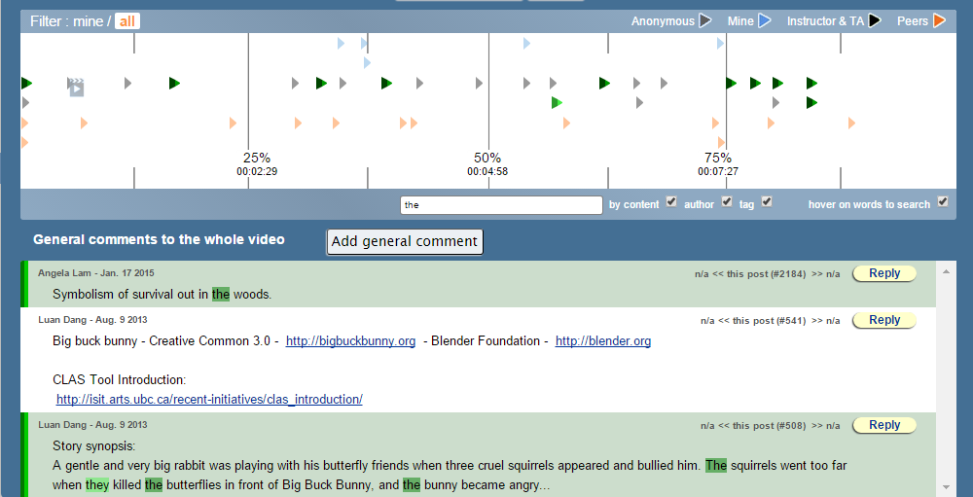

*Example: The word that is being hovered over is “****test****” (a trivial example to make the highlighting easier to see on the small screenshot). All corresponding annotations or comments that have used that word are highlighted in green. Partial matches are highlighted lighter, such as the word “testing”.*

Hovering over **usernames** will search specifically for annotations and comments made by that user:

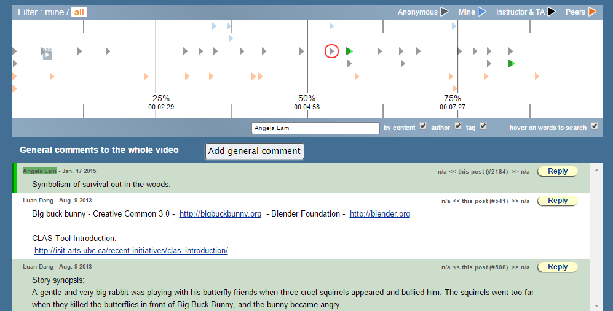

**10**

 ANONYMOUS VIEW AND ACCESS

CLAS sites can be set to be viewable by the public (users without CWLs). By clicking on the **public share** icon on the sidebar, you can choose to share either the entire playlist or only the video. There are also options to allow anonymous viewers to post comments and annotations, and allow students to download the video.

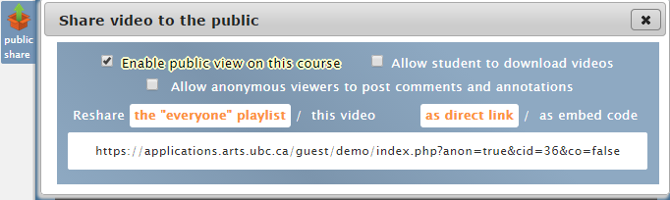



**110**

SELF-REGISTER AND SELF-SUBSCRIBE

Users without CWL accounts can create a CLAS Guest Account to access courses. If you would like this feature enabled for your CLAS site, please send a request to [arts.helpdesk@ubc.ca](mailto:arts.helpdesk@ubc.ca)

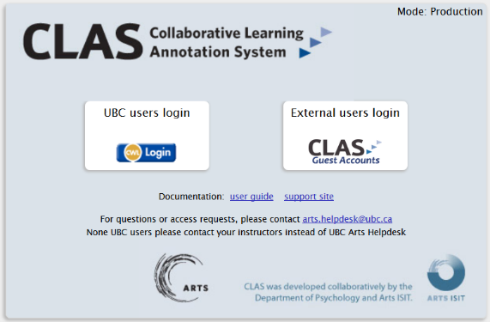

# QUOTA

**12**

Quota refers to the total number and size of files that each user can upload. Quotas are predefined based on a user’s role in the course:

* **Instructors: 400GB / 2000 Files**
* **TA: 400GB / 2000 Files**
* **Student: 10GB / 100 Files**

**Note:** video responses (annotations or comments) do not count towards a user’s quota. Your quota can be found in the “Admin & Upload” page:

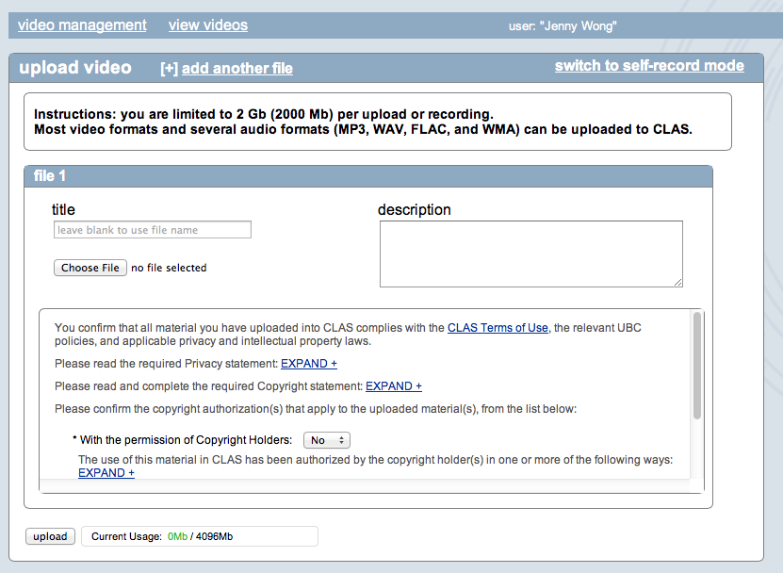

# EDIT VIDEO METADATA INLINE

**130**

You can now easily edit video metadata in CLAS by clicking the title or description text, which can be accessed by clicking **Upload & Manage Videos** in the toolbar.



Mouse over the title or description you want to edit.

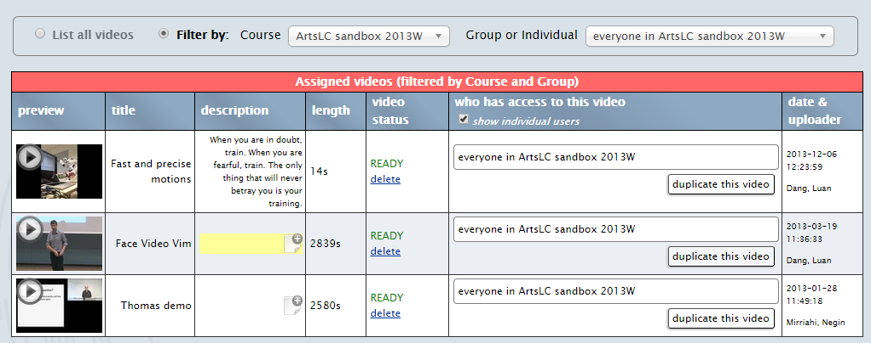

Click inside the title or description box to bring up the yellow editing area.

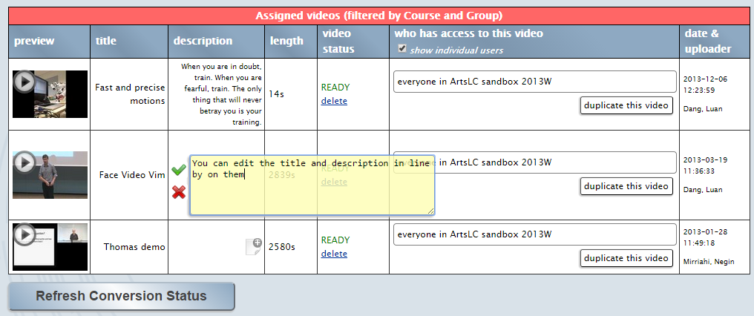

Click on the Green checkmark when completed or the red X to cancel. 



# INSTRUCTOR CONSOLE SECTION

**140**

To access the instructor console, click on **Manage Courses and Collections** on the toolbar.



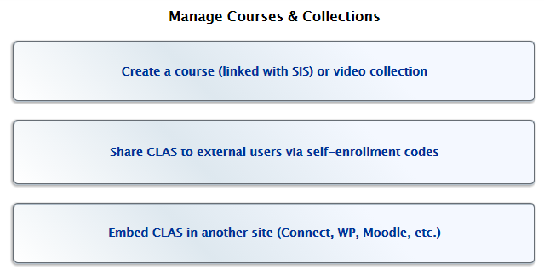



**150**

# CREATE A COURSE (LINKED WITH SIS) OR VIDEO COLLECTION

1. Click on “**Create a course (linked with SIS) or video collection**”

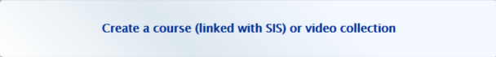

1. You can create two types of CLAS sites:
   * **Course Collection (auto enrollment list from SIS)**: linked to an SIS course
   * **Standalone Collection**: not linked to an SIS course
2. If you select **Course Collection (auto enrollment list from SIS)**, fill in the following fields:  
     
   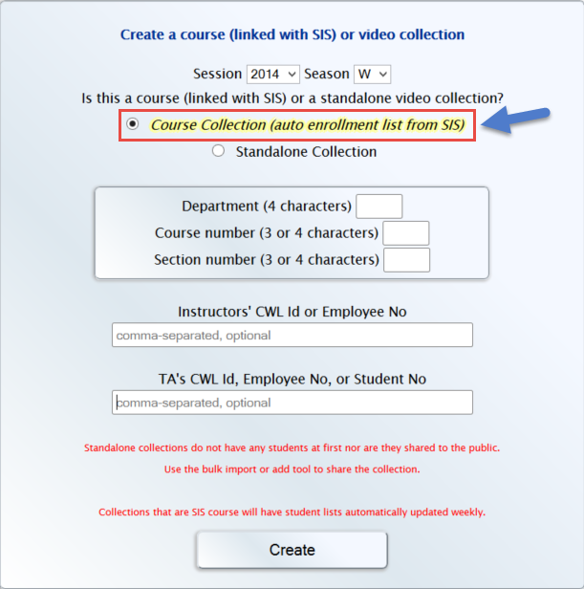

* **Session**: the year the course is offered (e.g. 2013)
  + **Season**: choose between summer or winter term (e.g. W)
  + Type in the **department code** (e.g. GRSJ), **course number** (e.g. 224C)**,** and **section number** (e.g. 001)
  + The title of the CLAS site will become: “GRSJ224C_001_2013W”

1. If you select **Standalone Collection,** type in a course name of your choice.
   * Note: spaces cannot be used, use underscores (_) instead
2. Enroll the instructor(s) and TA(s) that need access by typing in their CWLs/employee #/student #.
3. Click on “**create**” to create the CLAS site.
4. You will see a page that confirms the course has been created successfully. Check to ensure everything is green similar to what is seen below:

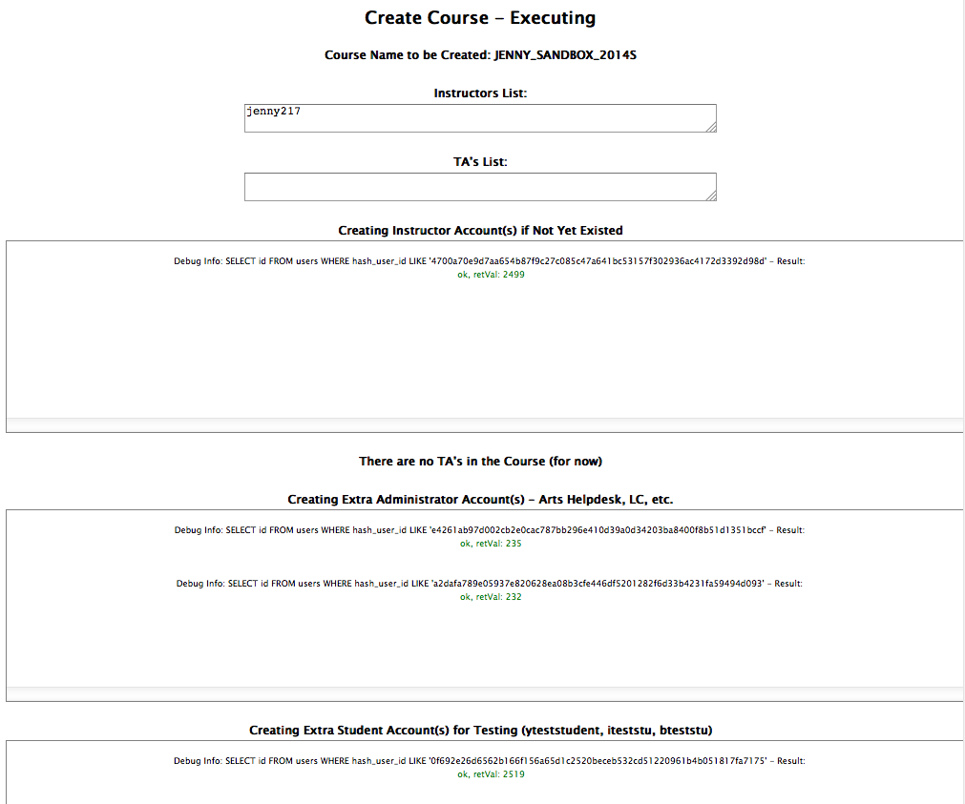

You will also see a message on the bottom of the page: **“Course Creation Successful!”**

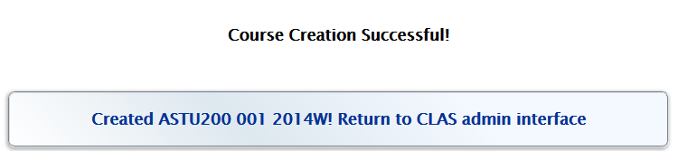

1. Return to the CLAS admin interface by clicking on “**Created [course name]! Return to CLAS admin interface**” at the bottom of the page.

# SHARE CLAS TO EXTERNAL USERS VIA SELF-ENROLLMENT CODES

**160**

1. Click on “**Share CLAS to external users via self-enrollment codes”**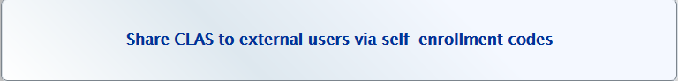
2. Choose the course
3. Fill in the following fields:  
   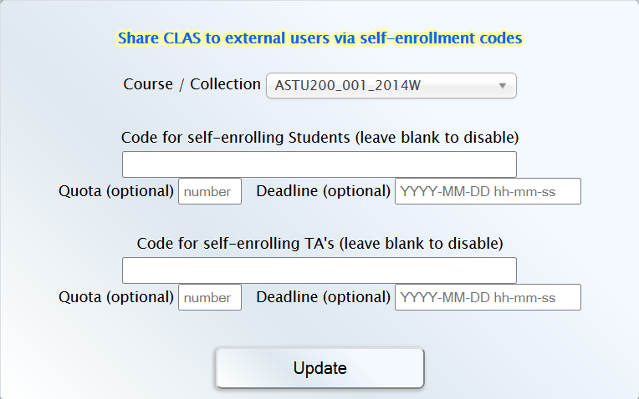

* **Code for self-enrolling Students / TA’s:** the code to give to students
  + **Quota (OPTIONAL):** The option to limit the number of enrollments to your course (if this field is blank, the number of enrollments allowed is infinite)
  + **Deadline (OPTIONAL):** the deadline for students or TA’s to enroll in your course

1. Click on “**Update**”  
   C:\Users\jansenle\AppData\Local\Microsoft\Windows\INetCache\Content.Word\21.png
2. Check to see settings are correct  
   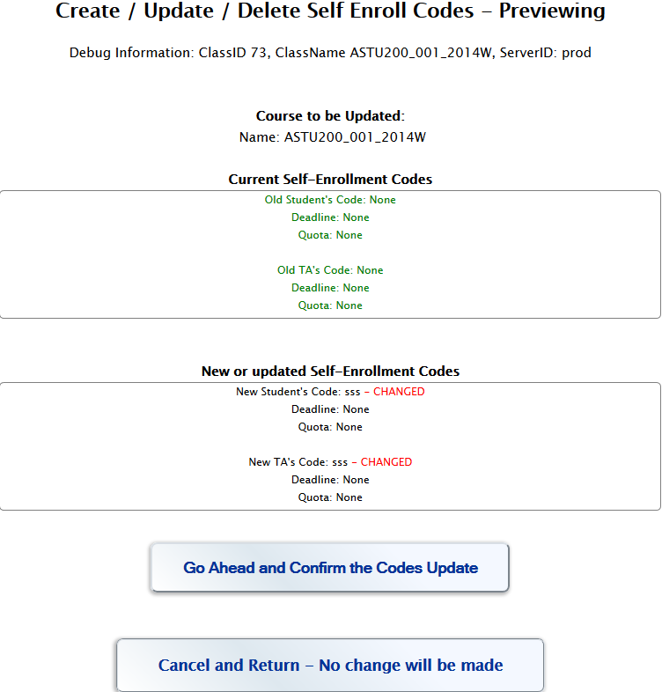
3. Click “**Go Ahead and Confirm the Codes Update**”  
   C:\Users\jansenle\Desktop\CLAS SS\32.png
4. Check to make sure everything is **green**  
   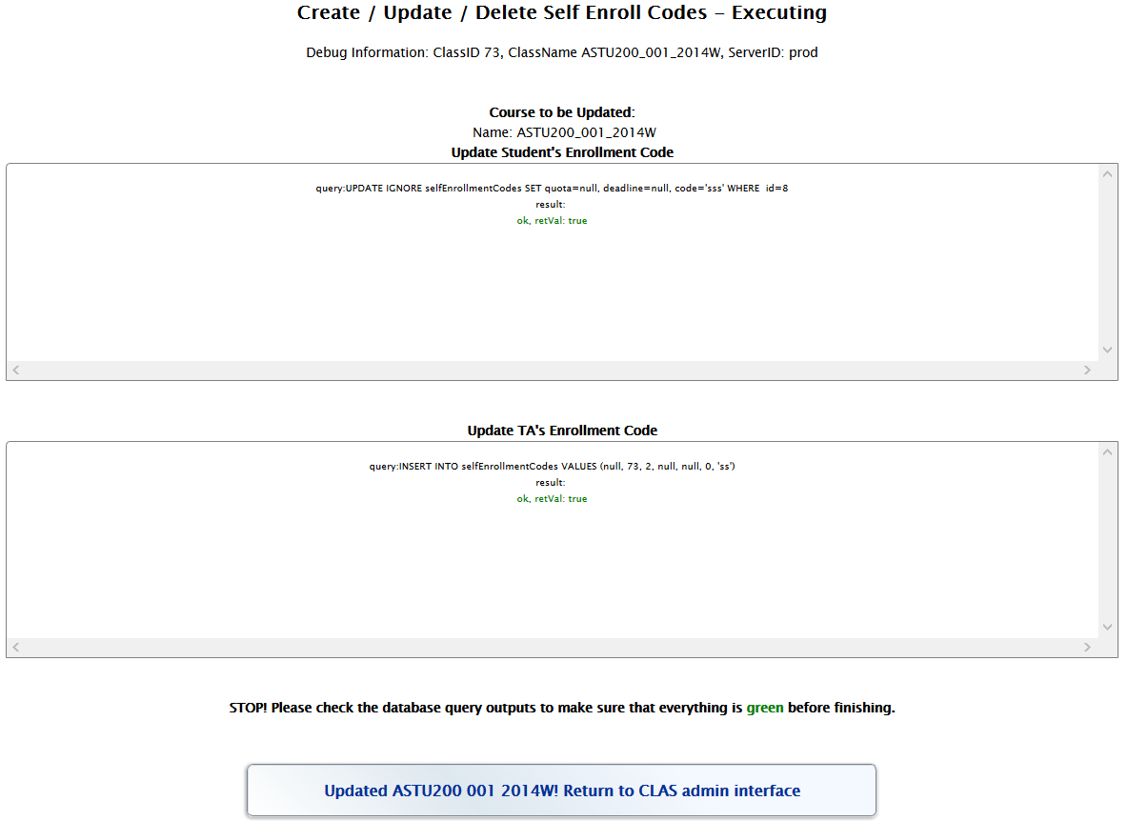
5. Click “**Updated COURSE_NAME! Return to CLAS admin interface**”  
   C:\Users\jansenle\Desktop\CLAS SS\34.png
6. Return to “**Share CLAS to external users via self-enrollment codes”**
7. The interface will now be updated with the self-enrollment codes you have entered as well as the invitation links.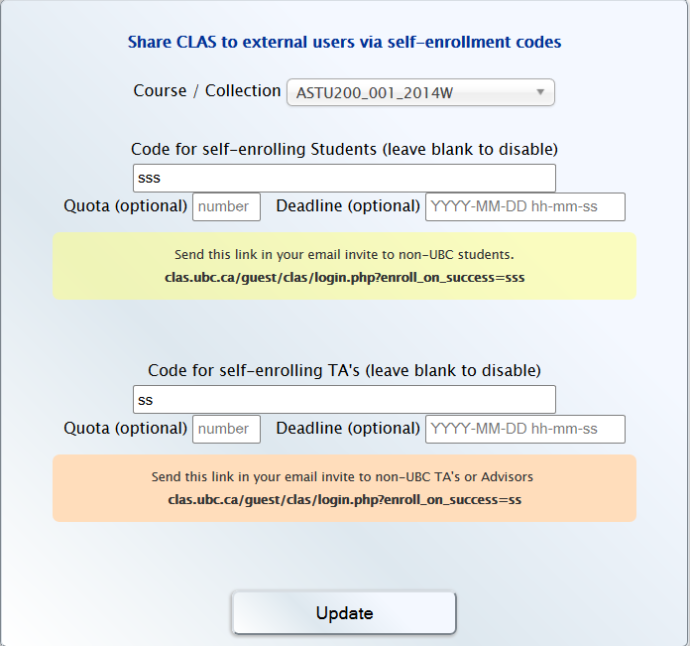

The enrollment-code can be distributed to students or Guest Accounts for them to access the respective course. Alternatively, you can distribute the invitation link.



**170**

# EMBED CLAS IN ANOTHER SITE (CONNECT, WP, MOODLE, ETC.)

You can now embed CLAS within the “Connect” Learning Management System and UBC Blogs/CMS. Students no longer need to remember an extra website and log in twice.

1. Click on “**Embed CLAS in another site (Connect, WP, Moodle, etc.)”**
2. Choose the course
3. Select the appropriate option:

* Allow both commenting and annotation
* Commenting only, no annotation
* Video only, no commenting or annotation

The embed code will change according to the option you select.  
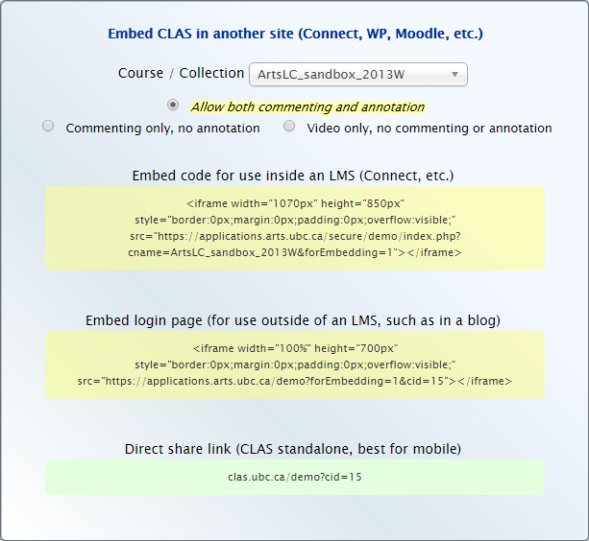

1. Copy the embed code according to which platform you are trying to embed into:

* Embed code for use inside an LMS (e.g. **Connect**)
* Embed login page (for use outside of an LMS, such as in a **blog**)
* Direct share link (CLAS standalone, best for **mobile**)

## 17.1. EMBED CLAS INTO CONNECT

1. Log into your Connect course you want to embed in at [elearning.ubc.ca/connect/](http://elearning.ubc.ca/connect/)
2. Hover over the **“+”** located on the top-right and click on “**Content Area**”  
   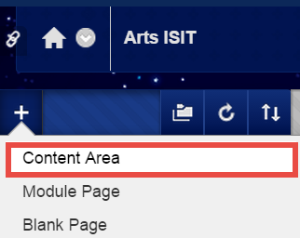
3. Give it a Name called CLAS, check “Available to Users” and click Submit.  
   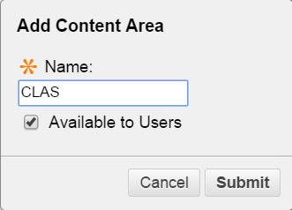
4. Click into the Content Area you just created found on the left navigation menu.  
   C:\Users\jansenle\Desktop\CLAS SS\38.png
5. Hover over “**Build Content**” and select “**Item**” 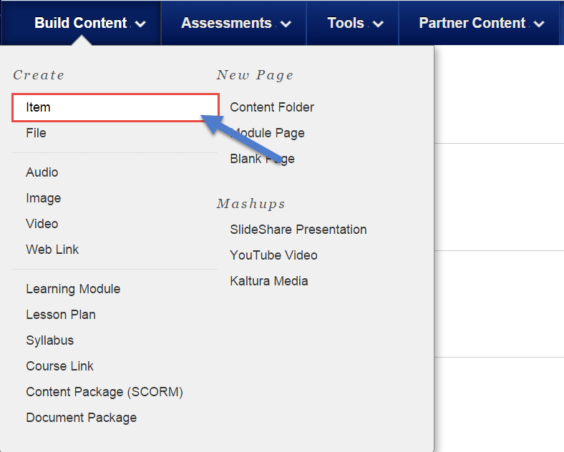
6. Enter a Name for the item in the “Name” section and Click on “**HTML**” icon under the “Text” section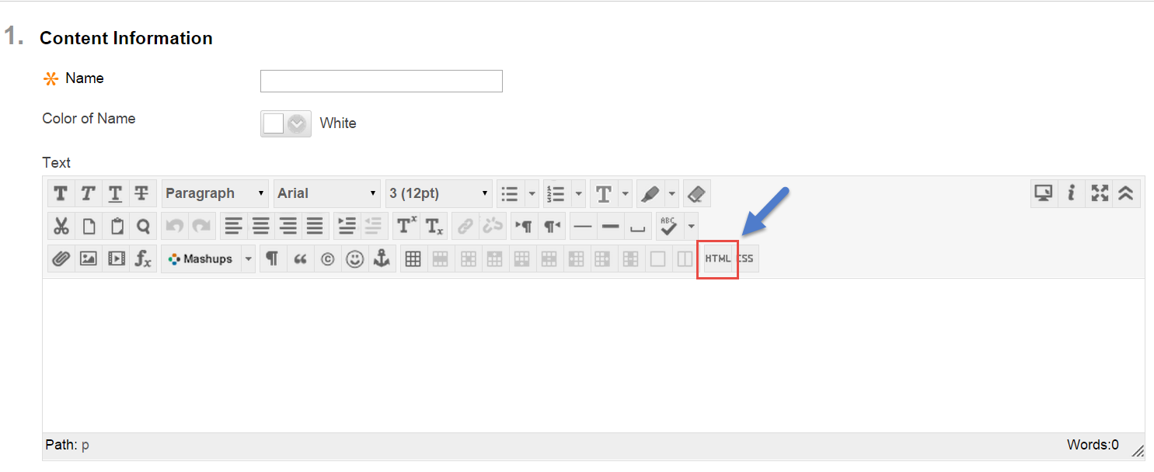
7. Paste your embed code into the HTML text area and click “**Update**”  
   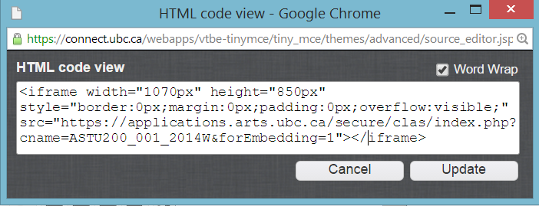

Click “**Submit**”  
C:\Users\jansenle\Desktop\CLAS SS\submit.png

## 17.2. EMBED CLAS INTO UBC BLOGS

* 1. Log into UBC Blogs at [blogs.ubc.ca/](http://blogs.ubc.ca/)
  2. Click on “**Dashboard**” in the UBC Blogs site where you want to embed   
     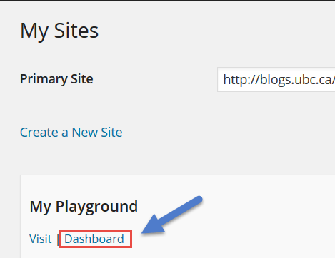
  3. Click on “**Pages**” on the left navigation menu and click on the page you want to embed CLAS into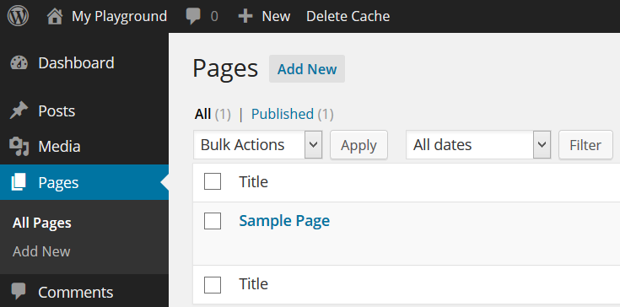
  4. While in the “Edit Page” mode, make sure you select the “**Text**” tab on the top-right.

In the text area, paste your Embed Code

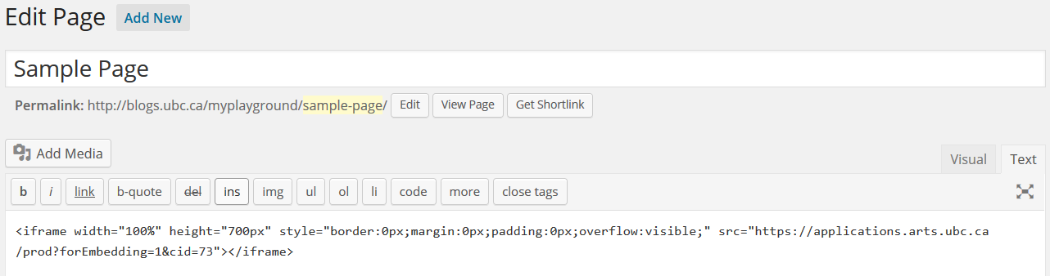

* 1. Click on “**Update**”  
     C:\Users\jansenle\Desktop\CLAS SS\update.png

If your CLAS course is a standalone course, the best option is to share your course via “Direct Share Link”, found at the bottom.

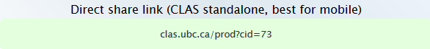

# HELP

**180**

If you have any questions or problems with CLAS, please email: [arts.helpdesk@ubc.ca](mailto:arts.helpdeks@ubc.ca)