Matthew, Jennifer, Johanna, Mary & Shelley

EDCP 320 Group Teaching Assignment: Grade 1 Gymnastics
Presentation Date: October 8th

Resources:
-Community Centers
-Specialized Gyms
-CAN (canucks autism network)
-Special Olympics
-Gymnastics Schools

Safety Concerns:
-Paying attention
-Following instructions
-Hazards: Slippery floors, broken glass
-Matts are properly in place relation to the benches, velcroed together ensuring no gaps and hazard free.

Prescribed Learning Outcomes:

Active Living | Movement Skills | Safety, Fair Play and Leadership
Identify the parts of the body that can work together during physical activity. | Move through general space while maintaining control. | Describe why safety guidelines for physical activity are important.
Identify choices they can make to be more physically active | Change level of body position while maintaining control. | Respond appropriately to instructions and safety guidelines when participating in physical activity.
Identify physical activities that they feel they did well. | Demonstrate proper technique for performing specific locomotor movement skills.
Participate daily in moderate to vigorous physical activities.

Management & Organizational Strategies:
Organizing the group into a large circle for the warm up.
Breaking them into smaller groups for the essential movements.
Utilizing a whistle as well as music to signal transitions.

Assessment and Evaluation:

Gymnastics Rubric Grade 1:

Aspect: | Approaching Expectations | Meets Expectations | Fully Meets Expectations | Exceeds Expectations
Balancing | Able to balance with help | Able to balance on your own (wobbly) | Able to balance on your own without wobbling | Able to balance on your own while standing on one foot without wobbling
Rolling | Able to begin a roll without help | Able to complete a roll with help | Able to complete a roll without help | Able to complete more than one type of roll (log and forward) without help
Jumping | Able to jump | Able to jump and land on two feet | Able to jump and land on two feet with bent knees | Able to jump and land on two feet with bent knees from a small height
Participation | Able to follow instructions sometimes with help  Still learning how to move in free space | Able to follow instructions most of the time with help  Still learning how to move in free space | Able to follow instructions all of the time without help  Has learned how to move in free space | Able to follow instructions all of the time with no help  Has learned how to move in free space

Gym Setup:
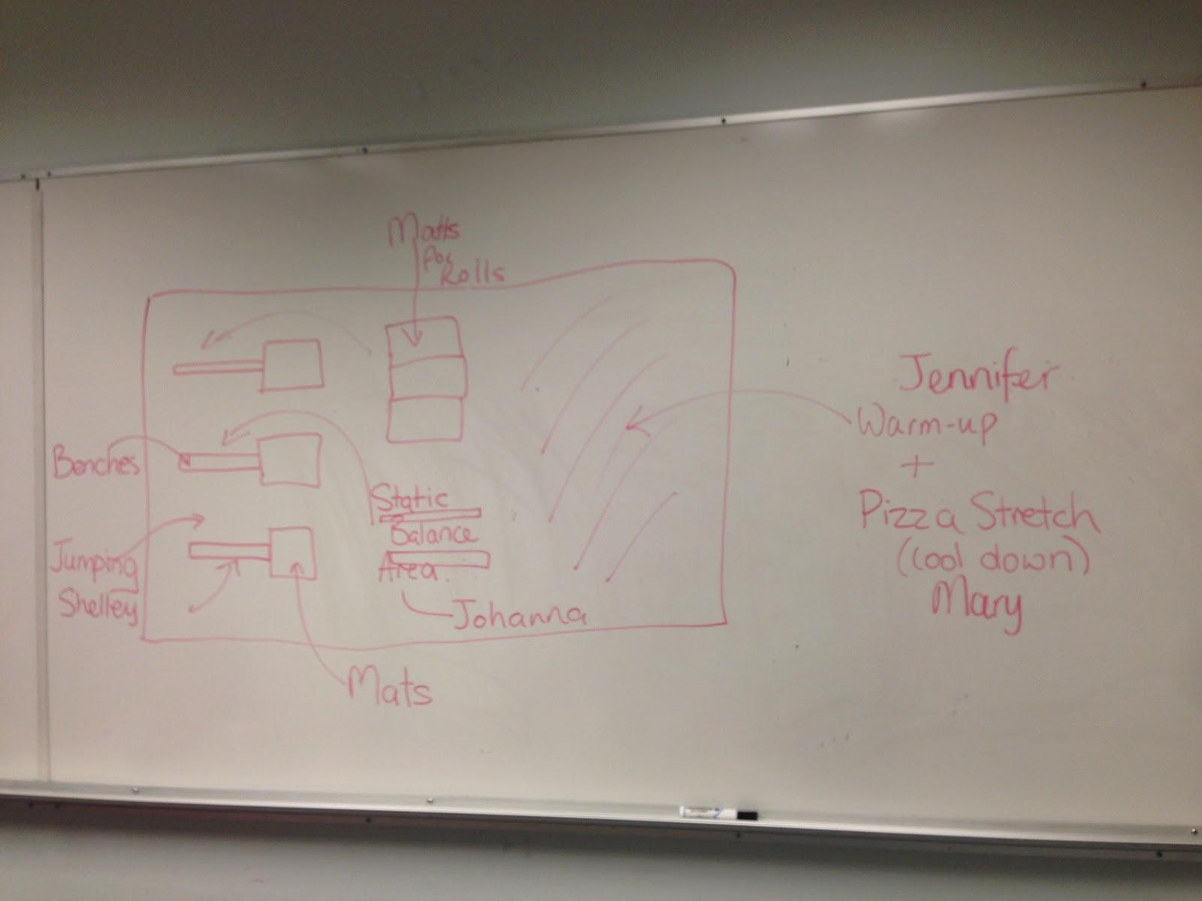

Lesson Plan
Skill Theme: Basic gymnastic skills.

Lesson: 1 of 1 Grade: 1 Class Length: 20 min # of students: 25

Equipment Needed:
-Mats
-Benches
-Speakers/Music
-Whistle

Objectives:
Students will be able to demonstrate proper technique for basic jumping, balancing and rolling skills.
Evaluation: Teacher observation of students looking for jumping balancing and rolling skills. Student self assessment.

Identify the parts of the body that can work together during physical activity.

Evaluation: Teacher asks questions verbally at the end of the class following the cool down activity.

Respond appropriately to instructions and safety guidelines when participating in physical activity.
Evaluation: Teacher observation of students throughout the lesson.

Entry Activity: None for this class.

Movement Experience | Organization | Teaching Points

- Warm Up/Shape of the Day (Total Time: 5 min): Jennifer & Team

Running on the spot | In a circle | - to gradually build up your speed (when running)
Jumping Jacks | In a circle | - to to learn proper jumping techniques with knees bent, feet hip width apart  - to improve jumping abilities
High Knees | In a circle | -to gradually build proper form and body position
Bum Kicks | In a circle | -to gradually build proper form and body position
Donkey Kicks | In a circle | -to gradually build proper form and body position

- Skill Development (Total Time: 2 min each = 6 min total): Matt, Shelley & Johanna

Balance | Divided into three smaller groups. Using benches. | Balancing on one leg in a variety of positions. Limit wobbling.
Rolls | Divided into three smaller groups. Using mats. | Forward rolls and log rolls. Proper form, how to be safe.
Jumping | Divided into three smaller groups. Using benches. | Landing properly with knees bent

- Skill Application (Total Time: 4 min): Matt, Shelley, Johanna, Mary & Jennifer

Combined course using all skills practiced during the course of the lesson. Step up onto benches, travel along bench to middle, stop and do a static balance, continue to end of bench, jump off and land properly, do a roll. | Each group gets one bench and one mat placed at the end of the bench. | Ability to utilize previously learned skills (balance, jumping and rolling) and apply to a consecutive routine.

- Self Assessment/Pizza Stretch/Review (Total Time: 5 min): Mary & Team

Self Assessment: Each student receives a sticker with his or her name on it. Following the Skill Application activity students assess their overall performance on the rubric board.
Pizza Stretch: spread the dough; add pizza sauce; sprinkle the toppings; open the oven, put in the pizza; twist the timer; hold for 10 seconds and count down.
When pizza is finished, beep beep beep, put it on the ground, cut the pizza, eat it (face forward and down).
Review:

Q.Who can review what we did today?
A. Repeat lesson

Q. What muscles or body parts did you use today?
A. Variety of demonstrative answers (legs, arms, whole body, etc.)

Q. What IB learner profile did you demonstrate today?
A. Principled, Balanced, Risk taker, Caring, Communicator

Q.How can you use these skills outside of school?
A.On the playground, balancing on logs, jumping over puddles

Differentiated Instruction

Accommodations and/or modifications:  Balance: Utilizing lines on the gym floor instead of benches.  Forward Rolls: Rolling sideways on shoulders or practice getting into rolling position (feet over head and half roll).  Jumping: Jumping on the floor rather than on the bench. | Extensions:  Balance: Using a narrower beam (flip the bench upside down), raising balance height and with an apparatus (ball, balance beam).  Rolls: Somersaults, consecutive rolls and backwards rolls.  Jumping: Increasing height and distance. targeted jumping and using a trampoline.

Additional Resources:
http://jumpgymnastics.ca/ A non-competitive Kids Developmental Gymnastics School with branches in Yaletown and North Vancouver
http://www.phoenixgymnastics.com/ A not-for-profit developmental gymnastics gym located near Queen Elizabeth Park focusing on recreational gymnastics, including classes for Elementary students.
http://vancouver.ca/parks-recreation-culture/community-and-cultural-centres.aspx Vancouver’s webportal for local community centres, some of which offer gymastics programs and / or gymnastic themed drop-in programs throughout the city.
http://www.canucksautism.ca/ CAN (Canucks Autism Network) provides recreational, sports, social and vocation development programs for individuals and families living with autism.
http://www.specialolympics.bc.ca/what-we-do/sports-programs Special Olympics provides sports programs and competitions including gymnastics to children and adults with intellectual disabilities to gain confidence, skills and friendships.

