EDCP 320 Lesson Plan for October 13, 2015
Group: Matt Coady, Eric Hua, Krystal Rajan, and Samantha Weaver

Lesson/Activity Theme: Invasion Games/Teaching Games For Understanding
Grade Level: Grade 7
Number of Students: 32

Class length: 30 minutes

Equipment: Hoops, Foam Blocks, Gator Balls

Aims and Objectives:
Objective:
Introduce Invasion Games:
Invasion Games are a game where the goal is to move an implement into the opposing teams goal and successfully attack their area. Also called Territorial Games. The most common examples include hockey, handball and soccer.
- Attacking a goal – taking risks
- Defending a goal – getting back to the base as soon as possible
- Communicating as a team
Students will be introduced to a new game, Praire DogPick-Off (We call it Space
Invaders to fit the theme), using the Teaching Games for Understanding Model –
students will be able to learn the basic strategies of all invasion/territorial games

Learning Goals:

Affective –
Students will demonstrate teamwork to score points and guard the target.
Students will be able to communicate with others by calling out names.
Involve others as they develop strategies to pass the ball in the playing area.
Students will value their individual various skills of blocking, catching, and passing
Evaluation –
- Teacher will observe the students being able to work together/communicate in teams
- Teacher will observe all students active involvement in the game as part of the team. Everyone should be able to be a part of the team based on their strengths as catchers, passers, blockers.

Motor –
Students will demonstrate effective guarding of pins by moving quickly, efficiently and gracefully to stop the ball from hitting their foam pin/target. Students will practice their hand-eye coordination skills.
Students will successfully pass the ball to other players using underhand throwing techniques
Students will successfully catch the ball to complete the passes
Students will be able to locate and move into open spaces to make yourself available for a pass
Students can effectively hit the targets by throwing or rolling the ball
Evaluation –
- Teacher will observe students effectively passing the ball over long or short distances
- Students can use underhand throwing techniques only to catch the ball.
- Students will be able to move quickly to block targets, using a variety of movements (hopping, zig-zag, pivoting) and body parts (hands, feet).
Cognitive –
Students will be able to demonstrate effective “play-making strategies” by passing the ball to others and knocking down pins of the opponent.
Students will follow the basic rules of the game – do not go cross over hoop boundaries, do not take more than three steps with the ball, do not throw overhand.
Students will be able to connect the rules of this game as a building block of understanding for other invasion games (hockey, basketball, soccer).
Evaluation –
- Teacher will observe the students ability to organize themselves/the group into strategic positions to pass the ball and work together to hit the target.
- Teacher will ask for verbal understanding of plays/strategies.
- Teacher will check for understanding verbally to discuss similarities between this game and other common sport games (hockey, soccer, basketball)

Safety Considerations:
- Play with large foam balls to minimize injury
- Large space to allow for area to run safely
- Staying within the boundaries of the game, do not trip on hoops or go out of bounds
- Throw underhand
- Always be aware. Do not introduce more balls into play if the group is not all ready

Prescribed Learning Outcomes:
- Demonstrate physical literacy to be able to block the ball and protect the target
- Demonstrate alertness as difficulty of game increases with more or less balls in play
- Demonstrate proper catching and throwing techniques at various distances
- Demonstrate team work in an active environment

OUTLINE: SPACE INVASION GAME THEME

Introduction: Krystal (2 minutes)
- BLOW ONE WHISTLE
- Welcome students to class and recognize we are guests conducting our lesson on the traditional, ancestral, unceded territory of the Musqueam people
- Go over schedule for the day: Warm-Up/Teach a brand new game/Practice/Play for 15 minutes or until one team wins/Cool-down stretches with hula hoops/Modified Carousel Reading Discussion
- Explain age group/level of understanding we assume they have (able to catch and throw and react quickly)
- Explain whistles as use of class management. One means stop and listen. Two means begin/resume playing.

Instant Activity *Space Ship Captain*: Eric (10 minutes)

- BLOW ONE WHISTLE
- Divide into 3 lines using number system– Hold hands and walk single-file.
- Follow Eric’s lead into the gym/field
- Explain Space Ship Captain:
  - Goal – Warm up by increasing heart rate.
  - Goal – Practice physical literacy and stretches through creative movement
  - Goal – Practice finding strategies for open spaces quickly
  - Goal – Practice mental alertness by following instructions
- Each corner of the field is a different area of the space ship and we are being INVADED! Follow Eric’s instructions as you work hard to defend the gym and meet interesting characters along the way.
- Each character has a specific body movement to copy
- Every time we move stations we walk differently (lunges, hopping, skipping,
dancing, lunges)
- BLOW TWO WHISTLES TO BEGIN. BLOW ONE WHISTLE TO STOP.
- Check heart rates – explain that we effectively raised our heart rates and now we are warmed up, stretched out and ready to play the game
- Go sit down on the center line of the gym.

Main Physical Literacy and Health Lesson:

Introduction: Sam

- Introduce Space Invaders (aka Prairie Pit Pick-off) : Explain the game, the largest space in the gym (black lines) are the boundaries, basic strategies and safety. Explain that there will be multiple balls in this game. Students must always be ready and communication is key.
- The game is over when one team has all of the players or time is up. This is a cooperative game.
- Introduce Teaching Games for Understanding by comparing this game to other sports we know (hockey, baseball)
Demonstration of skills and strategies: Matt and Eric, Sam and Krystal (5 min)

- Demonstrate how to defend ball from hitting target without over stepping boundaries
- Demonstrate how to work together as a team to pass the ball and knock over targets
- Demonstrate team communication by calling for the ball
- Demonstrate where to put foamie when hit (in alien jail/equipment bin)
- Demonstrate how one team grows

Questions and Verbal Review:
- Take questions from students to check for understanding of rules and boundaries
- Ask students about strategies they might use (calling names, forming alliances)

Simplified Practice Round: Matt, Eric, Krystal, Sam (5 minutes)

- Verbal instructions (Make groups of 3, 4 if necessary). The person with the next birthday is the Guard and the other members work together to knock over their foam with the ball. Everyone gets a hoop and a foam and spreads out within the boundaries of the game for a practice session.
- BLOW ONE WHISTLE TO BEGIN GETTING EQUIPMENT AND FINDING SPACE
- TRANSITION TO ACTUAL GAME ACTIVITY BY BLOWING WHISTLE TWO TIMES.

Activity (Space Invader Game): Matt, Eric, Krystal, Sam (20 minutes)

- BLOW ONE WHISTLE TO STOP PRACTICE ROUND.
- Introduce/take away foam balls to adjust level of difficult as needed.
- BLOW TWO WHISTLES TO BEGIN PLAYING THE GAME
- Start game with 4 balls.
- Students being knocking over each others foam aliens with the ball.
- If foam alien target is hit, that player must sprint to the alien jail and put their foam alien in the equipment bin.
- Student must skip or silly walk to join the person who knocked over their target. Place the two hoops touching beside each other. They are now a team. Students must work together to guard one alien and invade more territory.
  - To make more difficult, add more balls.
  - Rather than being able to step to defend territory, one must hop from side to side.
- Game is finished when only one team is remaining, or, when time is up.

- Modifications are outlined below under Game Modifications
- BLOW ONE WHISTLE TO END THE GAME.
- Students transition to the cool down stretching circle in the middle of the gym.
- Put foamie equipment away and bring hoops. Stand in a large circle.

Cool Down/Hula Hoop Stretch: Sam (5 minutes)

- Students meet at centre circle after equipment is put away
- Group led stretching with hula hoops. Allow for 1 minute to practice hula hooping before beginning stretches.
- Debrief on how lesson went for students
  - ? What did you think of that game?
  - ? Was it difficult to learn a new game?
  - ? What was an effective strategy you used to block the ball
  - ? What was an effective strategy you used to hit a target
  - ? How many balls in play was too many? 4? 8? 2?
- Number students off 1, 2, 3, 4 and instruct them where to go for our summary and discussion questions of readings

- BLOW WHISTLE TWICE TO SIGNAL END OF PHE CLASS

APPENDIX:
TEACHERS NOTES AND GUIDELINES: MATT COADY
Introduction to Space Invaders/Prairie Dog Pickoff

Invasion Games are sports in which the objective of the game is to invade your opponents territory to score points. For example, in soccer the objective is to work as a team to kick the ball past your opponents goalie. In invasion games you are also responsible for defending your own zone and preventing the opposing team from scoring any points. Examples of invasion games include: rugby, football, soccer, ultimate frisbee and many others. Today we will be introducing the invasion game “Space Aliens/Prairie Dog Pickoff”
In our lead-up to Space Aliens we will be beginning with a quick warm-up outside (weather permitting) to loosen our muscles with a mini-game called Space Pirates.

~ Following Eric’s Space Pirates Lesson ~

The game we are introducing today is Space Invaders/Prairie Dog Pickoff. Before moving into the full game we will be introducing a few warm-up activities to lead us into the full game. To begin we ask that students form groups of three. From your newly formed groups, one member must collect a hula-hoop, a gator or foam ball and a foam pin/“your alien”. Once you have all three items, find an open space to set up your equipment. Safety comes first and when setting up your stations please be wary of your surroundings. Avoid setting up your station directly beside another group - space out.

To begin:
Place the hula-hoop on the floor and your foam pin/“alien” in the center.
In your group of three, one person will be defending the foam pin.
The other two members of your group will be working together as attackers to knock over the foam pin.
If you are attacking, you may not run with the ball - you may only pivot. Secondly, your safety is a major concern and we do not want anyone getting hurt.
Therefore, if you’re attacking with the ball you may only toss it underhand, not overhand.
If you are defending and an attacker manages to knock your alien over, you will swap positions with that individual, (attacker becomes defender and vice versa).
In this introductory exercise you will be learning the bare essentials of “Space Invaders”/Prairie Dog Pickoff.

Introduce Main Game
Questions:
“What happens when my pin is knocked over?”
If your pin has been knocked over, you will take your alien and place it off the playing field. The individual whom managed to knock over your alien is now your teammate. You will link up with your new teammate by linking hula-hoops. The game will end once all active participants have formed one large team.

Game Modifications:

- Introduce more balls
- Change the size of the balls to increase difficulty
- Each player keeps their foam target instead of putting it away when they join into a new team. This way there are more teams forming around the gym.
- Create a zone style of defense/offense while playing the game – students must stay in their zones

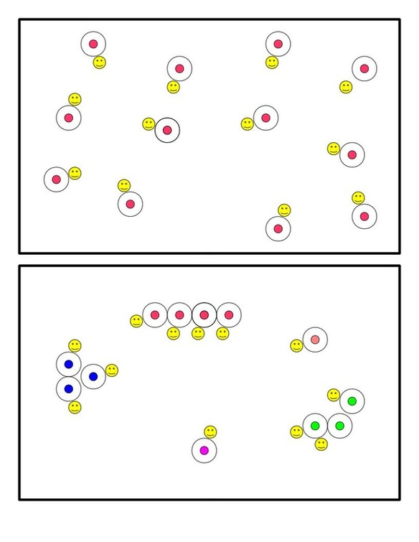
Resources

Textbook:

Robinson & Randall – Pedagogy of Teaching Physical Education
Chapter 3: Curriculum Models
Chapter 4: Planning for Instruction
Chapter 6: Assessment and Physical Education
Chapter 12: Movement Domains

Websites:

The Physical Educator.com

http://www.thephysicaleducator.com/resources/games/invasion/prairie_dog_pickoff/

Growing Young Movers

http://growingyoungmovers.com/+pub/document/connecting%20outcomes%20to%20games/Prairie%20dog%20.pdf

Prairie Dog Pick-Off Strategies

http://frazmcc.weebly.com/prairie-dog-pick-off.html

Assessment Rubric:
Needs Improvement | Satisfactory | Good | Outstanding
- Cannot perform the proper physical motions needed to coordinate throwing ball and knocking over opponent’s Alien.  - Unable to block ball to defend territory.  - Does not leave personal territory to advance objective of game.  - Displays uninterested attitude. | - Has some ability to perform the proper physical motions needed to coordinate throwing the ball and knocking over Aliens.  - Can step from side to side in order to block the ball and defend territory about half of the time.  - Shows some initiative to play as a team beyond guarding one’s own hoop (personal territory).  - Shows some interest in game with a mostly positive attitude. | - Has the ability to perform the proper physical motions needed to coordinate throwing the ball and knocking over Aliens.  - Can step from side to side in order to block the ball and defend territory most of the time.  - Has an understanding of strategy and technique of the game.  - Shows some interest in the game. | - Has the ability to perform the proper physical motions needed to coordinate throwing the ball and knocking over Aliens.  - Can step from side to side in order to block the ball and defend territory most of the time.  - Very positive attitude.  - Willing to help others with strategy and technique.

