Proposal to Digitize Best Buy Mobile Pacific Center’s Price Tag System

For Stephen Arcay, Best Buy District Manager
Best Buy Canadian Headquarters
Burnaby, BC

To be Peer Reviewed By Joyce Wu

By Usman Zahoor
ENGL 301
Dec, 4, 2019

Table of Contents
Introduction 3
Background 3
Purpose 3
Limitations 3
Scope of the Inquiry 4
Conclusion 4
Report Section 4
Environmental Impact 4
Best Buy Mobile 4
Digital Price Tags 5
Conclusion 7

Introduction

Background
Paper is one of Canada’s most wasted products (ibfgroup.ca). Not only does it require an immense amount of fossil fuels to produce, but it requires tonnes of water (ibfgroup.ca). Environmental awareness has spiked dramatically over the past decade and our generation is one of the most informed, curious, and aware. As a Best Buy Mobile employee, I have seen where paper consumption and retail service intersect/collide and believe the issue should be addressed.

Purpose
Best Buy has updated 240 stores worldwide to ESLs (electronic shelf labels), leaving behind archaic paper price tags. Nearly 20% of their US stores have implemented ESLs, but where does this leave SASs (standalone stores)? No SASs exist in the US after Best Buy closed all 250. Meanwhile, Canada has nearly 60F. Through careful research and surveys with Best Buy Mobile employees (management, full-time, and part-time), this report will outline/examine why Best Buy Canada’s should implement a digital price tag system.

Limitations
Considerations include the following:
- The report is still being conducted
- Several employees have yet to complete the survey

Scope of the Inquiry
This report covers topics of environmental awareness, paper waste, ESLs, and the Best Buy corporation.

Conclusion
I recommend that Best Buy Canada follow in the footsteps of its American neighbour and digitize the price tag system.

Report

Environmental Impact
It takes approximately 324 litres of water to produce 1kg of paper (ibfgroup.ca). Paper manufacturing is actually one of the largest industrial consumers of water. Unfortunately, only about a quarter of paper we use is actually recycled (ibfgroup.ca).

More statistics to come

Best Buy Mobile
It is estimated that at least 40 hours per week goes into managing paper price tags. In Canada, there are at least 56 Best Buy Mobiles, not including the ones inside big box stores. This means approximately 2000 hours are spent every year changing price tags. This time could be better spent helping customers, maintaining stock and stores, and in other words, be used more efficiently.

In terms of paper, around 100 sheets are used daily for contracts, pricing grids, and price tags. This does not include the hundreds of receipts that are printed daily as well. In a given week, a single store will use a minimum of 1000 sheets of paper. Consider this number across the numerous SASs and 136 big box stores.

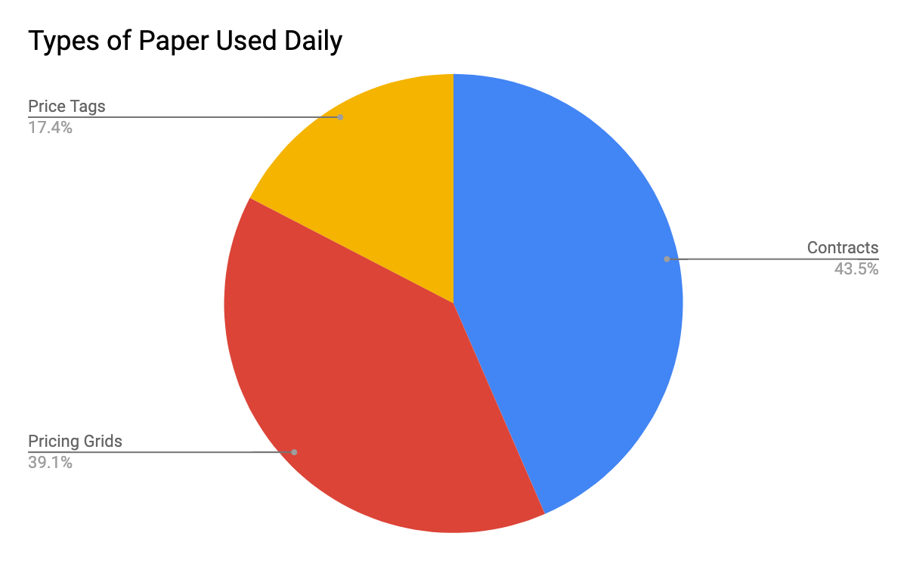
Fig 1. Various uses of paper at a given SAS store. Does not include the hundreds of sheets used for receipts.

Digital Price Tags
ESLs (electronic shelf labels) are used by retailers to display the prices of products on shelves. They are controlled by a central server which can update them at a moment’s notice. The market is expected to grow dramatically over the next few years, with grocery giants like Superstore implementing them in all locations (Electronic Shelf Label Market to hit $1bn by 2024, Global Market Insights).

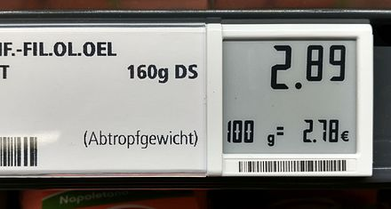
fig 2. Example of ESL.

American Best Buys are currently using Pricer brand ESLs (electronic shelf labels) in over 150 stores, costing the company around 36 million dollars (Best Buy Commits to Additional Pricer ESL Deployment, Pricer). This is around $240k per store. Seeing that the Canadian Best Buys are comprised of not only big box stores, but much smaller SASs, it should cost much less for Pacific Center’s location.

The potential drawbacks of ESLs is the initial investment. Installation is marginally high, making the monetary benefits hard to quantify immediately. However, the benefits of ESLs include accurate and consistent pricing across all systems as employees will not be required to manually replace each price tag (leaving room for human error). Not only would it save employee time, but it would save the stores from having to spend money to print out price tags. Additionally, ESLs also enable more accurate stock count which helps both customers and employees save time (There’s More to Electronic Shelf Labels than Pricing, Eileen Keehan).

Conclusion
As consumers become more aware of their environmental impact, large corporations are taking notice. Not only are ESLs a step towards environmental sustainability, but it’s an act of social responsibility. Considering the energy is takes to produce paper, the amount that goes to waste, and the sheer tonnage consumed by retailers, it seems natural for Best Buy Canada to adopt the same digital price tag system as its American counterpart.

I recommend Best Buy Canada begin implementing ESLs immediately. Especially in high profile stores like the Pacific Center location, which has high traffic and therefore uses an exceptional amount of paper. While replacing paper price tags with ESLs may seem like a small step towards sustainability, it is exactly why it should be done. As we know, small changes accumulate to produce large results.

