**MS Word Tutorial**

1. Equation Editor

* Press “Alt” and “=” to start a new equation (for PC only).
* In general, to customize keyboard shortcuts:
* Windows: **File** 🡪 **Options** 🡪 **Customize Ribbon** 🡪 Find **Customize** button
* Mac: **Tools** 🡪 **Customize Keyboard…**

We can therefore assign a shortcut command for equation editor on Mac.

* Select the equations, right click, then click on “Align at =” to align all the selected equations at the equal signs. We can also set up a shortcut command for this.
* In equation editor, “\” followed by command to type some special symbols.

Some useful commands:

|  |  |
| --- | --- |
| **Command** | **Output** |
| \omega | $$ω$$ |
| \Omega | $$Ω$$ |
| \infty | $$∞$$ |
| \in | $$∈$$ |
| \doubleR | $$R$$ |
| \x_1^2 (or \x^2_1) | $$x_{1}^{2}$$ |
| \ge (or >=) | $$≥$$ |
| \le (or <=) | $$≤$$ |
| \ne (or /=) | $$≠$$ |
| \approx | $$≈$$ |
| \sim | $$∼$$ |
| \angle | $$∠$$ |
| \perp | $$⊥$$ |
| \int | $$∫$$ |
| \sum | $$∑$$ |
| \sqrt(x+y) | $$\sqrt{x+y}$$ |
| \overline(x) | $$\overline{x}$$ |
| x \cdot y (x times y) | $$x⋅y$$ |
| (n\atop k) (n choose k) | $$\left({n \atop k}\right)$$ |

* Putting bracket around the terms makes all the terms involved in the command.

For example, 2^x+3 gives $2^{x}+3$, while 2^(x+3) gives $2^{x+3}$

* More examples:

x=(-b+-\sqrt(b^2-4ac))/2a gives

$$x=\frac{-b±\sqrt{b^{2}-4ac}}{2a}$$

\int_-1^1 \sqrt(1-x^2) dx = \pi /2 gives

$$\int_{-1}^{1}{\sqrt{1-x^{2}}dx}=\frac{π}{2}$$

\overline(x) =\sum_(i=1)^n x_i/n gives

$$\overline{x}=\sum_{i=1}^{n}{\frac{x_{i}}{n}}$$

1. Alignment

* Using tabs:

On the ruler at the top of the page, click the points you want to set as the “tab stops”, and press “Tab” key to jump to the tab stops:

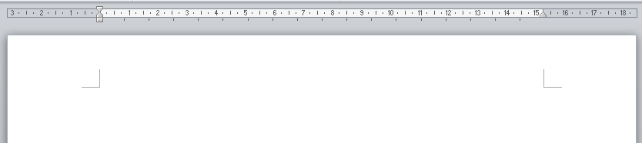

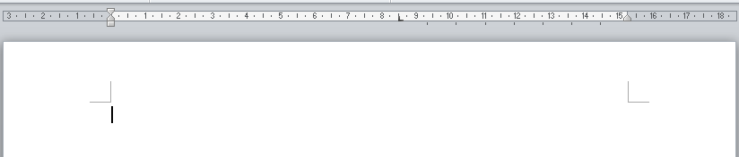

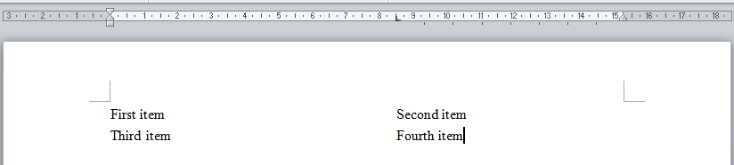

* Using tables

Inert a table and input the content. You can hide the lines by clicking Table Tool 🡪 Design 🡪

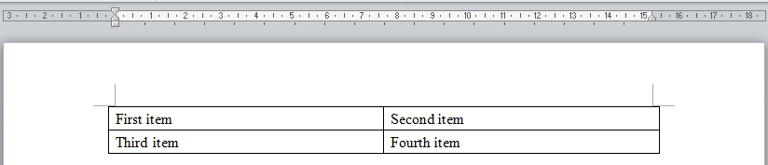

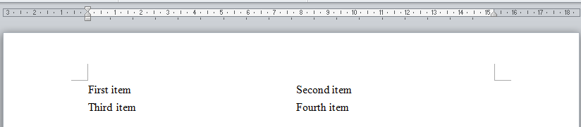

1. Other tips

* Press Ctrl and Z (Windows) or Command and Z (Mac) to undo. This not only works for Microsoft Word but many other documents/interfaces in the computer.
* Shift and Arrow Key (for both Windows and Mac) to select text. This helps sometimes if you don’t feel like to switch between keyboard and mouse.
* For Windows only: You might have this experience that you accidently clicked something and it turns out when you insert the words between words, the new coming words just replace all the following words. That is because you press Insert by accident. To switch back, simply press Insert again.

1. Making geometric shapes

* Specific shapes
* Labelling
* Shade the Area
* Parallel label

$$30°$$

$$A$$