File name: VR_3T_LP3_EnvironmentalScience_Science_12
Topic: Environmental Science
Keywords: Monarch butterflies, Canada, migrations,
Suggested grade level: Grade 12
Estimated activity time: 15 min

Environmental Science – Science 12

Human activities and the global community

VR 360⁰ exploration: 3D Monarch Butterflies in 360° | National Geographic
https://www.youtube.com/watch?v=xmei3faE6F0

General Introduction:
Doing a VR 360⁰ exploration/expedition is like going on a vacation or trip. You have to plan e.g. your destinations, places to eat, relax, and meet friends and family. It means identifying your objectives.

For teachers:
In this section, you will see a modified planning and preparation arranged into three (3) steps. As a teacher, these steps help you maximize the learning opportunities a VR 360⁰ exploration/expedition can potentially offer.

Three steps:

- Pre-exploration: Preview the playlist exploration yourself. By doing this, you are identifying possible questions and activities that might enrich students’ VR experience.

- During exploration: Provide guide or key questions or ask the students to formulate new questions about the playlist and encourage students to refer to other resources (e.g., YouTube videos, articles, etc.) to connect and enrich the playlist.

- Post-exploration: Follow-up on the new questions and wonders students have identified. These questions might lead to an interdisciplinary inquiry project, blog posts or short video clips to link with the original unit or chapter coverage.

Description:
In this 15-minute exploration activity, you’ll see a 360⁰ panorama of a swarm of a billion monarch butterflies.

“In eye-popping 3D, National Geographic VR plunges you into the middle of a swarm of a billion monarch butterflies. One of the most spectacular migrations on Earth, these fragile creatures have flown thousands of miles from Canada to breed in this remote forest grove in the mountains of Mexico.” National Geographic VR

Objective:
The core learning outcome of this playlist is to enrich students’ understanding of climate change and human activities by looking into one of the most spectacular migrations of living things on earth.

However, unlike a regular 2D video, this VR provides a 360⁰ panorama, which allows your students to focus on different points of interest that might vary from student to student. So, take time to explore the playlist using different angles and positions.

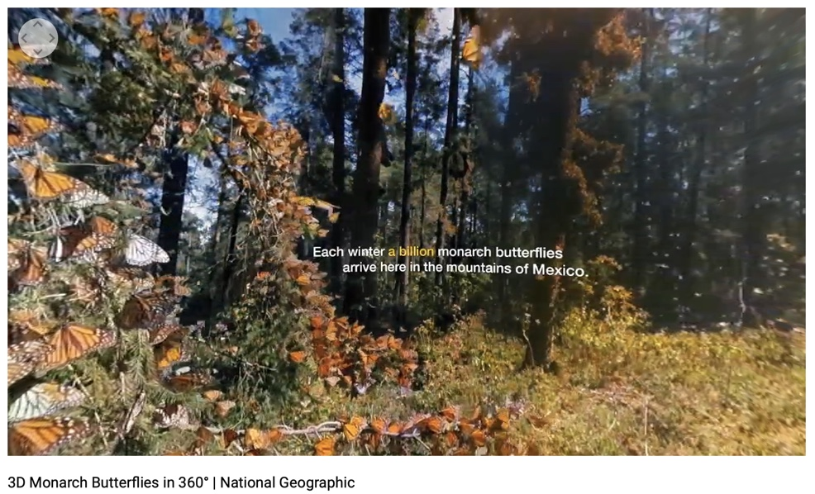

Suggested Guide:

- Pre-exploration:
Monarch Butterflies | National Geographic: https://www.youtube.com/watch?v=Rko78QktS9A

- During exploration:
What key questions could pique students’ interest as they watch this playlist?
As well, ask them to think of interesting questions they want to answer as they watch the playlist. Let them discuss these questions and their possible answers.
They can do this by groups of two or three.

With limited number of Google cardboards, let students work in pairs. Let them take turn to watch the playlist and do a Q & A. For example, Student 1 will describe to student 2 what he/she is seeing right now. Student 2 will explain the playlist, to Student 1 and each student will take turns doing Q & A.

- Post-exploration:
Give time for the pair/class to think about the questions and answers they have generated after watching the playlist.

Let them recall experiences that might relate to the playlist e.g. early preparation and research before hiking on mountain ranges or active volcano or the hazards/effects of volcanic ash on aircraft.

Then invite them to read the link below. With the playlist, let them express their understanding, reactions into any interdisciplinary inquiry projects, blog posts, short video clips, etc.

Monarch Butterflies | National Geographic: https://www.youtube.com/watch?v=Rko78QktS9A

References:
https://edu.google.com/products/vr-ar/expeditions/?modal_active=none

https://www.youtube.com/watch?v=xmei3faE6F0

https://www.youtube.com/watch?v=Rko78QktS9A

