File name: VR_4T_LP3_Geology_Science_12
Topic: Environmental Science
Keywords: Grand Canyon, climate change, topography
Suggested grade level: Grade 12
Estimated activity time: 15 min

Geology – Science 12

Minerals, rocks, and earth materials

VR 360⁰ exploration: Grand Canyon VR Video
https://www.youtube.com/watch?v=a1OoOdTNiUM

General Introduction:
Doing a VR 360⁰ exploration/expedition is like going on a vacation or trip. You have to plan e.g. your destinations, places to eat, relax, and meet friends and family. It means identifying your objectives.

For teachers:
In this section, you will see a modified planning and preparation arranged into three (3) steps. As a teacher, these steps help you maximize the learning opportunities a VR 360⁰ exploration/expedition can potentially offer.

Three steps:

- Pre-exploration: Preview the playlist exploration yourself. By doing this, you are identifying possible questions and activities that might enrich students’ VR experience.

- During exploration: Provide guide or key questions or ask the students to formulate new questions about the playlist and encourage students to refer to other resources (e.g., YouTube videos, articles, etc.) to connect and enrich the playlist.

- Post-exploration: Follow-up on the new questions and wonders students have identified. These questions might lead to an interdisciplinary inquiry project, blog posts or short video clips to link with the original unit or chapter coverage.

Description:
In this 15-minute exploration activity, you’ll see a 360⁰ panorama on Grand Canyon.

“For over 100 years, the Grand Canyon has challenged filmmakers with some of the roughest conditions on Earth. In June, with help from Google, 360 Labs took the Jump 360º 3D camera system on a 10 day river trip with Western River Expeditions. VR producer, Matt Rowell managed 32 GoPro cameras across multiple 360º arrays for the principle photography on "As It Is: A Grand Canyon VR Documentary" due out this winter across a variety of platforms. In this Jump piece, we explore just a few of its wonders while listening to the final night's passage in the journal of Buzz Holmstrom who rowed the length of the Colorado River from Wyoming to Hoover Dam in a handmade boat in 1937.”
https://www.youtube.com/watch?v=a1OoOdTNiUM

Objective:
The core learning outcome of this playlist is to enrich students’ understanding of minerals, rocks and earth materials in a bigger scale as exemplified by Grand Canyon using 360⁰ camera.

However, unlike a regular 2D video, this VR provides a 360⁰ panorama, which allows your students to focus on different points of interest that might vary from student to student. So, take time to explore the playlist using different angles and positions.

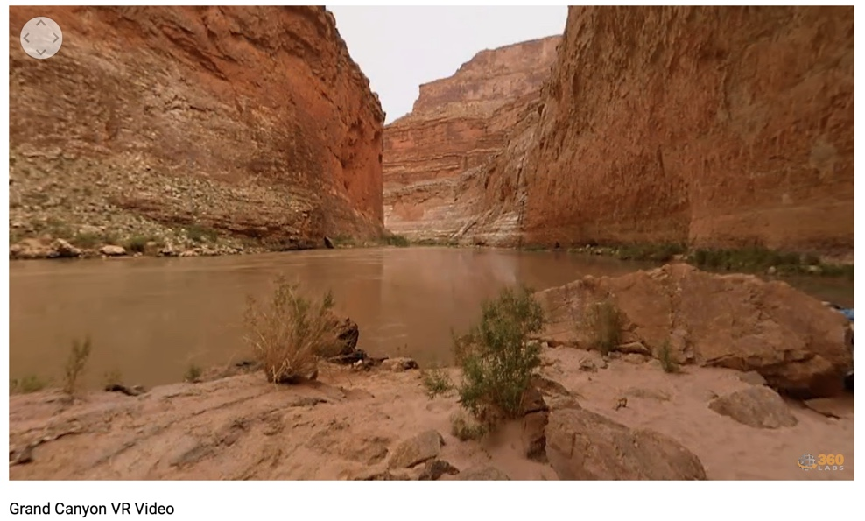

Suggested Guide:

- Pre-exploration:
Research suggests climate change likely to cause significant shift in Grand Canyon vegetation: https://phys.org/news/2017-04-climate-significant-shift-grand-canyon.html

- During exploration:
What key questions could pique students’ interest as they watch this playlist?
As well, ask them to think of interesting questions they want to answer as they watch the playlist. Let them discuss these questions and their possible answers.
They can do this by groups of two or three.

With limited number of Google cardboards, let students work in pairs. Let them take turn to watch the playlist and do a Q & A. For example, Student 1 will describe to student 2 what he/she is seeing right now. Student 2 will explain the playlist, to Student 1 and each student will take turns doing Q & A.

- Post-exploration:
Give time for the pair/class to think about the questions and answers they have generated after watching the playlist.

Let them recall experiences that might relate to the playlist e.g. early preparation and research before hiking on mountain ranges or active volcano or the hazards/effects of volcanic ash on aircraft.

Then invite them to read the link below. With the playlist, let them express their understanding, reactions into any interdisciplinary inquiry projects, blog posts, short video clips, etc.

Research suggests climate change likely to cause significant shift in Grand Canyon vegetation: https://phys.org/news/2017-04-climate-significant-shift-grand-canyon.html

References:
https://edu.google.com/products/vr-ar/expeditions/?modal_active=none

https://www.youtube.com/watch?v=a1OoOdTNiUM

https://phys.org/news/2017-04-climate-significant-shift-grand-canyon.html

