File name: VR_1.1T_LP3_EarthScience_Science_11
Topic: Earth science, plate tectonic theory
Keywords: Mt. Everest, mountain climbing, rescue
Suggested grade level: Science 11
Estimated activity time: 15 min

Earth Science – Science 11

Plate Tectonic theories (theory and consequences of tectonic plate interactions)

VR 360⁰ exploration: Fly a Helicopter on Mt. Everest In Incredible Virtual Reality
https://www.youtube.com/watch?v=n0lm4crJ8cc

General Introduction:
Participating in a VR 360⁰ exploration/expedition is like going on a vacation or trip. You have to plan your destinations, places to eat, relax, and where you would like to meet your friends and family. It means that you have to identify your objectives.

For teachers:
In this section, you will see a modified planning and preparation arranged into three steps. The steps are our suggestions. We hope they will help you maximize the learning opportunities a VR 360⁰ exploration/expedition can potentially offer.

Three steps:

- Pre-exploration: Preview the playlist exploration yourself. By doing this, you are identifying possible questions and activities that might enrich students’ VR experience.

- During exploration: Provide guide or key questions or ask the students to formulate new questions about the playlist and encourage students to refer to other resources (e.g., YouTube videos, articles, etc.) to connect and enrich the playlist.

- Post-exploration: Follow-up on the new questions and wonders students have identified. These questions might lead to an interdisciplinary inquiry project, blog posts or short video clips to link with the original unit or chapter coverage.

Description:
In this 15-minute exploration activity, you’ll see a 360⁰ panorama of riding along with the elite helicopter rescue pilots of and experience the breathtaking beauty of Everest, from a perspective that few ever get to see.

Objective:
The core learning outcome of this playlist is to enrich students’ understanding about the risks of mountain climbing and rescue operations involved.

However, unlike a regular 2D video, this VR provides a 360⁰ panorama, which allows your students to focus on different points of interest that might vary from student to student. So, take time to explore the playlist using different angles and positions.
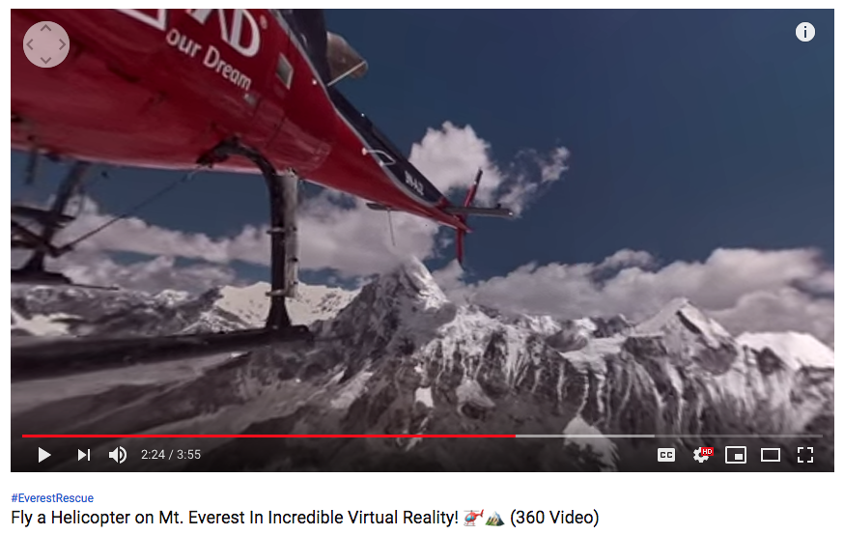

Suggested Guide:

- Pre-exploration:
Himalayas: https://www.britannica.com/place/Himalayas

Trekking in the Himalayas:
https://www.theguardian.com/travel/2013/may/24/trekking-in-the-himalayas-nepal-everest

- During exploration:
What key questions could pique students’ interest as they watch this playlist?
As well, ask them to think of interesting questions they want to answer as they watch the playlist. Let them discuss these questions and their possible answers.
They can do this by groups of two or three.

With limited number of Google cardboards, let students work in pairs. Let them take turn to watch the playlist and do a Q & A. For example, Student 1 will describe to student 2 what he/she is seeing right now. Student 2 will explain the playlist, to Student 1 and each student will take turns doing Q & A.

- Post-exploration:
Give time for the pair/class to think about the questions and answers they have generated after watching the playlist.

Then invite them to read/watch the links below on their free time. With the playlist, let them express their understanding, reactions into any interdisciplinary inquiry projects, blog posts, short video clips, etc.

How Rescuers Save Climbers on the World's Tallest Mountains: https://www.nationalgeographic.com/adventure/activities/climbing/himalayan-mountains-everest-climb-rescue-video-spd/

The Himalayas: https://www.imdb.com/title/tt4253360/videoplayer/vi1126152217?ref_=tt_ov_vi

Everest: https://www.imdb.com/title/tt2719848/

References:
https://edu.google.com/products/vr-ar/expeditions/?modal_active=none

https://www.youtube.com/watch?v=n0lm4crJ8cc

https://www.britannica.com/place/Himalayas

https://www.theguardian.com/travel/2013/may/24/trekking-in-the-himalayas-nepal-everest

https://www.nationalgeographic.com/adventure/activities/climbing/himalayan-mountains-everest-climb-rescue-video-spd/

https://www.imdb.com/title/tt4253360/videoplayer/vi1126152217?ref_=tt_ov_vi

https://www.imdb.com/title/tt2719848/

