File name: VR_1.1T_LP4_EarthScience_Science_11
Topic: Earth science, plate tectonic theory
Keywords: Earthquake, geological activity, history
Suggested grade level: Science 11
Estimated activity time: 15 min

Earth Science – Science 11

Plate Tectonic theories (theory and consequences of tectonic plate interactions)

VR 360⁰ exploration: Earthquake: Evidence of a Restless Planet - fulldome trailer 360°
https://www.youtube.com/watch?v=z1xyb1W9kqI

General Introduction:
Participating in a VR 360⁰ exploration/expedition is like going on a vacation or trip. You have to plan your destinations, places to eat, relax, and where you would like to meet your friends and family. It means that you have to identify your objectives.

For teachers:
In this section, you will see a modified planning and preparation arranged into three steps. The steps are our suggestions. We hope they will help you maximize the learning opportunities a VR 360⁰ exploration/expedition can potentially offer.

Three steps:

- Pre-exploration: Preview the playlist exploration yourself. By doing this, you are identifying possible questions and activities that might enrich students’ VR experience.

- During exploration: Provide guide or key questions or ask the students to formulate new questions about the playlist and encourage students to refer to other resources (e.g., YouTube videos, articles, etc.) to connect and enrich the playlist.

- Post-exploration: Follow-up on the new questions and wonders students have identified. These questions might lead to an interdisciplinary inquiry project, blog posts or short video clips to link with the original unit or chapter coverage.

Description:
In this 15-minute exploration activity, you’ll see a 360⁰ panorama of a fulldome trailer “Earthquake: Evidence of a Restless Planet”.

“Earthquake: Evidence of a Restless Planet is a sweeping geological journey that explores the forces that transform the surface of our planet. Data-driven visualizations illustrate Earth's story, revealing how subtle motions and sudden ruptures have shaped our planet over eons — and how geological activity influences the course of human history. Earthquake: Evidence of a Restless Planet was written by Ryan Wyatt and produced by the visualization studio of the California Academy of Sciences.”
Loch Ness Productions Published on Mar 27, 2017

Objective:
The core learning outcome of this playlist is to enrich students’ understanding about earthquakes and spread public awareness in the event of natural calamities, like earthquakes.

However, unlike a regular 2D video, this VR provides a 360⁰ panorama, which allows your students to focus on different points of interest that might vary from student to student. So, take time to explore the playlist using different angles and positions.

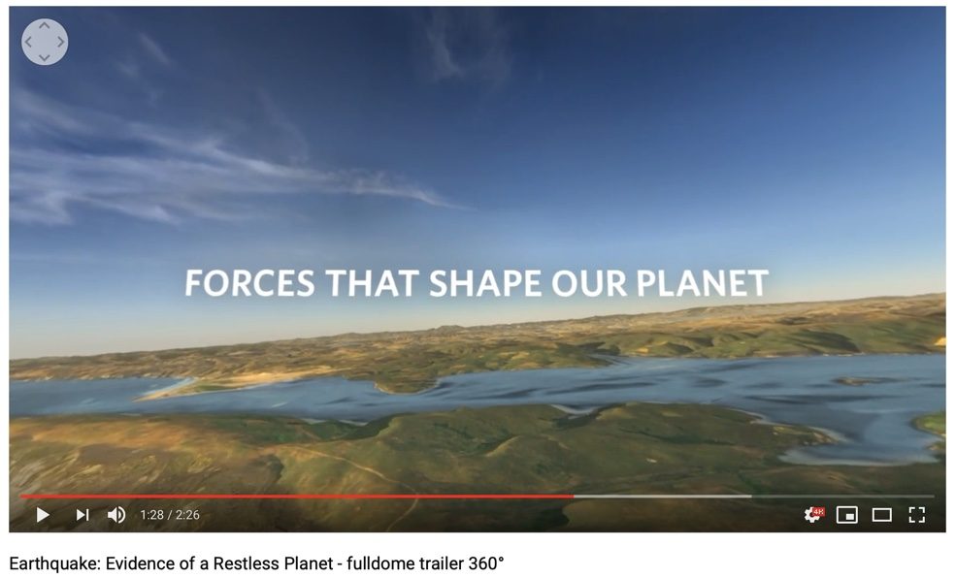
Suggested Guide:

- Pre-exploration:
Review how earthquakes link with tectonic plate interactions
Earthquakes 101 | National Geographic: https://www.youtube.com/watch?v=VSgB1IWr6O4&feature=youtu.be

How does the City of Vancouver prepare for the “Big One”?
https://vancouver.ca/home-property-development/earthquake-facts.aspx
https://www.cbc.ca/news/canada/british-columbia/fault-lines-big-one-1.3795416

- During exploration:
What key questions could pique students’ interest as they watch this playlist?
As well, ask them to think of interesting questions they want to answer as they watch the playlist. Let them discuss these questions and their possible answers.
They can do this by groups of two or three.

With limited number of Google cardboards, let students work in pairs. Let them take turn to watch the playlist and do a Q & A. For example, Student 1 will describe to student 2 what he/she is seeing right now. Student 2 will explain the playlist, to Student 1 and each student will take turns doing Q & A.

- After exploration:
Give time for the pair/class to think about the questions and answers they have generated after watching the playlist.

Then invite them to read the link below. With the playlist, let them express their understanding, reactions into any interdisciplinary inquiry projects, blog posts, short video clips, etc.

Earthquakes 101 | National Geographic: https://www.youtube.com/watch?v=VSgB1IWr6O4&feature=youtu.be

References:
https://edu.google.com/products/vr-ar/expeditions/?modal_active=none

https://www.youtube.com/watch?v=z1xyb1W9kqI

https://www.youtube.com/watch?v=VSgB1IWr6O4&feature=youtu.be

https://vancouver.ca/home-property-development/earthquake-facts.aspx

https://www.cbc.ca/news/canada/british-columbia/fault-lines-big-one-1.3795416

https://www.youtube.com/watch?v=VSgB1IWr6O4&feature=youtu.be

