File name: VR_1.2T_LP3_EarthScience_Science_11
Topic: The Atmosphere and weather
Keywords: Hurricane Maria, Puerto Rico, hurricanes
Suggested grade level: Grade 11
Estimated activity time: 15 min

Earth Science – Science 11

The Atmosphere and the weather it creates and climate change

VR 360⁰ exploration: Maria's Destruction in Puerto Rico | 360 Video + Audio | NPR
https://www.youtube.com/watch?v=KPEVJOqIc5s&list=PLWesODFOmbiV950J5XQjcyYKtR1BYsnYU&index=10

General Introduction:
Participating in a VR 360⁰ exploration/expedition is like going on a vacation or trip. You have to plan your destinations, places to eat, relax, and where you would like to meet your friends and family. It means that you have to identify your objectives.

For teachers:
In this section, you will see a modified planning and preparation arranged into three steps. The steps are our suggestions. We hope they will help you maximize the learning opportunities a VR 360⁰ exploration/expedition can potentially offer.

Three steps:

- Pre-exploration: Preview the playlist exploration yourself. By doing this, you are identifying possible questions and activities that might enrich students’ VR experience.

- During exploration: Provide guide or key questions or ask the students to formulate new questions about the playlist and encourage students to refer to other resources (e.g., YouTube videos, articles, etc.) to connect and enrich the playlist.

- Post-exploration: Follow-up on the new questions and wonders students have identified. These questions might lead to an interdisciplinary inquiry project, blog posts or short video clips to link with the original unit or chapter coverage.

Description:

In this 15-minute exploration activity, you’ll see a 360⁰ panorama of Maria's Destruction in Puerto Rico.

“In the aftermath of Hurricane Maria, Puerto Ricans are coping with devastation in myriad ways. Take a 360-degree look at the situation on the ground.” NPR Published on Oct 5, 2017

Objective:
The core learning outcome of this playlist is to enrich students’ understanding about the destruction brought by Hurricanes and develop empathy for the victims.

However, unlike a regular 2D video, this VR provides a 360⁰ panorama which allows you to see different points of interest different from other viewers. So, take time to explore the playlist in different angles and positions.

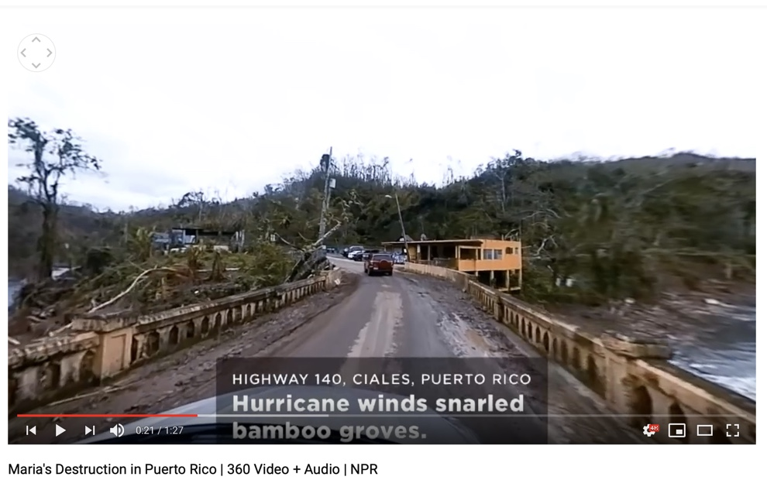

Suggested Guide:

- Pre-exploration:
Hurricanes 101
https://video.nationalgeographic.com/video/101-videos/00000165-c429-de15-afef-c73da3c90000?source=searchvideo

- During exploration:
What key questions could pique students’ interest as they watch this playlist?
As well, ask them to think of interesting questions they want to answer as they watch the playlist. Let them discuss these questions and their possible answers.
They can do this by groups of two or three.

With limited number of Google cardboards, let students work in pairs. Let them take turn to watch the playlist and do a Q & A. For example, Student 1 will describe to student 2 what he/she is seeing right now. Student 2 will explain the playlist, to Student 1 and each student will take turns doing Q & A.

- Post-exploration:
Give time for the pair/class to think about the questions and answers they have generated after watching the playlist.

Then invite them to read the links below. With the playlist, let them express their understanding, reactions into any interdisciplinary inquiry projects, blog posts, short video clips, etc.

Daddy, will monster hurricanes come to B.C.?
https://www.bchydro.com/news/unplug_this_blog/2012/hurricanes-in-bc.html

Hurricane Maria
https://www.cnn.com/interactive/2017/09/world/hurricane-maria-puerto-rico-cnnphotos/

References:
https://edu.google.com/products/vr-ar/expeditions/?modal_active=none

https://www.youtube.com/watch?v=KPEVJOqIc5s&list=PLWesODFOmbiV950J5XQjcyYKtR1BYsnYU&index=10

https://video.nationalgeographic.com/video/101-videos/00000165-c429-de15-afef-c73da3c90000?source=searchvideo

https://www.bchydro.com/news/unplug_this_blog/2012/hurricanes-in-bc.html

https://www.cnn.com/interactive/2017/09/world/hurricane-maria-puerto-rico-cnnphotos/

