File name: VR_1.3T_LP1_EarthScience_Science_11
Topic: Water distribution, weather and climate
Keywords: Hurricane, Hurricane Maria, rainfall, precipitation
Suggested grade level: Grade 11
Estimated activity time: 15 min

Earth Science – Science 11

Water distribution and its influence on weather and climate

VR 360⁰ exploration: Inside Hurricane Maria in 360°
https://www.youtube.com/watch?v=A7MIVsE2oMM

General Introduction:
Participating in a VR 360⁰ exploration/expedition is like going on a vacation or trip. You have to plan your destinations, places to eat, relax, and where you would like to meet your friends and family. It means that you have to identify your objectives.

For teachers:
In this section, you will see a modified planning and preparation arranged into three steps. The steps are our suggestions. We hope they will help you maximize the learning opportunities a VR 360⁰ exploration/expedition can potentially offer.

Three steps:

- Pre-exploration: Preview the playlist exploration yourself. By doing this, you are identifying possible questions and activities that might enrich students’ VR experience.

- During exploration: Provide guide or key questions or ask the students to formulate new questions about the playlist and encourage students to refer to other resources (e.g., YouTube videos, articles, etc.) to connect and enrich the playlist.

- Post-exploration: Follow-up on the new questions and wonders students have identified. These questions might lead to an interdisciplinary inquiry project, blog posts or short video clips to link with the original unit or chapter coverage.

Description:
In this 15-minute exploration activity, you’ll see a 360⁰ panorama of what’s Inside Hurricane Maria.

“Two days before Hurricane Maria devastated Puerto Rico, the NASA-Japan Global Precipitation Measurement Core Observatory satellite captured a 3-D view of the storm. At the time Maria was a Category 1 hurricane. The 3-D view reveals the processes inside the hurricane that would fuel the storm’s intensification to a category 5 within 24 hours. For the first time in 360-degrees, this data visualization takes you inside the hurricane. The precipitation satellite has an advanced radar that measures both liquid and frozen water. The brightly colored dots show areas of rainfall, where green and yellow show low rates and red and purple show high rates. At the top of the hurricane, where temperatures are colder, blue and purple dots show light and heavy frozen precipitation. The colored areas below the dots show how much rain is falling at the surface.” NASA Goddard Published on Oct 4, 2018

Objective:
The core learning outcome of this playlist is to enrich students’ understanding about hurricane and spread public awareness on the destructive power of natural calamities.

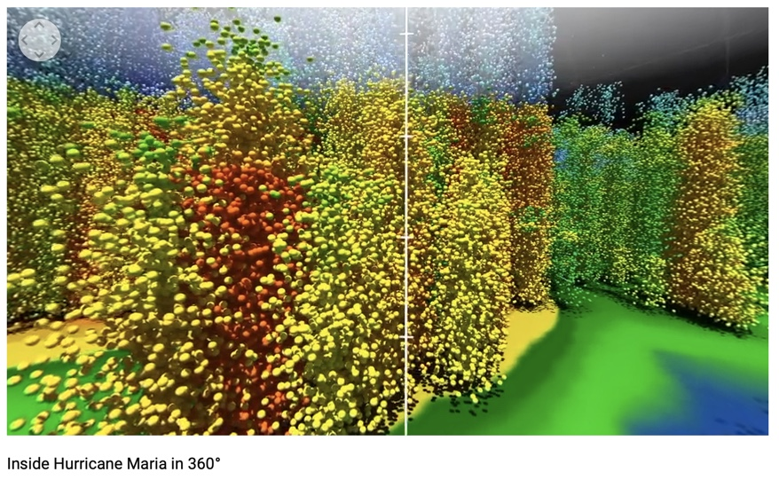
However, unlike a regular 2D video, this VR provides a 360⁰ panorama, which allows your students to focus on different points of interest that might vary from student to student. So, take time to explore the playlist using different angles and positions.

Suggested Guide:

- Pre-exploration:
What are hurricanes’ “hot towers”?
https://www.nasa.gov/feature/goddard/2018/dive-into-a-360-view-of-hurricane-maria

- During exploration:
What key questions could pique students’ interest as they watch this playlist?
As well, ask them to think of interesting questions they want to answer as they watch the playlist. Let them discuss these questions and their possible answers.
They can do this by groups of two or three.

With limited number of Google cardboards, let students work in pairs. Let them take turn to watch the playlist and do a Q & A. For example, Student 1 will describe to student 2 what he/she is seeing right now. Student 2 will explain the playlist, to Student 1 and each student will take turns doing Q & A.

- Post-exploration:
Give time for the pair/class to think about the questions and answers they have generated after watching the playlist.

Then invite them to read the link below. With the playlist, let them express their understanding, reactions into any interdisciplinary inquiry projects, blog posts, short video clips, etc.

How do you protect yourself from hurricanes?
https://www.ready.gov/hurricanes

References:
https://edu.google.com/products/vr-ar/expeditions/?modal_active=none

https://www.youtube.com/watch?v=A7MIVsE2oMM

https://www.nasa.gov/feature/goddard/2018/dive-into-a-360-view-of-hurricane-maria

https://www.ready.gov/hurricanes

