File name: VR_1.3T_LP2_EarthScience_Science_11
Topic: Water distribution, weather and climate
Keywords: National Park, Buck Island Reef, underwater
Suggested grade level: Grade 11
Estimated activity time: 15 min

Earth Science – Science 11

Water distribution and its influence on weather and climate

VR 360⁰ exploration: 360° Underwater National Park | National Geographic
https://www.youtube.com/watch?v=v64KOxKVLVg&t=23s

General Introduction:
In this section, you will see a modified planning and preparation arranged into three steps. The steps are our suggestions. We hope they will help you maximize the learning opportunities a VR 360⁰ exploration/expedition can potentially offer.

Three steps:

- Pre-exploration: Preview the playlist exploration yourself. By doing this, you are identifying possible questions and activities that might enrich students’ VR experience.

- During exploration: Provide guide or key questions or ask the students to formulate new questions about the playlist and encourage students to refer to other resources (e.g., YouTube videos, articles, etc.) to connect and enrich the playlist.

- Post-exploration: Follow-up on the new questions and wonders students have identified. These questions might lead to an interdisciplinary inquiry project, blog posts or short video clips to link with the original unit or chapter coverage.

Description:
In this 15-minute exploration activity, you’ll see a 360⁰ panorama of an Underwater National Park.

Plunge into a Caribbean gem with National Geographic photographer Brian Skerry to explore the Buck Island Reef – America’s first protected marine monument. Sea of Hope: America's Underwater Treasures airs on Nat Geo Sunday 1/15 at 8/7c: http://bit.ly/NGSeaofHope

Objective:
The core learning outcome of this playlist is to enrich students’ understanding about natural resources and spread public awareness and literacy on how to protect them.

However, unlike a regular 2D video, this VR provides a 360⁰ panorama, which allows your students to focus on different points of interest that might vary from student to student. So, take time to explore the playlist using different angles and positions.
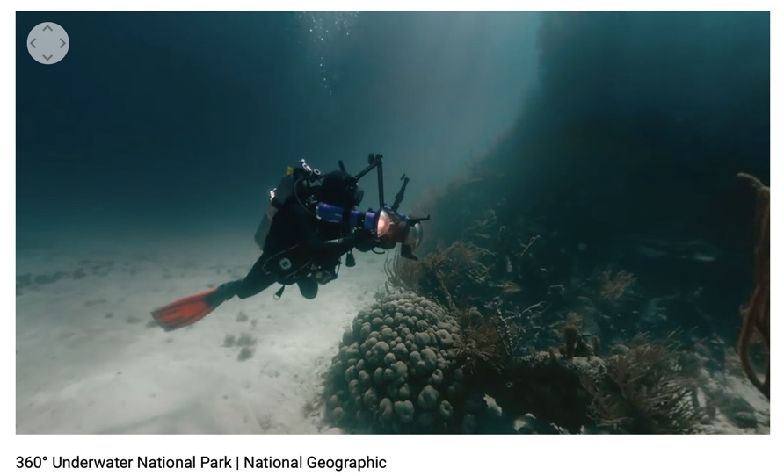

Suggested Guide:

- Pre-exploration:
Learn more about Buck Island Reef:
https://www.nationalparks.org/explore-parks/buck-island-reef-national-monument

https://www.nationalparkstraveler.org/2014/03/exploring-parks-day-buck-island-reef-national-monument24608

- During exploration:
What key questions could pique students’ interest as they watch this playlist?
As well, ask them to think of interesting questions they want to answer as they watch the playlist. Let them discuss these questions and their possible answers.
They can do this by groups of two or three.

With limited number of Google cardboards, let students work in pairs. Let them take turn to watch the playlist and do a Q & A. For example, Student 1 will describe to student 2 what he/she is seeing right now. Student 2 will explain the playlist, to Student 1 and each student will take turns doing Q & A.

- Post-exploration:
Give time for the pair/class to think about the questions and answers they have generated after watching the playlist.

Then invite them to go back again to the playlist, watch it and let them express their understanding, new insights, and reactions into any interdisciplinary inquiry projects, blog posts, short video clips, etc.

360° Underwater National Park | National Geographic
https://www.youtube.com/watch?v=v64KOxKVLVg&t=23s

References:
https://edu.google.com/products/vr-ar/expeditions/?modal_active=none

https://www.youtube.com/watch?v=v64KOxKVLVg&t=23s

https://www.nationalparks.org/explore-parks/buck-island-reef-national-monument

https://www.nationalparkstraveler.org/2014/03/exploring-parks-day-buck-island-reef-national-monument24608

https://www.youtube.com/watch?v=v64KOxKVLVg&t=23s

