File name: VR_1.3T_LP3_EarthScience_Science_11
Topic: Water distribution, weather and climate
Keywords: Wild dolphins, conservation, preservation
Suggested grade level: Grade 11
Estimated activity time: 15 min

Earth Science – Science 11

Water distribution and its influence on weather and climate

VR 360⁰ exploration: Wild Dolphins VR / 360° Video Experience
https://www.youtube.com/watch?v=BbT_e8lWWdo

General Introduction:
Participating in a VR 360⁰ exploration/expedition is like going on a vacation or trip. You have to plan your destinations, places to eat, relax, and where you would like to meet your friends and family. It means that you have to identify your objectives.

For teachers:
In this section, you will see a modified planning and preparation arranged into three steps. The steps are our suggestions. We hope they will help you maximize the learning opportunities a VR 360⁰ exploration/expedition can potentially offer.

Three steps:

- Pre-exploration: Preview the playlist exploration yourself. By doing this, you are identifying possible questions and activities that might enrich students’ VR experience.

- During exploration: Provide guide or key questions or ask the students to formulate new questions about the playlist and encourage students to refer to other resources (e.g., YouTube videos, articles, etc.) to connect and enrich the playlist.

- Post-exploration: Follow-up on the new questions and wonders students have identified. These questions might lead to an interdisciplinary inquiry project, blog posts or short video clips to link with the original unit or chapter coverage.

Description:
In this 15-minute exploration activity, you’ll see a 360⁰ panorama of a Wild Dolphins Experience.

“Swim with wild dolphins in your own home through virtual reality. The Dolphin Swim Club came to us with a revolutionary vision. Let the whole world experience swimming with wild dolphins anytime and anywhere through virtual reality. So we helped them to create some stunning footage of wild dolphins. The mission of The Dolphin Swim Club is to film the most beautiful 360 video footage ever made of wild dolphins. Through Virtual reality, this footage will be accessible by anyone on the planet. Whether it’s for fun, but also for healthcare purposes by treating anxiety disorders for example. We worked on the production of the 360° videos, a brand new website and several promotional videos. After almost a year of preparation and research, lots of brainstorm sessions and overcoming various obstacles, we did it. We filmed more than 80 wild spinner, and bottlenose dolphins each day for a whole week. Location: the Red Sea in Egypt.” VIEMR - Virtual Reality & Augmented Reality Published on Jul 12, 2016

Objective:
The core learning outcome of this playlist is to enrich students’ understanding about natural resources and spread public awareness and literacy on how to protect them.

However, unlike a regular 2D video, this VR provides a 360⁰ panorama, which allows your students to focus on different points of interest that might vary from student to student. So, take time to explore the playlist using different angles and positions.

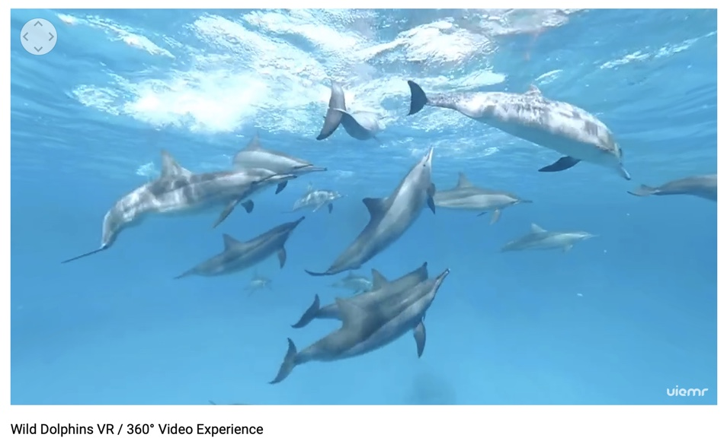

Suggested Guide:

- Pre-exploration:
Find out more why dolphins are one of the most valuable species that we need to protect?
https://www.wwf.org.uk/wildlife/dolphins

- During exploration:
What key questions could pique students’ interest as they watch this playlist?
As well, ask them to think of interesting questions they want to answer as they watch the playlist. Let them discuss these questions and their possible answers.
They can do this by groups of two or three.

With limited number of Google cardboards, let students work in pairs. Let them take turn to watch the playlist and do a Q & A. For example, Student 1 will describe to student 2 what he/she is seeing right now. Student 2 will explain the playlist, to Student 1 and each student will take turns doing Q & A.

- Post-exploration:
Give time for the pair/class to think about the questions and answers they have generated after watching the playlist.

Develop students’ concern and empathy towards the protection of dolphins and other valuable
marine species.

Let the students play and replay the playlist and solicit the emotions they have while watching
the playlist.

Then invite them to read the link below. With the playlist, let them express their understanding, reactions into any interdisciplinary inquiry projects, blog posts, short video clips, etc.

Dolphins-world: https://www.dolphins-world.com

References:
https://edu.google.com/products/vr-ar/expeditions/?modal_active=none

https://www.youtube.com/watch?v=BbT_e8lWWdo

https://www.wwf.org.uk/wildlife/dolphins

https://www.dolphins-world.com

