File name: VR_1.3T_LP4_EarthScience_Science_11
Topic: Water distribution, weather and climate
Keywords: Aqueduct system, drinking water, water consumption
Suggested grade level: Grade 11
Estimated activity time: 15 min

Earth Science – Science 11

Water distribution and its influence on weather and climate

VR 360⁰ exploration:
Virtual Reality Video of the Colorado River Aqueduct System
https://www.youtube.com/watch?v=5GAotsHvfiE

General Introduction:
Participating in a VR 360⁰ exploration/expedition is like going on a vacation or trip. You have to plan your destinations, places to eat, relax, and where you would like to meet your friends and family. It means that you have to identify your objectives.

For teachers:
In this section, you will see a modified planning and preparation arranged into three steps. The steps are our suggestions. We hope they will help you maximize the learning opportunities a VR 360⁰ exploration/expedition can potentially offer.

Three steps:

- Pre-exploration: Preview the playlist exploration yourself. By doing this, you are identifying possible questions and activities that might enrich students’ VR experience.

- During exploration: Provide guide or key questions or ask the students to formulate new questions about the playlist and encourage students to refer to other resources (e.g., YouTube videos, articles, etc.) to connect and enrich the playlist.

- Post-exploration: Follow-up on the new questions and wonders students have identified. These questions might lead to an interdisciplinary inquiry project, blog posts or short video clips to link with the original unit or chapter coverage.

Description:
In this 15-minute exploration activity, you’ll see a 360⁰ panorama of the Colorado River Aqueduct System.

Watch a virtual reality video of the Colorado River Aqueduct System and learn how water travels to Southern California.

Objective:
The core learning outcome of this playlist is to enrich students’ understanding and awareness about the structures and investments allotted for safe drinking water reaches our household, schools, businesses, etc.

However, unlike a regular 2D video, this VR provides a 360⁰ panorama, which allows your students to focus on different points of interest that might vary from student to student. So, take time to explore the playlist using different angles and positions.
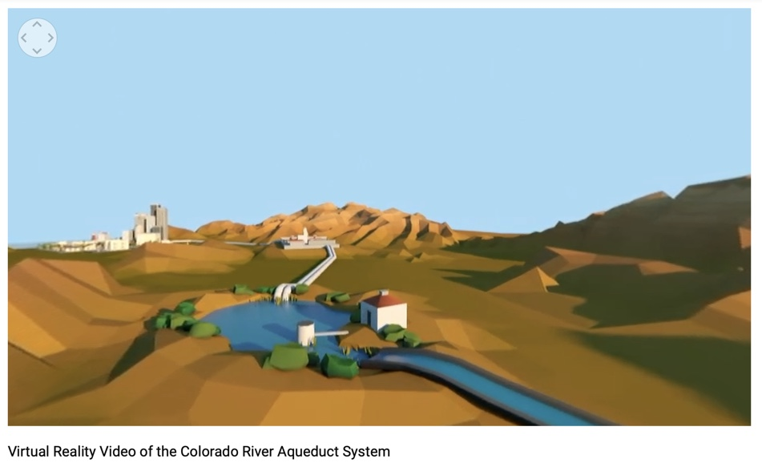

Suggested Guide:

- Pre-exploration:
Where does your drinking water in Vancouver come from?
http://www.metrovancouver.org/welovewater/water-source/where-our-water-comes-from/Pages/default.aspx

https://www.americanrivers.org/rivers/discover-your-river/drinking-water/

- During exploration:
What key questions could pique students’ interest as they watch this playlist?
As well, ask them to think of interesting questions they want to answer as they watch the playlist. Let them discuss these questions and their possible answers.
They can do this by groups of two or three.

With limited number of Google cardboards, let students work in pairs. Let them take turn to watch the playlist and do a Q & A. For example, Student 1 will describe to student 2 what he/she is seeing right now. Student 2 will explain the playlist, to Student 1 and each student will take turns doing Q & A.

- Post-exploration:
Give time for the pair/class to think about the questions and answers they have generated after watching the playlist.

Develop students’ concern and empathy towards the protection and preservation of water.

Discuss how do they reduce their personal water consumption?

Discuss or think of ways on how to use a little less water to help reduce its demand and minimize high costs of building water infrastructure?

Then invite them to express their understanding, reactions into any interdisciplinary inquiry projects, blog posts, short video clips, etc.

Reference:
https://edu.google.com/products/vr-ar/expeditions/?modal_active=none

https://www.youtube.com/watch?v=5GAotsHvfiE

http://www.metrovancouver.org/welovewater/water-source/where-our-water-comes-from/Pages/default.aspx

https://www.americanrivers.org/rivers/discover-your-river/drinking-water/

