File name: VR_1.4T_LP4_EarthScience_Science_11
Topic: Earth science, Astronomy
Keywords: International Space Station, weightlessness, gravity
Suggested grade level: Grade 11
Estimated activity time: 15 min

Earth Science – Science 11

Astronomy (theory and interactions of Earth and the solar system)

VR 360⁰ exploration: Tim Peake ISS 360° Planetarium Tour
https://www.youtube.com/watch?v=Kt04Pgmgxio&t=208s

General Introduction:
Doing a VR 360⁰ exploration/expedition is like going on a vacation or trip. You have to plan e.g. your destinations, places to eat, relax, and meet friends and family. It means identifying your objectives.

For teachers:
In this section, you will see a modified planning and preparation arranged into three (3) steps. As a teacher, these steps help you maximize the learning opportunities a VR 360⁰ exploration/expedition can potentially offer.

Three steps:

- Pre-exploration: Preview the playlist exploration yourself. By doing this, you are identifying possible questions and activities that might enrich students’ VR experience.

- During exploration: Provide guide or key questions or ask the students to formulate new questions about the playlist and encourage students to refer to other resources (e.g., YouTube videos, articles, etc.) to connect and enrich the playlist.

- Post-exploration: Follow-up on the new questions and wonders students have identified. These questions might lead to an interdisciplinary inquiry project, blog posts or short video clips to link with the original unit or chapter coverage.

Description:
In this 15-minute exploration activity, you’ll see a 360⁰ panorama of a life in space and in the International Space Station.

“Fly side-by-side with astronauts in this the first ever 3D Virtual Reality film shot in space. Now YOU can experience weightlessness… hurtle around the globe at 17-thousand miles per hours…and take in an impossibly stunning view of our home that just might change how you think about Earth. Featuring Astronauts Chris Hadfield, Mae Jemison, Mike Massimino and Nicole Stott.” NSCcreative Published on Jun 18, 2016

Objective:
The core learning outcome of this playlist is to enrich students’ understanding about life in space and in the International Space station in 360⁰ view.

However, unlike a regular 2D video, this VR provides a 360⁰ panorama, which allows your students to focus on different points of interest that might vary from student to student. So, take time to explore the playlist using different angles and positions.
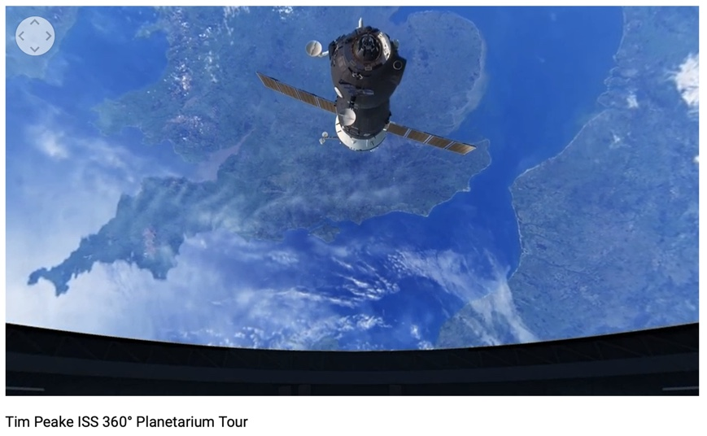

Suggested Guide:

- Pre-exploration:
International space station fast facts:
https://www.cnn.com/2013/10/22/world/international-space-station-fast-facts/index.html

- During exploration:
What key questions could pique students’ interest as they watch this playlist?
As well, ask them to think of interesting questions they want to answer as they watch the playlist. Let them discuss these questions and their possible answers.
They can do this by groups of two or three.

With limited number of Google cardboards, let students work in pairs. Let them take turn to watch the playlist and do a Q & A. For example, Student 1 will describe to student 2 what he/she is seeing right now. Student 2 will explain the playlist, to Student 1 and each student will take turns doing Q & A.

- Post-exploration:
Give time for the pair/class to think about the questions and answers they have generated after watching the playlist.

Let them recall experiences that might relate to the playlist e.g. early preparation and research before hiking on mountain ranges or active volcano or the hazards/effects of volcanic ash on aircraft.

Then invite them to read the link below, listen and watch the video. With the playlist, let them express their understanding, reactions into any interdisciplinary inquiry projects, blog posts, short video clips, etc.

Chris Hadfield and Barenaked Ladies | I.S.S. (Is Somebody Singing):
https://www.youtube.com/watch?v=AvAnfi8WpVE

References:
https://edu.google.com/products/vr-ar/expeditions/?modal_active=none

https://www.youtube.com/watch?v=Kt04Pgmgxio&t=208s

https://www.cnn.com/2013/10/22/world/international-space-station-fast-facts/index.html

https://www.youtube.com/watch?v=AvAnfi8WpVE

