File name: VR_2T_LP2_EnvironmentalScience_Science_11
Topic: Environmental Science
Keywords: Bees, red honey, honey hunter
Suggested grade level: Grade 11
Estimated activity time: 15 min

Environmental Science – Science 11

Diversity and sustainability of ecosystems

VR 360⁰ exploration: 360° Dangerous Honey Hunting (4K) | Explorer | National Geographic
https://www.youtube.com/watch?v=esGz-HrB-Js

General Introduction:
Doing a VR 360⁰ exploration/expedition is like going on a vacation or trip. You have to plan e.g. your destinations, places to eat, relax, and meet friends and family. It means identifying your objectives.

For teachers:
In this section, you will see a modified planning and preparation arranged into three (3) steps. As a teacher, these steps help you maximize the learning opportunities a VR 360⁰ exploration/expedition can potentially offer.

Three steps:

- Pre-exploration: Preview the playlist exploration yourself. By doing this, you are identifying possible questions and activities that might enrich students’ VR experience.

- During exploration: Provide guide or key questions or ask the students to formulate new questions about the playlist and encourage students to refer to other resources (e.g., YouTube videos, articles, etc.) to connect and enrich the playlist.

- Post-exploration: Follow-up on the new questions and wonders students have identified. These questions might lead to an interdisciplinary inquiry project, blog posts or short video clips to link with the original unit or chapter coverage.

Description:
In this 15-minute exploration activity, you’ll see a 360⁰ panorama of danger in hunting the “red” honey!

“Hang beside National Geographic Photographer, Renan Ozturk as he dangles off remote Nepal cliffs to document 'The Last Honey Hunter' magazine story. Renan and team are tracking Mauli, the last hunter in his village who pursues a hallucinogenic ‘red’ honey, known in equal measure for its medicinal properties and its value on the black markets across Asia. Without any protective equipment, Mauli will spend all day suspended hundreds of feet above the ground from hand made bamboo rope while engulfed in a swarm of angry bees. As roads and technology change the landscape of such wild places across the globe, these ancient traditions are under threat, making this story important to document the traditions are lost. Follow along like never before on this high stakes adventure!”
National Geographic Published on Nov 19, 2016

Objective:
The core learning outcome of this playlist is to enrich students’ understanding on how technology changes the landscapes of wild places and ancient traditions such as honey hunting.

However, unlike a regular 2D video, this VR provides a 360⁰ panorama, which allows your students to focus on different points of interest that might vary from student to student. So, take time to explore the playlist using different angles and positions.

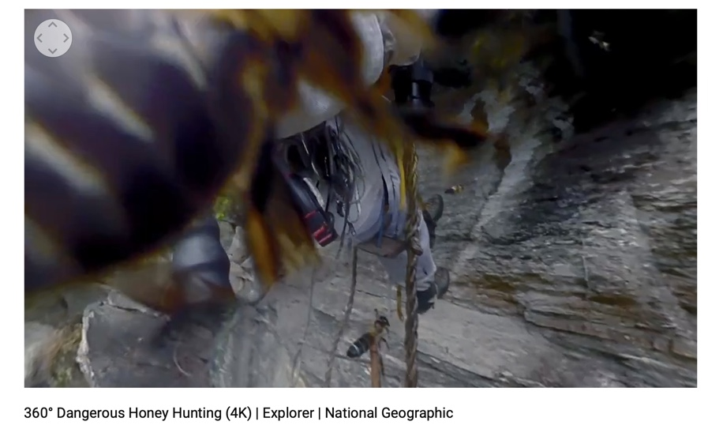

Suggested Guide:

- Pre-exploration: Death defying honey hunting:
https://www.nationalgeographic.com/magazine/2017/07/honey-hunters-bees-climbing-nepal/

- During exploration:
What key questions could pique students’ interest as they watch this playlist?
As well, ask them to think of interesting questions they want to answer as they watch the playlist. Let them discuss these questions and their possible answers.
They can do this by groups of two or three.

With limited number of Google cardboards, let students work in pairs. Let them take turn to watch the playlist and do a Q & A. For example, Student 1 will describe to student 2 what he/she is seeing right now. Student 2 will explain the playlist, to Student 1 and each student will take turns doing Q & A.

- Post-exploration:
Give time for the pair/class to think about the questions and answers they have generated after watching the playlist.

Let them recall experiences that might relate to the playlist e.g. early preparation and research before hiking on mountain ranges or active volcano or the hazards/effects of volcanic ash on aircraft.

Then invite them to read the link below. With the playlist, let them express their understanding, reactions into any interdisciplinary inquiry projects, blog posts, short video clips, etc.

The Last Death-Defying Honey Hunter of Nepal:
https://www.nationalgeographic.com/magazine/2017/07/honey-hunters-bees-climbing-nepal/

References:
https://edu.google.com/products/vr-ar/expeditions/?modal_active=none

https://www.youtube.com/watch?v=esGz-HrB-Js

https://www.nationalgeographic.com/magazine/2017/07/honey-hunters-bees-climbing-nepal/

