File name: VR_2T_LP4_EnvironmentalScience_Science_11
Topic: Environmental Science
Keywords: Global demand, fishing industry, fish crisis
Suggested grade level: Grade 11
Estimated activity time: 15 min

Environmental Science – Science 11

Diversity and sustainability of ecosystems

VR 360⁰ exploration: Ocean to Plate: A Journey into the Seafood Supply Chain
https://www.youtube.com/watch?v=pkfgILiGbVk

General Introduction:
Doing a VR 360⁰ exploration/expedition is like going on a vacation or trip. You have to plan e.g. your destinations, places to eat, relax, and meet friends and family. It means identifying your objectives.

For teachers:
In this section, you will see a modified planning and preparation arranged into three (3) steps. As a teacher, these steps help you maximize the learning opportunities a VR 360⁰ exploration/expedition can potentially offer.

Three steps:

- Pre-exploration: Preview the playlist exploration yourself. By doing this, you are identifying possible questions and activities that might enrich students’ VR experience.

- During exploration: Provide guide or key questions or ask the students to formulate new questions about the playlist and encourage students to refer to other resources (e.g., YouTube videos, articles, etc.) to connect and enrich the playlist.

- Post-exploration: Follow-up on the new questions and wonders students have identified. These questions might lead to an interdisciplinary inquiry project, blog posts or short video clips to link with the original unit or chapter coverage.

Description:
In this 15-minute exploration activity, you’ll see a 360⁰ panorama of seafood supply chain.

“World Wildlife Fund, Condition One and Google present a 360° video and virtual reality film project for Daydream Impact. As populations and appetites for nutritious protein like seafood grow, global fisheries are reaching their ecological capacity, and we have precious few resources to spare. Yet at least a third of harvested fish and seafood is lost or wasted along the supply chain. To experience how what we eat gets from the sea to our plate and why we can’t afford to waste it, follow this immersive journey into one U.S. seafood supply chain. This video is best experienced in a VR Headset.” - World Wildlife Fund Published on Jun 8, 2018

Objective:
The core learning outcome of this playlist is to enrich students’ understanding seafood supply chain and how technology and society’s food demands change the global fishing industry.

However, unlike a regular 2D video, this VR provides a 360⁰ panorama, which allows your students to focus on different points of interest that might vary from student to student. So, take time to explore the playlist using different angles and positions.
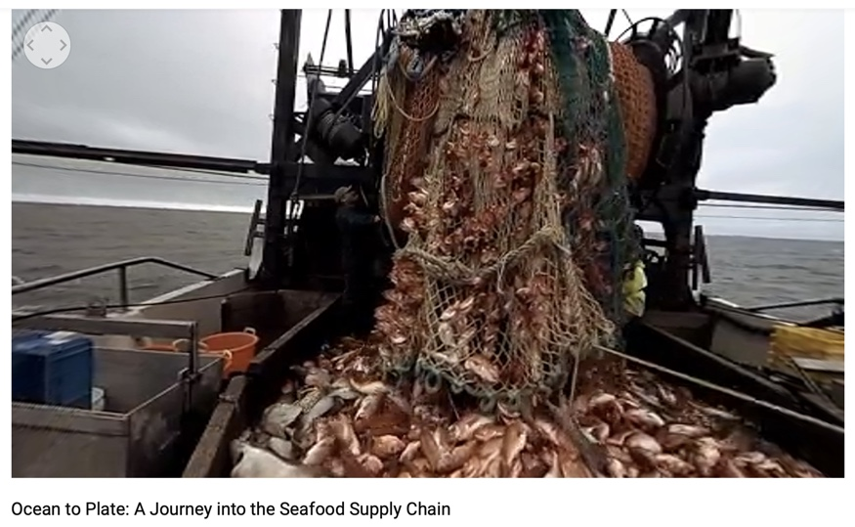

Suggested Guide:

- Pre-exploration:
Canada’s next fish crisis
https://www.edc.ca/en/weekly-commentary/canadas-next-fish-crisis.html

- During exploration:
What key questions could pique students’ interest as they watch this playlist?
As well, ask them to think of interesting questions they want to answer as they watch the playlist. Let them discuss these questions and their possible answers.
They can do this by groups of two or three.

With limited number of Google cardboards, let students work in pairs. Let them take turn to watch the playlist and do a Q & A. For example, Student 1 will describe to student 2 what he/she is seeing right now. Student 2 will explain the playlist, to Student 1 and each student will take turns doing Q & A.

- Post-exploration:
Give time for the pair/class to think about the questions and answers they have generated after watching the playlist.

Let them recall experiences that might relate to the playlist e.g. early preparation and research before hiking on mountain ranges or active volcano or the hazards/effects of volcanic ash on aircraft.

Then invite them to read the link below. With the playlist, let them express their understanding, reactions into any interdisciplinary inquiry projects, blog posts, short video clips, etc.

Canada’s next fish crisis:
https://www.edc.ca/en/weekly-commentary/canadas-next-fish-crisis.html

References:
https://edu.google.com/products/vr-ar/expeditions/?modal_active=none

https://www.youtube.com/watch?v=pkfgILiGbVk

https://www.edc.ca/en/weekly-commentary/canadas-next-fish-crisis.html

