Bio
Brendan Tang (b. 1975) is one of Canada’s most exciting emerging ceramics-based artists. His work came to wider attention in the late 2000s with the development of his Manga Ormolu series. In these pieces, Tang combines traditional Ming vase palettes and patterns with forms that are more futuristic or comic book–like. The results speak to contemporary culture, technology and globalization as well as to Tang’s own hybrid heritage. Future work aims to continue this dynamic, emphasizing the digital world and its role in reality and materiality.
Born and primarily raised in Dublin, Ireland, of Chinese-Indian-Trinidadian heritage, his family eventually settled in Nanaimo, BC, finding naturalized Canadian status. The experience of immigrants, and their respective cultures, plays a significant role in Tang’s work and can be seen, for example, in his juxtaposition of cultural symbols, and in the collapse of different epochs through form and function.
“My parents grew up dirt poor in Trinidad. My father’s family owned and operated a Laundromat. My mother’s family was also from a lower class. They were able to negotiate that and travel to Ireland and my dad was able to study and come over here. He’s now retired but he was a plastic surgeon in Nanaimo. They were always in the process of reconciling low and high culture.”
In Tang’s move from early functional ware to postmodern art, he’s become one of the most influential and tech-savvy artists in the Canadian spectrum of ceramics. Tang uses his art to balance the New World experience, both his own and that of his family, with old and new societies and cultural structures:

“I was always using my work as a vehicle for political commentary on a broader social or individual scale where my own self identify fits in within a western context.”

Tang has lectured at conferences and academic institutions across the continent, and his professional practice has also taken him to India, Europe and Japan. He has been a resident artist at the Archie Bray Foundation for the Ceramic Arts (Montana) and has participated in an international residency at the European Ceramic Work Centre (Netherlands).
Tang has been exhibited at the Museum of Fine Art in Boston, the Musée d'Art Contemporain de Montréal, and Nelson-Atkins Museum of Art in Kansas City, as well being a recipient of the 2016 Biennale Internationale de Vallauris contemporary ceramic award.
He has been profiled by The Knowledge Network, and featured in printed publications including The National Post, Wired (UK and Italy), and ELLE (Canada). Tang’s work can be found in such collections as the Seattle Art Museum, the Ariana Muse in Geneva, Switzerland, Canada House in London (UK) and the Art Bank of Canada. Brendan has also spent many years teaching and researching ceramics at various levels and is currently teaching a ceramics course at Emily Carr.

My artistic practice embodies the influences, tensions and contradictions that define the postmodern world. At once, my works exhibit the paradoxical tendency to be irreverent, frivolous, and playful, as well as thoroughly engaged in critical reflection. Admittedly, my aesthetic is driven by a hedonistic engagement with visual culture, yet I remain apprehensive about the all-encompassing diversions of contemporary society. Although my works are non-functional, I often employ vessel forms, or otherwise allude to incongruous functionality (for example, “wiring” of non-electronic parts). These apparent tensions may be particularly salient to my chosen field of ceramics, a medium interested in the notion of art versus craft.
It is perhaps due to my sense of belonging in the remix generation (as evidenced by electronic music and its "mash-ups") that I tend to borrow and reconfigure ideas and influences to create works that I find both visually and intellectually compelling. I liken aspects of my artistic practice to channel surfing, where I absorb, interpret and bank a great deal of visual information to inform my personal aesthetic.
Always interested in refined forms, I draw inspiration from such diverse realms as contemporary pop culture (e.g., plastic toys and Japanese comics), art history (e.g., in the form of Chinese Ming dynasty vessels and 18th century French rococo), and historical and contemporary practices in self-portraiture. Drawing on such rich cultural symbology, I abstract and configure images, forms and colors within a narrative.
Humour is an essential communication device in my work; I find this is an especially effective means of viewer engagement when addressing sensitive subject areas (e.g., war, climate change, geo-politics). not only satisfying technical challenges, but also vital kinesthetic connectivity to my artistic practice.

GENERAL ARTIST STATEMENT – BRENDANTANG.COM

As evidenced in my reconfiguration of historical art traditions and my use of mixed media, I am intrigued by cultural appropriation and hybridity. Undoubtedly, these predominant themes in my work are a reflection of my own ambiguous cultural identity. Although I am considered Asian Canadian within the dominant culture’s framing, my family has lost even vestiges of connectivity to Asia through several generations of intercontinental migration and ethnic intermarriage. I have used self-portraiture to explore issues of race, class and sexual identity in greater depth.
While my aesthetic is driven by a seemingly manic consumption of visual culture, my work is labour intensive and detail oriented. I place high value on craftsmanship, as refinement allows me to reference art history, and notions of class and value. I employ hand painting, gold luster, airbrushing, hand-modeled filigree, and photo-based decals, among other means, to create alluring pieces. Working primarily in clay, I exploit its ability to convincingly emulate other materials, such as “robotic” prosthetics. Undeniably, working in clay offers not only satisfying technical challenges, but also vital kinesthetic connectivity to my artistic practice.
Through my approach to art making, I work as a visual ethnographer – documenting and interpreting contemporary culture through my own assumptions, preferences, values and personal history. My aim is to create work that serves as a portal for reflection and dialogue.

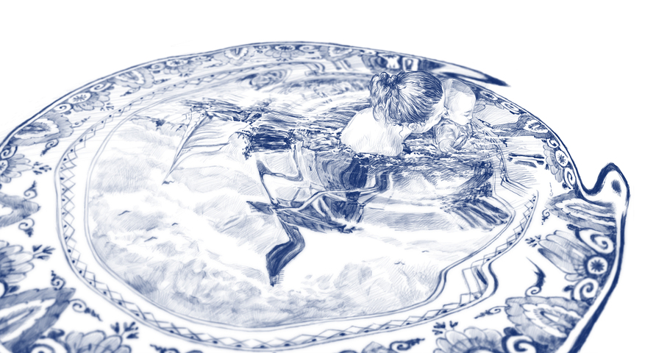
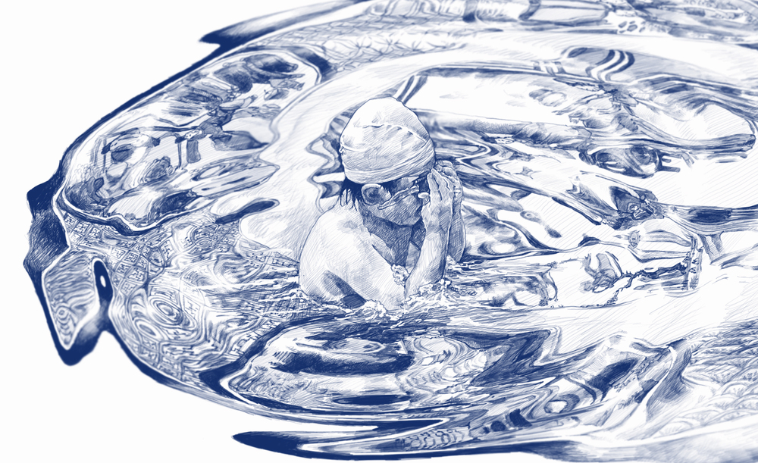
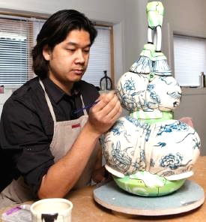
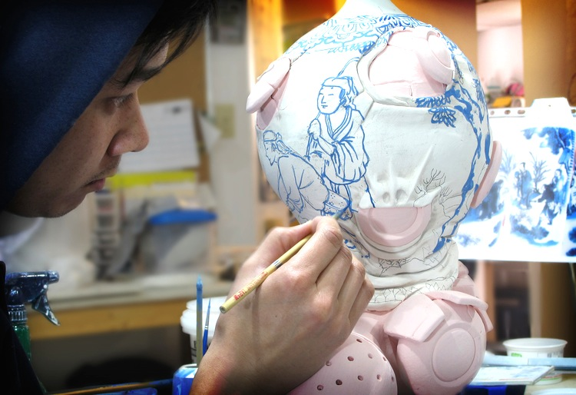
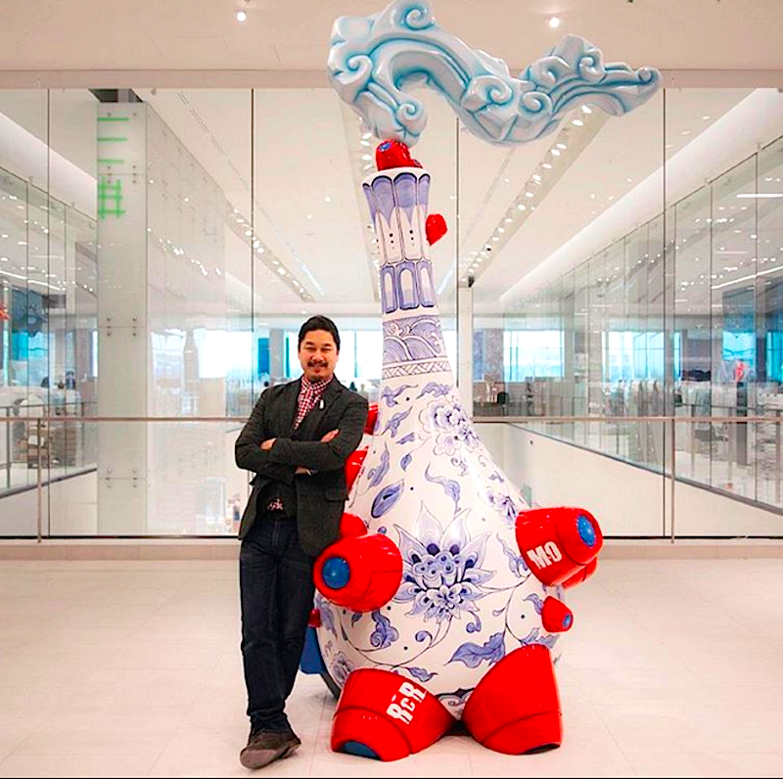
Artwork

- Untitled (Royal Delft)
2012 –18”x12.16” (45.72cm x 30.89cm), Inkjet Print (limited edition)

- Untitled (Ming 2)
2012 - 11.44” x 7” (29.06cm x 17.78), Inkjet Print (limited edition)
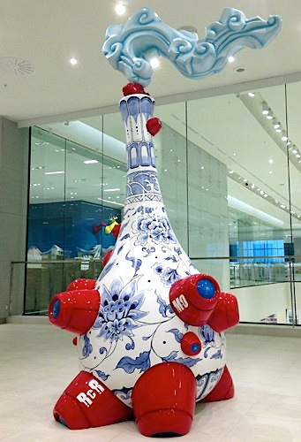
- Raincity Robot (2016) – fiberglass, H 10.5 ft

Commissioned for Quebecois retailer Simon’s:
“Juggling futuristic and traditional ideas, Raincity Robot brings to light the tensions and contradictions that characterize contemporary culture. The Chinese vase recalls the four sisters smokestacks of the old Lakeview Generating Station, while robotic limbs inspired by barnacles make up the base, a nod to Mississauga’s high-tech industry and the city’s lakeside location.”

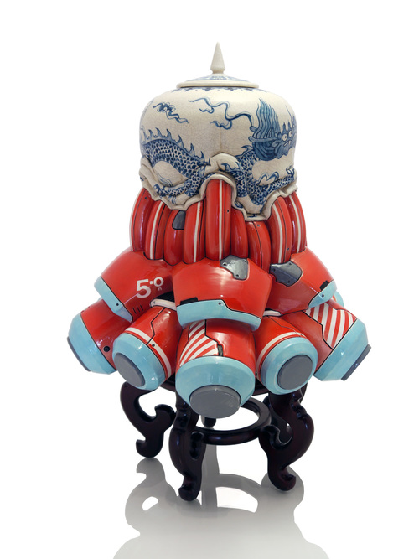
- Manga Ormolu Version 5.0-N (2013) H 25” (63.5cm)

This particular work has a symmetry not seen often in his work. As Tang shifts his intent, the focus of the work is now on the red, white and blue forms and their design. The blue and white form sits like a cap bundling the shapes together, stopping them from spilling onto the supporting surface.

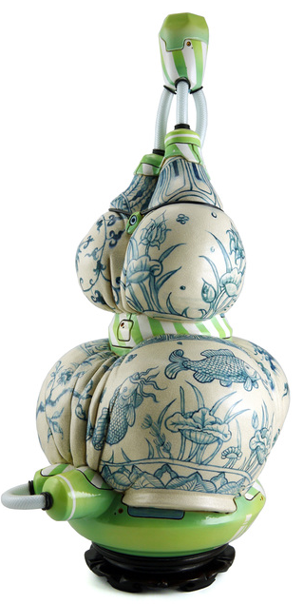

- Manga Ormolu Version 4.0-M (2011) H 25.5” (65cm)

Here he is using the “Huluping,” Double Gourd vase. The tight constriction of the waist creates an organic, female steatopygic quality, like a Chinese Venus of Willendorf. Lime green and white ormolu forms define the foot, waist and throat, contrasting in their simple surface flatness with the Ming blue and white carp and peonies that fold in on themselves in a tight bodily deformation. The whole rests on a conventional base. Here the Ming forms and decoration dominate. The techno-pop elements serve to either support, or constrict or attenuate.

Post-Manga-Ormolu: notes on sound and atmosphere
“Recently I’ve been playing with the robotic elements. I’m making them three dimensionally on the computer and then 3-D printing them. That’s something I’d like to play with more…
…I wanted to create a sonic representation of the ideas behind Manga Ormolu…I’m interested in creating a space where ones are playing music, other just sounds and there is a call and response between the objects. I was kind of surprised by how the presence of sound [permeates] through the space and [creates] an atmosphere for the work.”

Our Project
- A Burrard Arts Foundation (Main + Broadway – E 108 E Broadway)

- A residency show happening in Jan 2018. The concept for this project is the relationship between sight in reality and in virtual reality, where they meet and where they overlap.

- The plan is to construct geometric sculptures from paper and wood, reminiscent of the cloud motifs used in traditional Chinese ceramics, combined with the rendering process of video games and other digital mediums.

- Illustrations, sound, and digital projections may also be incorporated.

- Sculptures and paper shapes will create a maze-like space, ranging in height and size, inviting the viewer to explore the form and the space created.

https://www.instagram.com/brendantang/
https://www.brendantang.com/

Our Work So Far:

- As our project for the show had not been sorted our completely, we are mostly doing online research in order to form rich ideas to support Brendan. Via Pinterest or Dropbox we share images and links with Brendan, using the accumulated research as inspiration to push the idea further.

- We have also built the maquette for BAF Gallery, which will be used when determining the set up of the sculpture and best use of space. Possibly the maquette will be included as part of the sculpture to show the process of making.

- In November we will begin construction, followed by further installation and construction in December, while the show premieres in January.

- A Burrard Arts Foundation (Main + Broadway – E 108 E Broadway)

- A residency show happening in Jan 2018. The concept for this project is the relationship between sight in reality and in virtual reality, where they meet and where they overlap.

- The plan is to construct geometric sculptures from paper and wood, reminiscent of the cloud motifs used in traditional Chinese ceramics, combined with the rendering process of video games and other digital mediums.

- Illustrations, sound, and digital projections may also be incorporated.
- Sculptures and paper shapes will create a maze-like space, ranging in height and size, inviting the viewer to explore the form and the space created.
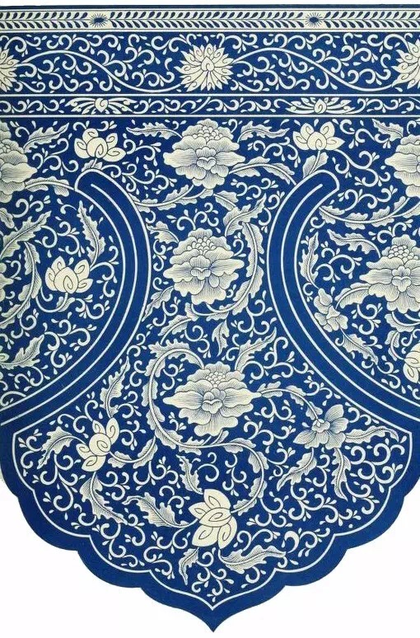
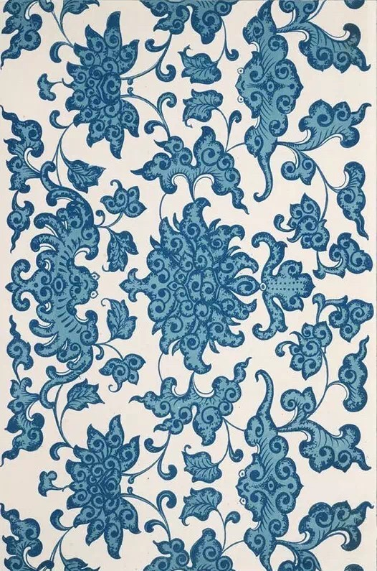
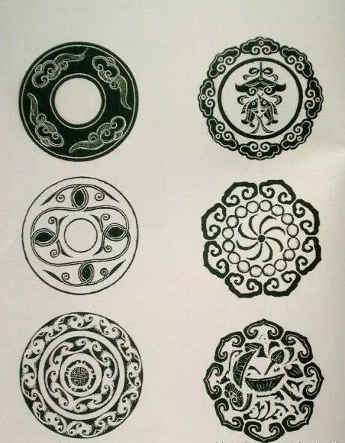

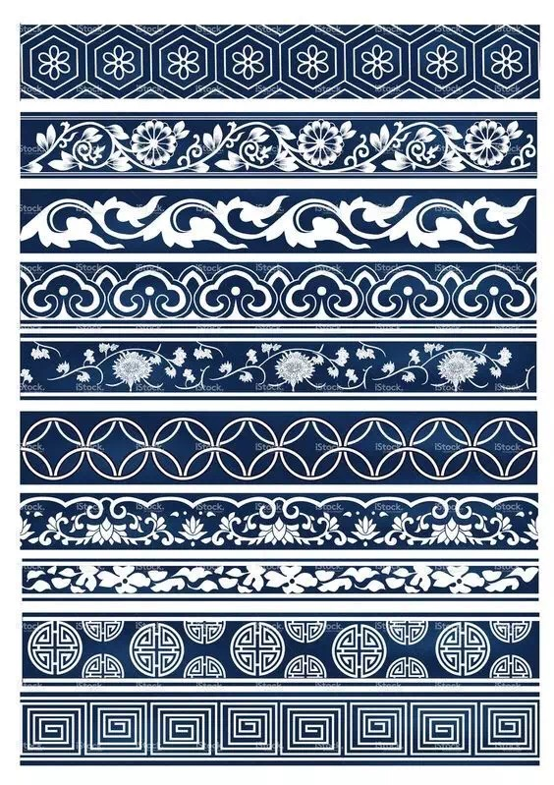

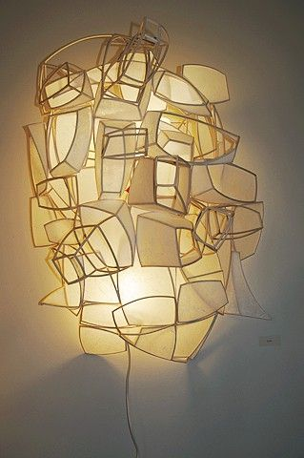
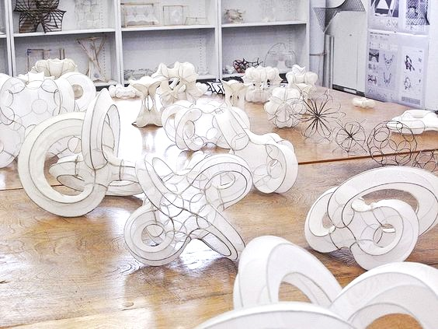
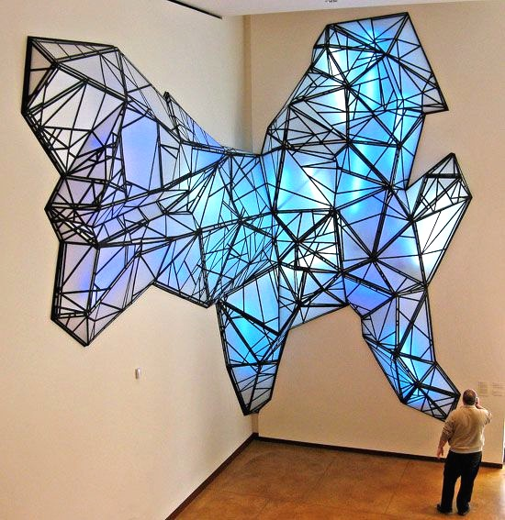
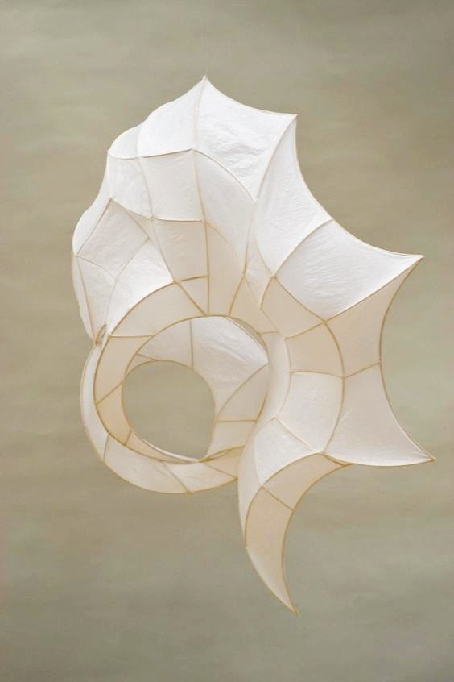
Topics for Research:
- Cloud forms, new + old
- Glitch technology - screen tears, skew morphing
- Fragmentation - renderings of the real world and where they get messed up within the virtual space

- Producing the “uncanny.”
- Precedents of analog representations of digital things, different aesthetics of what a glitch looks like

- Scaffolding and wooden support structures
- Materials we are thinking of using and our potential techniques (various papers, projector, etc)
- Practice making paper cubes, spheres, and other geometric shapes (to be used as models for potential sculptures within the installation).

