CONSTRUCTIVISM AND E-LEARNING FINAL ASSIGNMENT

Wanyi Wong
(86598125)

University of British Columbia
ETEC530-65B-Constructivism Strategies for E-Learning
Option A

Part A
I chose option A to complete for this assignment. The lesson plan in this document is based on the Ontario Ministry of Education Grade 4 curriculum expectation for Social Studies and Literacy. Instead of creating a completely new lesson plan for this assignment, I decided to use the lesson plan I created previously for a short lesson for this unit, however this version includes modifications drawn from actual feedback after the lesson delivery and from the contents drawn from this course. The original unit lesson plan for this was created for about ten 50-minutes lessons that were taught in the span of two to three weeks covering all multiple expectations listed in the curriculum for the unit. Because it is also an integrated lesson with not just Literacy, but also Math, Art and Science. The original lessons also included a Medieval Feast celebration with other classes at the end as the unit wrap-up activity. However, this modified lesson plan will only cover some of the key expectations for this specific lesson in the unit. This socials studies topic was integrated into the literacy curriculum to practice oral communication and reading skills on top of building knowledge about early societies.
The form of e-learning used for this lesson is blended learning, using textbooks as reference and reading material and the computer for online resources and lesson delivery. The constructive approach used in this lesson was a mixture of Inquiry-Based Learning and Guided Instruction. The main objective of the lesson is to teach students the different point of views of people from different social classes and jobs during Medieval ages. The lesson was taught after they had already been exposed to the Medieval Times unit and the structure of Castles and its infrastructure and functions. It is designed to build understanding from prior knowledge and scaffolding with hands-on activities that students can participate in together to promote learning. Most parts of the lesson were taught with the teacher being a coach, scaffolding and guiding the contents as the students discuss the material by asking questions and giving problems.
In the beginning of the lesson, students are asked to brainstorm together what jobs are around in current society and what jobs they think are around in early societies. This form of teaching allowed the teacher to get an understanding of what knowledge the students possessed to better cater and work the materials around them, to help them make better connections for information retention.
This opening was a lead into the main section of the lesson, the “During” component, where students were introduced to medieval jobs at first glance. They were then given a chance to write down their thoughts about jobs that interested them. Then, after sharing a few responses, students are given detailed descriptions of the jobs that were previously introduced. After reading all the descriptions, a small discussion is commenced to further discuss how things might be like during that era. This also helps the students justify any belief they had about Medieval jobs with new data and information.
Upon conclusion of the discussion, students are given time to complete the second section of their worksheet, where they can write detailed reasons for their job selection. This is meant for the job interview activity that will take place at the end of class and throughout the unit. At the end of class, a simple but fun comprehension activity takes places to apply the knowledge the students have gained. As an overall unit activity, students are also asked to apply for jobs at the castle/keep by having one-on-one interviews with the teacher who will act as the king or queen. Their reasoning for why they are the best for the jobs they applied to, was a demonstration of the knowledge they’ve learned and comprehended as on the spot question would also be conducted. All the students took it seriously and would ask if they’ve got the job at the end of the interview sessions. The Job Interview activity was an oral assessment method that allowed the teacher a chance to see how much the student understood and to really assess whether they understood enough to build their own perspectives about the topic, as required in the curriculum.
The lesson aimed to help students gain perception as if they were there by recreating an imaginary environment of the Middle Ages. But like Pritchard stated, this form of perceptual knowledge, indirect realism, is only what we believe the world appeared it may not actually but how it is. Therefore, each student had a different understand and perception for the jobs that were introduced in the lesson. However, with this lesson plan, students could share knowledge they had about Medieval times from outside the classroom with the rest of the class and complete simple but fun activities that helped them understand the unit content. Thus, they could successfully learn the required content and concepts in the curriculum.

Part B
Curriculum Expectations covered in Lesson Plan
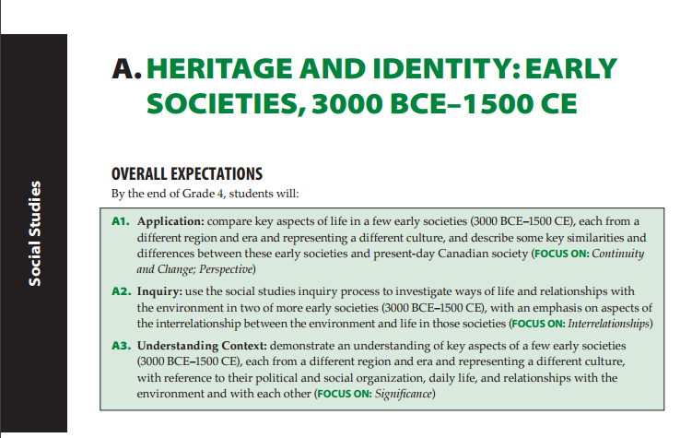
Overall Expectations of Grade 4 Socials Studies Section A
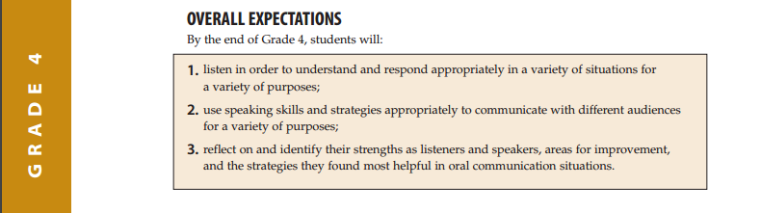
Overall Expectations for Grade 4 Language: Oral Communication

Lesson Plan

Subject |  |  | Lesson Topic |  | Grade | Duration
Literacy/Socials Studies |  |  | Jobs in the Medieval Time |  | 4 | 60-80mins
Topic: |  | Discuss and learn about jobs during the medieval times
Curriculum Expectations: |  | Focus: Interrelationships/Significance/ Point of Views  S.S A3.9 describe some key reasons why different groups in early societies cooperated or came into conflict at different times  Literacy 1.8 identify the point of view presented in oral texts and ask questions about possible bias
Learning Goals:  By the end of class, I will be able to identify the different roles that people played in Medieval Culture. I will be able to choose a job from the medieval times and describes its duties. |  |  |  | Resources:  - Nelson literacy  - Smartboard lesson  - Worksheets
Time | Instructions (Teacher/Student Actions)
Before  (5-10 mins)  During  (20-25 mins)  After  (5 mins)  (10 mins) | Talk about the variety of jobs that are around during the medieval times and now. Brainstorm a list together.  Use Medieval Society presentation from Ontario Education Resource bank to introduce the topic.  After presentation of different types of jobs: Give out the point of view chart worksheet, to complete the first part. Have students share their answers after.  - What job I would like to have in medieval times / My reasons  *Be sure to list out potential jobs: kings or queens, nobles, clergy, professionals and business peoples, peasants. Doctors, teachers, craftspeople, entertainers.  Princess, Falconer, Barber, Minstrel, Housewife.  Read Nelson Literacy page 90 – 91 (Jobs in medieval times)  Focus and Discuss professional skills. Like Doctors, Teachers, Craftspeople, entertainers, business owners. Imagine how life would be like to live and worked during those times. Discuss how it might be different from now.  Complete part two of the worksheet  - Do you still want to do that job or do you prefer another job? If so, what job?  Assessment Game/Activity: Chain game cards  In pairs, you will be given a piece of paper that has a job and a description on each side. One student/group will start by reading the description out, the rest of the students must listen to the description and then find the job that matches that description. The student/group that identified the job title first, will read their description to find the next job. Continue until all jobs have been found.
Post Lesson Evaluations / Explanations (5-10mins or till the end of class)
Comprehension Assessment Activity: Job Interviews
As part of the overall assessment, students will be given time to organize their thoughts and prepare for a job interview at the Castle with the King/Queen(Teacher). Teacher conducts job interviews for positions at the Castle that students must apply for after they have completed the activities for the lesson. During the interview, they must tell the King/Queen what job they are applying for, and why they are suitable for the job and the describe the tasks they can complete at the job.

Point of view Assessment Worksheet for Lesson
Date: ________________________ Name: _____________________

Jobs during Medieval Times Part 1

What job would I like to have in Medieval Times?

My reasons:

Jobs during Medieval Times Part 2

Do you still want to do that job or do you prefer another job? If so, what job?

My reasons:

Job Interview Activity Assessment (Oral Presentation Assessment)
Student:
Applying for:
Stated Reasons:

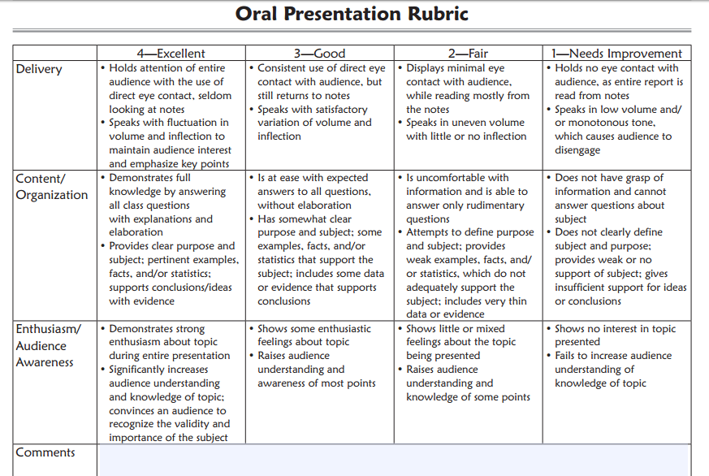

References
MacKenzie, J. (2007). Nelson literacy 4. Toronto, Ont.: Thomson Nelson.

Oral Presentation Rubric - ReadWriteThink. (n.d.). Retrieved April 10, 2017, from http://www.readwritethink.org/classroom-resources/printouts/oral-presentation-rubric-30700.html

Pritchard, D. (2014). What is this thing called knowledge? Third Edition; Routledge. Available from Routledge, Amazon kindle, and the UBC Bookstore.

Social Studies, Grades 1-6; History and Geography, Grades 7-8, 2013 (revised) (Publication). (2013). Retrieved http://www.edu.gov.on.ca/eng/curriculum/elementary/sshg18curr2013.pdf

