To: TechTrek Organizing Team
From: Wesley Berry
Date: February 3, 2016
Subject: Proposal to increase female participation in UBC TechTrek event

Introduction
Women are underrepresented in the computer science industry and this ratio of inequality propagates throughout the University of British Columbia’s computer science department and related events. This gender gap prevents a full spectrum of perspectives in the field, while consequently contributing to further professional economic, and social imbalances.

TechTrek, UBC’s yearly event aimed at encouraging computer science interest in pre-university students, is a prime opportunity to encourage female participation in the computer science industry. By supplementing interesting and creative projects with inspiring speakers and a taste of the field, TechTrek demonstrates the possibilities in computer science and helps inspire among next generation of computer scientists.

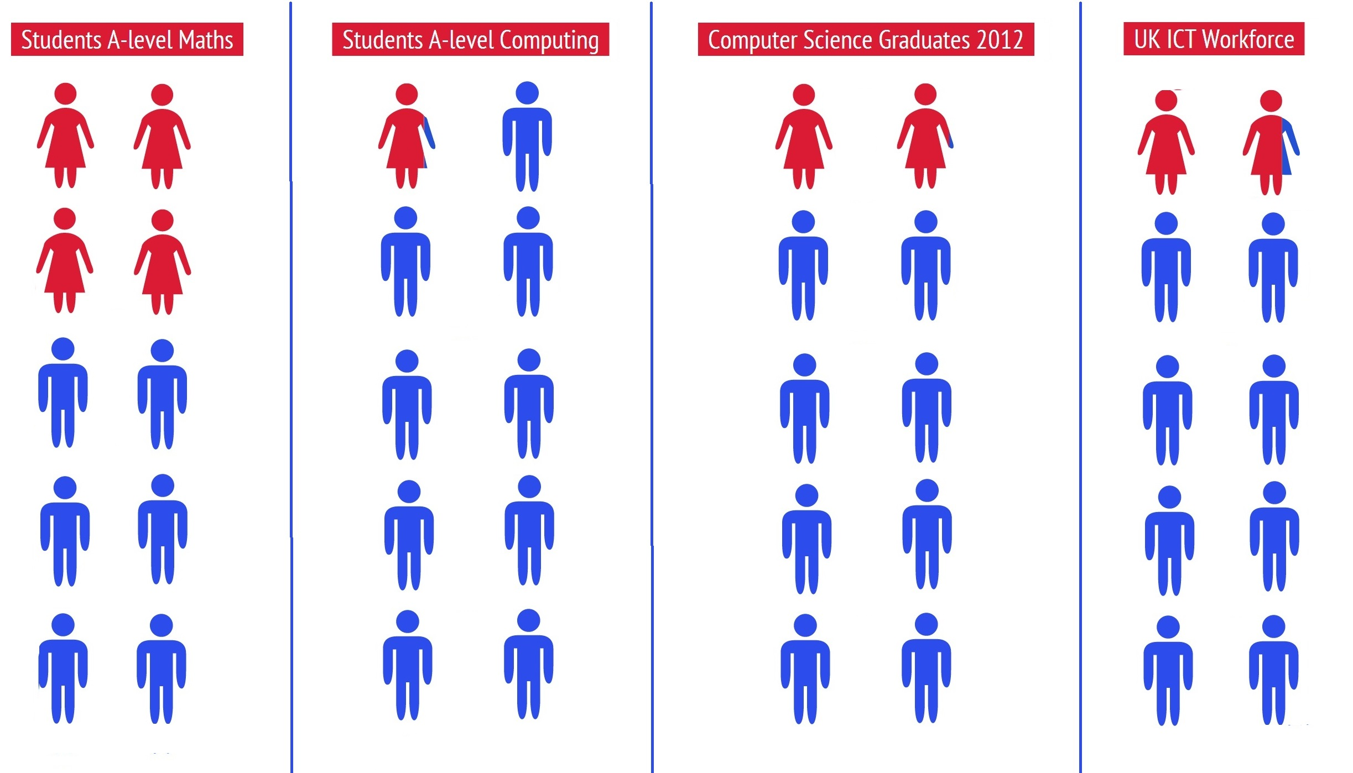
Currently, the demographics of TechTrek parallel those of the industry, despite focuses on inclusiveness. However, highlighting specific areas of inspiration, identifying pitfalls in the current marketing structure, and implementing specific promotion strategies may help assuage this gender participation gap.

Statement of Problem
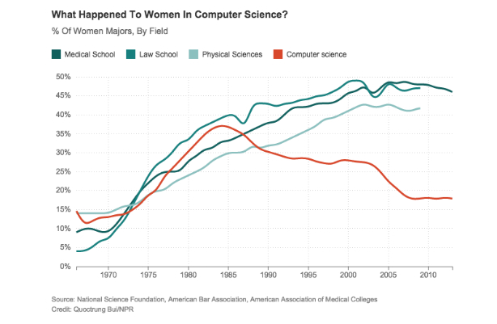
The underrepresentation of women at TechTrek perpetuates inequality in industry. Increasing the number of girls participating in TechTrek will inspire and empower the next generation of female computer scientists, while helping to shift male-dominated attitudes and perspectives at TechTrek and beyond. From a functional standpoint, each participant brings unique experiences and perspectives to the table, contributing to a more robust and thorough whole. The voice for female perspectives is not nearly loud enough and by including more girls in TechTrek, the event and industry will gain more comprehensive value, while pushing towards gender equality on a larger scale.

Proposed Solution
There is a need to identify why this gender gap occurs and what actions organizers can take to effectively increase female participation in TechTrek. By specifically identifying the factors that resonate with female students, marketing to these interests, and reducing obstacles to participation, TechTrek can encourage female participation with the goal of increasing female attendance by 20%.

Scope
To assess factors contributing to the gender gap and effectively address these influences, I plan to investigate the following facets:
- What methods do TechTrek organizers use to market the event and are these methods effective (for males and females)?
- How are these attempts at reaching out received by the target audiences?
- What are the obstacles blocking female participation in TechTrek and the computer science industry at large? Is there a link between these obstacles?
- What factors promotes male participation in TechTrek and computer science careers? Do these factors relate to and reflect female participation?
- What aspects effectively promote females to pursue computer science interests?

Methods
The primary sources for this investigation will include surveys and personal interviews with computer science students and industry professionals (males and females), pre-university students, TechTrek organizers, participants, and volunteers, and, if possible, individuals who considered computer science careers, but chose to pursue different interests instead.
Secondary sources will include academic publications investigating female participation in male-dominated fields. These sources will help provide context, perspective, and numerical data relevant to our exploration of TechTrek’s gender divide.

My Qualifications
As a computer science student and TechTrek volunteer organizer, I’ve seen firsthand the shortage of females at TechTrek and in UBC’s computer science department. Moreover, in pursuing my previous degree in sociology, I investigated the prevalent and inherent aspects of gender inequality and how these factors affect future choices. These studies underscored the importance of diversity in all realms, especially where gender is concerned. Gender equality is a pervasive goal, which means that all fields must promote equality between genders. Computer science presents a prime area for improvement.

My connections to TechTrek also allow me resources for investigating what methods the event organizers use to promote TechTrek, why fewer girls participate in the event and how the organizers can increase participation among female students.

Conclusion

Everyone brings a unique set of experiences and perspectives to the table and these diverse perspectives coalesce into important innovations and fresh ideas. By maintaining or accepting a male-dominated industry, computer science reduces its appeal to half the population, critically hindering the growth of ideas and limiting progress for all.

Reducing the gender gap in industry is not simply a noble pursuit, but rather a critically necessary step towards gender equality across the board. Societies cannot effectively realize and alleviate constraints placed on certain demographics without doing so across industries. Computer science is no exception and the gender gap in this field festers and perpetuations without action. TechTrek, with its focus on learning, inspiration, and empowerment, is a prime place to act. By identifying the successes and shortcomings of past events and experiences, TechTrek can effectively increase female participation and help turn the crank towards gender equality. With your approval, I will begin my research.

