Casual and Feasibility Analysis
of Expanding and Enriching
the BCS Study Room

for
Dr. Steven Wolfman
Director of BCS Program
University of British Columbia
Vancouver, British Columbia

by
Yingying Wu
English 301 Student

March 23, 2018

Table of Contents
Abstract …………………………………………………………………………………………ⅲ Introduction ……………………………………………………………………………………… 1 Data Section ……………………………………………………………………………………… 2
Expanding the BCS Study Room ………………………………………………………… 2
The demand………………………………………………………………………. 2
A potential New Location………………………………………………………….3
Enriching the BCS Study Room…………………....……………………………………...4
The demand……………………….………………………….……………………4
Revamping the Tutor Corner………….………………………….………………..4
Organized Social Nights………………………….……………………………......5
Quiet Study Hour Time………………………….………………………….…..…5
Cost and Funding………………………….……………………………………………….5
Conclusion ………………………………………………………………………………………. 7
Summary and Interpretation of findings………………………….…………………......…7
Recommendations………………………….………………………….……………......…7
Works Cited………………………….………………………….………………………………...8

Abstract

Introduction
The BCS study room, located in ICICS X330 is a small, 12-seated room reserved for BCS undergraduates. It is comprised of 2 four-person desk, 2 lab computers, 1 two-person couch, a microwave and a mini fridge. The room is crowded during regular school days for individual study or group projects and hosts the BCS tutor office hours. Along with the popularity of the program, the current study room space does not meet the demand of a growing student population (BCS Program (Second Degree)). Equally important, the lack of activities hosted in the study room fail to promote a sense of belonging among BCS students.

Given the situation, the BCS program should consider revamping the current study room to accommodate more students and to promote more organized activities within the student body. The most direct solutions are the below:
- Expanding the BCS study room by relocating to a larger room
- Enriching the BCS study room by promoting more activities

To further explore the possibilities of these two solutions, this report analyzes information gathered from surveys and on-site observations. Twenty-five current BCS students responded to a short survey designed to analyze perception of the current study room as well as gauge interest in revamping the room. An analysis of potential costs and funding was performed to determine the feasibility of such solutions. In addition, on-site observations of another comparable club room were conducted to provide more ideas. The analysis looks at the opportunities to expand and enrich the BCS study room. Each section defines the needs, and possible solutions. Finally, the analysis will review the cost and funding of such project.
Data Section
Expanding the BCS Study Room
To assess feasibility of a larger BCS study room, the below areas are examined.
The demand. Figure 1 illustrates the current layout of the BCS study room. The room is very small in size. One can imagine how crowded it gets during school days. Due to the small size, students also get distracted easily if there is another group of students socializing. This defeats the purpose of such study room.
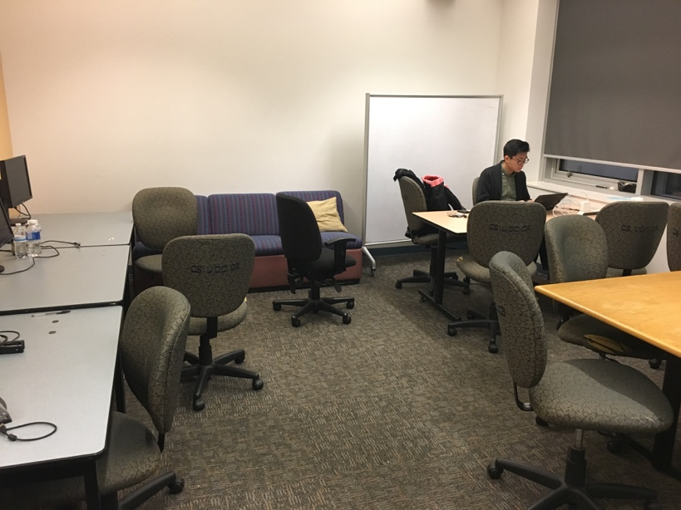Figure 1. Current BCS Study Room
How did students respond to the size of the study room? Based on the survey conducted (Figure 2), about 84% of respondents identified the issue of unable to find a seat in the BCS study room. This is alarming as no one reported he/she has no problem with the size of the current BCS study room. Indeed, with 576 active members in the official BCS Facebook group, there is no doubt that the student population has outgrown the 12-seat BCS study room (UBC BCS: Second Degree in Computer Science). The demand exists to look for an alternative room to host the BCS students.
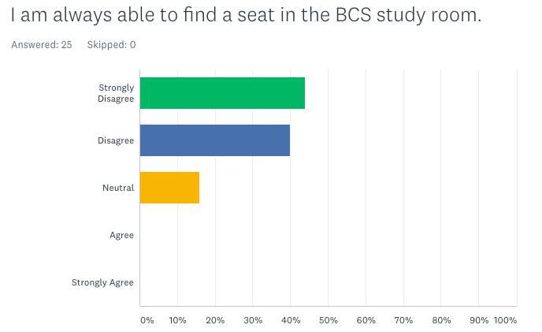
Figure 2. Survey Response to the Needs of a Larger Study Room
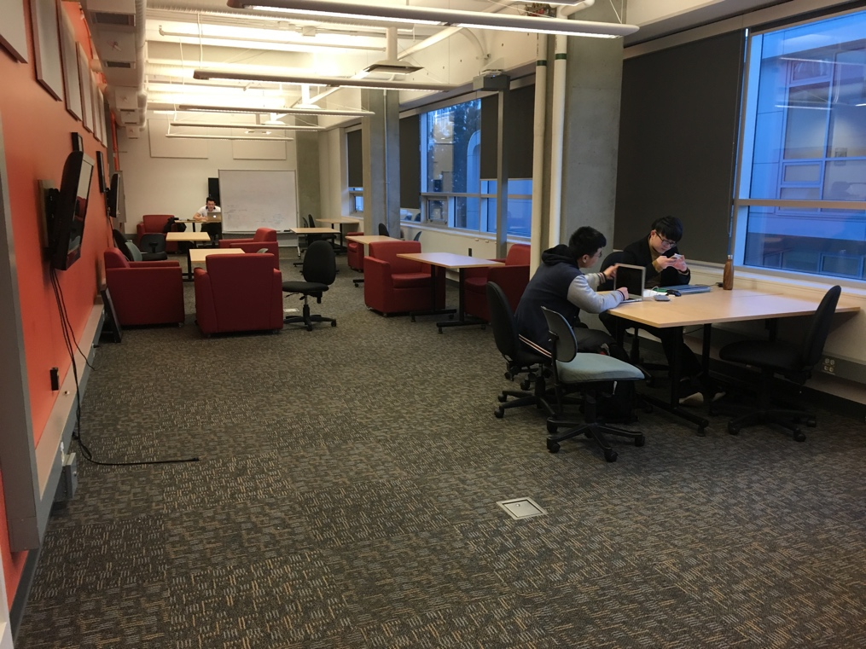
A potential new location. The ICICS building offers a lot of lab rooms for students to use. One of such rooms becomes the ideal candidate for the new Study Room due to its size, location and amenities. Located in X351, the Informal Learning Space (Figure 3) is currently a study area for the general public.
Figure 3. Room X351 Informal Learning Space
It is four times bigger in size than the current BCS study room. The Informal Learning Space is also on the same floor as the BCS study room, making the move a lot easier. Finally, the room is already equipped with tables, lounges, TVs and whiteboards. This lowers the costs of investing in new amenities for a larger BCS study room.
Enriching the BCS Study Room
The current use of the Study Room is for individual study or group project (if space allows). The room also hosts the BCS tutor office hours. No other activities are organized in the room. The below illustrate the needs for enriching the current study room and some ideas to achieve it.
The demand. Survey results show that 76% of students would like to see more organized events hosted in the BCS study room. Clearly, such demand exists for meeting more fellow BCS students and for becoming a more engaged student group.
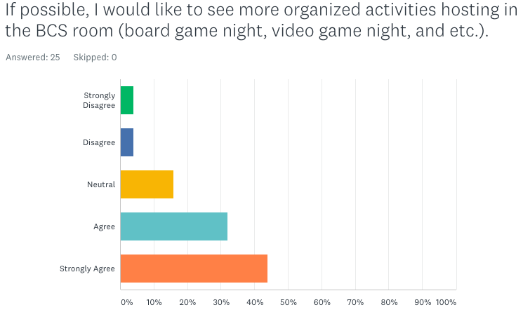
Figure 4. Survey Response to More Organized BCS Activities
Revamping the tutor corner. The current BCS tutor office hours have no sign or designated area for the tutors. They simply just sit wherever there is seat. This makes students who seek help hard to identify the tutors among other students. This can be easily resolved by having a designated tutor corner in the new BCS study room by a whiteboard. The tutor can help students using whiteboard to solve problems and engage in discussions.
Organized social nights. With more space available, the new BCS study room can have a board game shelf and a video game station set up for organized social nights. Figure 5 demonstrates an entertainment corner of another comparable club room.
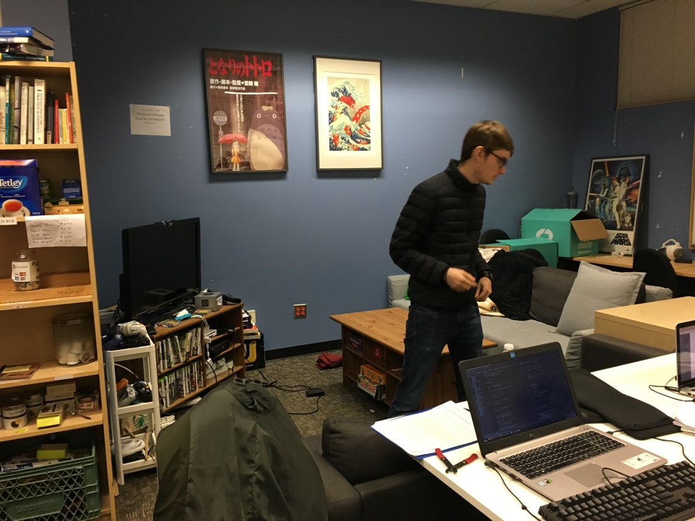
Figure 5. Board Game Shelf (left), Video Game Station (right) of a Comparable club room
Quiet study hour time. It will also be beneficial to have designated hours, for example, late afternoons on weekdays for quiet study time. As most BCS students have classes in the ICICS building which is far from any library on campus, the study room can provide a quiet place for students to study.
Cost and Funding
To evaluate the feasibility of this project, Table 1 illustrates the cost of relocating and enriching the BCS study room.
Cost of a New BCS Study Room
Action Item | Cost | Labour
Moving amenities from the current BCS study room to the new room | / | 4 hours
Ikea MULIG Shelf (for board games) | $44.79 (MULIG) | 1-hour installation  5 hours fundraising
Board games | By donation | /
Video games | By donation | /
Total Costs | $44.79 | 10 hours

Table 1. Cost of a New Study Room
The total cost of $44.79 seems to be very viable for a project that will benefit all BCS students. In the survey response in Figure 6, 96% of students are willing to donate their used items for the new BCS room. Another 80% of surveyed students are willing to volunteer their time to transform the BCS room, shown in Figure 7. Therefore, the cost of a new BCS study room can be self-absorbed via donation, volunteer hours, and fundraising.
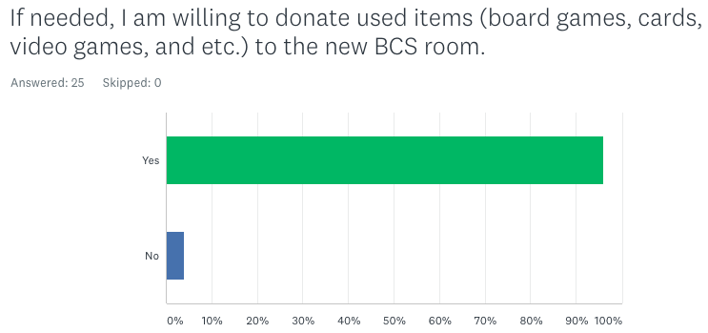

Figure 6. Response to Donate Used Items
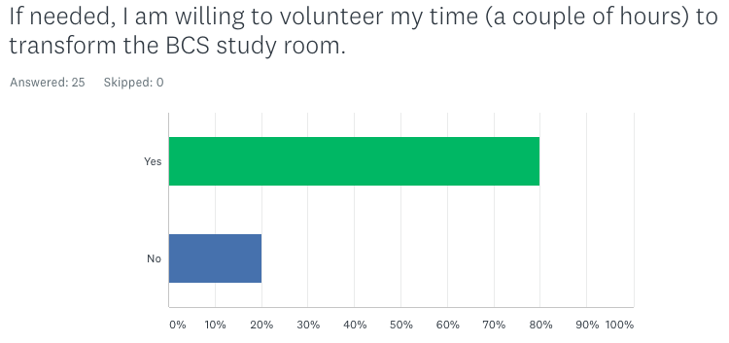

Figure 7. Response to Volunteer
Conclusion
Summary of Findings
There is a demand for expanding and enriching the current BCS study room. A potential new location for the BCS study room is identified. In order to enrich the activities in the study room, the options considered are: (1) tutor corner, (2) organized social nights, and (3) quiet study hour. The survey responses also support this self-sustained project.
Interpretation of Findings
In order to revamp the current BCS study room, it is necessary to find a larger room to accommodate the growing student population. Room X351 in the ICICS building proves to be the ideal candidate for the relocation due to its expanded size, convenient location, and existing amenities.
With a larger study room, the following can be achieved:
- Academic success: both students and tutors can benefit from a designated tutor corner.
- An engaged student group: students can meet with other BCS students from organized social nights.
- A dedicated student group: students can obtain quality study time from quiet study hour
The students will fund this project by donation, volunteer hours and fundraising events.
Recommendations
If you are interested in moving forward with this project, consider these suggestions:
- Relocating the BCS study room to ICICS X351.
- Having a designated tutor corner.
- Organizing more BCS social nights.
- Imposing a quiet study hour time.
Works Cited
BCS Program (Second Degree); 2018;
https://www.cs.ubc.ca/students/undergrad/programs/second-degree?page=1; 29 Jan 2018.
UBC BCS: Second Degree in Computer Science; 2018;
https://www.facebook.com/groups/ubcbcsclub/?multi_permalinks=940827192752196&notif_id= 1521597304397903&notif_t=group_highlights&ref=notif; 23 Mar, 2018.
MULIG; 2018; https://www.ikea.com/ca/en/catalog/products/40241045/; 23 Mar, 2018.

