Zahra Surani

Assignment 1:3:1  
Definitions

May 27, 2015

**Periodontal Disease**

Three types of definitions for Periodontal Disease will be given to a group of middle-aged construction workers. They do not have knowledge about oral healthcare or disease in the mouth because they have never been to a dentist. The following definitions will include parenthetical, sentence and expanded forms. The expanded form will demonstrate four methods used for creating a definition. The different levels of detail used in the following definitions show the importance of understanding your audience’s needs.

**Parenthetical definition**

Ms. Taylor has *periodontal disease* (disease of supporting structures of teeth) because she smokes and does not floss.

**Sentence definition**

Periodontal disease is a dental condition caused by advanced bacterial accumulation on the supporting structures of the tooth, which consist mainly of bone and fibers. Characteristics include inflammation, bleeding, and in some cases, pus.

**Expanded definition**

The word “periodontal” comes from the Greek prefix “peri-” meaning “around” and the suffix “-dont” meaning “tooth”. It is also known as “periodontitis” where the suffix “–itis” means inflammation. Literally, the word periodontal disease or periodontitis means infection or inflammation around a tooth. More specifically, it is a disease around the tooth of the supporting structures including bone and fibers that attach the tooth to the bone.

Periodontal Disease occurs when bacteria accumulates on teeth and under the gums when it is not removed by brushing and flossing. Bacteria threaten the health of teeth and gums and causes infection. If left untreated the disease progresses and destroys supporting structures of the teeth, particularly the bone. In severe cases this can lead to loss of teeth. People who have weakened immune systems and/or smoke are more prone to periodontal disease than healthy individuals.

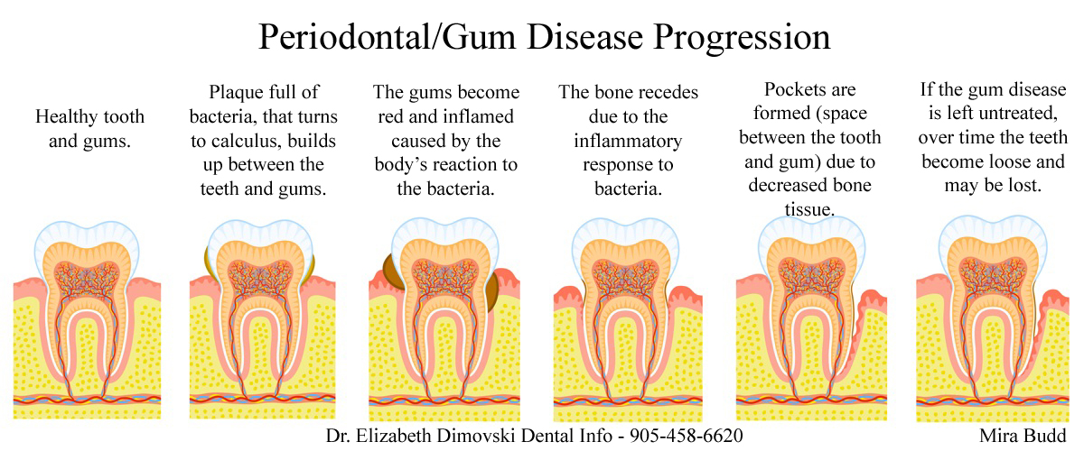

There are many stages of periodontal disease but the initial sign is gingivitis. If gingivitis progresses it can turn into worse forms such as aggressive, chronic, and necrotizing (death of gum tissue) periodontitis. However, gingivitis cannot be mistaken for periodontal disease as it is characterized by bleeding and inflammation and does not involve the bone. Gingivitis is also differentiated because thorough brushing and flossing, which can heal inflammation and bleeding, may reverse it. On the other hand, periodontal disease is irreversible because it destroys bone that cannot be restored.

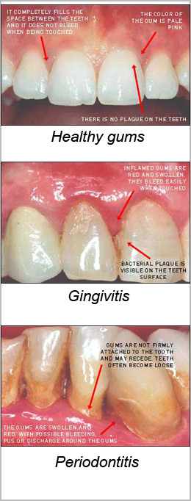

**REFERENCES**

1. American Academy of Periodontology. (n.d.). *Types of gum disease*. Retrieved May 25, 2015, from <http://www.perio.org/consumer/types-gum-disease.html>
2. Center for disease control and prevention. (2015, March 10). *Periodontal disease*. Retrieved from http://www.cdc.gov/OralHealth/periodontal_disease/index.htm
3. Dimovski, E. (2015, May 23). Periodontal/gum disease progression*.* Retrieved from https://dentistbrampton.wordpress.com
4. Katz, H. (2015, May 25). Comparison photos between health gums, gingivitis, and periodontitis. Retrieved from <http://www.periotherapy.com/gumdiseasepics.asp>
5. Periodontal. (n.d.). *Online Etymology Dictionary*. Retrieved May 27, 2015, from Dictionary.com website: http://dictionary.reference.com/browse/periodontal