Zahra Surani
Assignment 1:3:1
Definitions
May 27, 2015

Periodontal Disease

Three types of definitions for Periodontal Disease will be given to a group of middle-aged construction workers who have never been to a dentist. The following definitions will include parenthetical, sentence and expanded forms. The expanded form will demonstrate four methods including visuals. The different styles of definitions will demonstrate the need and importance of technical writing for a particular audience. They will also show levels of detail to be used circumstantially.

Parenthetical definition

Ms. Taylor has periodontal disease (disease of supporting structures of teeth) because she smokes and does not floss.

Sentence definition

Periodontal disease is a dental condition caused by advanced bacterial accumulation of the supporting structures of the tooth, mainly bone and fibers. Characteristics include inflammation, bleeding and in some cases, pus.

Expanded definition
The word “periodontal” comes from the Greek prefix “peri-” meaning “around” and the suffix “-dont” meaning “tooth”. It is also known as “periodontitis” where the suffix “–itis” means inflammation. Thus, periodontal disease is disease or inflammation around a tooth. More specifically, it is a disease around the tooth of the supporting structures including bone and fibers that attach the tooth to the bone.

Periodontal Disease occurs when bacteria accumulates on teeth and under the gums when it is not removed by brushing and flossing. The bacteria threaten the health of the teeth and gums and start to cause an infection. If left untreated the disease progresses and destroys supporting structures of the teeth, particularly the bone. In severe cases this can lead to loss of teeth. People who have a lowered immune system and/or habits like smoking are prone to periodontal disease.

Gingivitis is the first stage of periodontal disease and only effects the gums. It is characterized by bleeding and inflammation, and does not involve the bone. Gingivitis is reversible by meticulous brushing and flossing, which can heal inflammation and bleeding. However, Periodontal disease is irreversible because it destroys bone that cannot grow back.

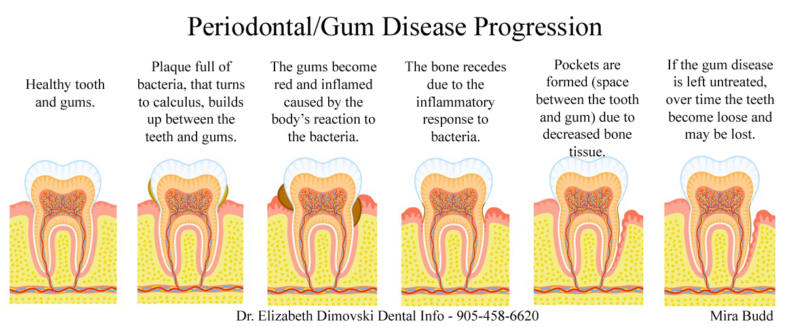
Figure. 1 A diagram showing the development of Periodontal Disease
Source: https://dentistbrampton.wordpress.com

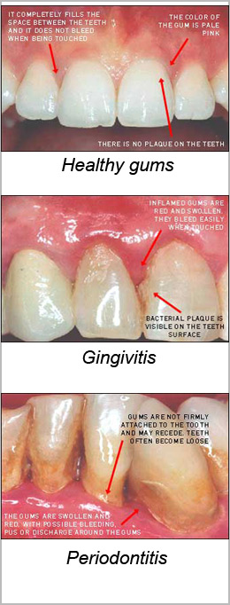
Figure. 2 A diagram of healthy gums to diseased gums
Source: periotherapy.com

REFERENCES
American Academy of Periodontology. (n.d.). Types of gum disease. Retrieved May 25, 2015, from http://www.perio.org/consumer/types-gum-disease.html
Center for disease control and prevention. (2015, March 10). Periodontal disease. Retrieved from http://www.cdc.gov/OralHealth/periodontal_disease/index.htm
Dimovski, E. (2015, May 23). Periodontal/gum disease progression. Retrieved from https://dentistbrampton.wordpress.com
Katz, H. (2015, May 25). Comparison photos between health gums, gingivitis, and periodontitis. Retrieved from http://www.periotherapy.com/gumdiseasepics.asp
Periodontal. (n.d.). Online Etymology Dictionary. Retrieved May 27, 2015, from Dictionary.com website: http://dictionary.reference.com/browse/periodontal

